# 

# A

# REPORT

# ON

# MACHINE LEARNING

By: **Ritu Utkarsha**

Problem Statement:

**You work for an office transport company. You are in discussions with ABC Consulting company for providing transport for their employees. For this purpose, you are tasked with understanding how do the employees of ABC Consulting prefer to commute presently (between home and office). Based on the parameters like age, salary, work experience etc. given in the data set ‘Transport.csv’,you are required to predict the preferred mode of transport. The project requires you to build several Machine Learning models and compare them so that the model can be finalised.**

**Dataset for Problem:**[**Transport.csv**](https://olympus.mygreatlearning.com/courses/75699/files/7212751/download?verifier=Jsdun3FfWJRfJwWHBRXh3D3s2CttClHPgGxNj80g&wrap=1)

**1.1. Read the dataset. Do the descriptive statistics and do null value condition check.**

**Solution:**

**HEAD OF THE DATASET: THE FIRST 5 ROWS OF THE DATASET**

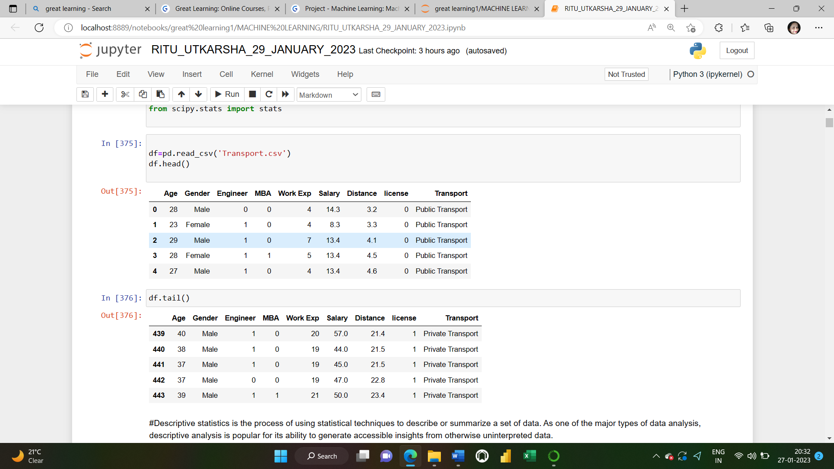

**TAIL OF THE DATASET: THE LAST 5 ROWS OF THE DATASET**



**DATATYPES OF EACH COLUMN IN THE GIVEN DATAFRAME**

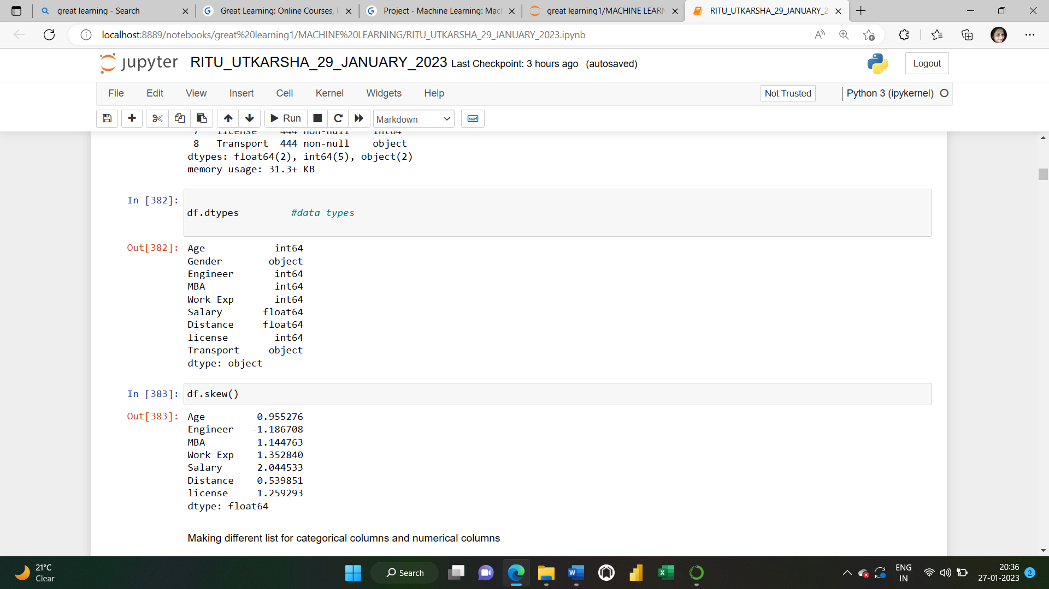

**SHAPE OF THE DATASET:**

Shape attribute tells us number of observations and variables we have in the data set. It is used to check the dimension of data. This dataset has 444 observations (rows) and 9 variables (columns) in the dataset.

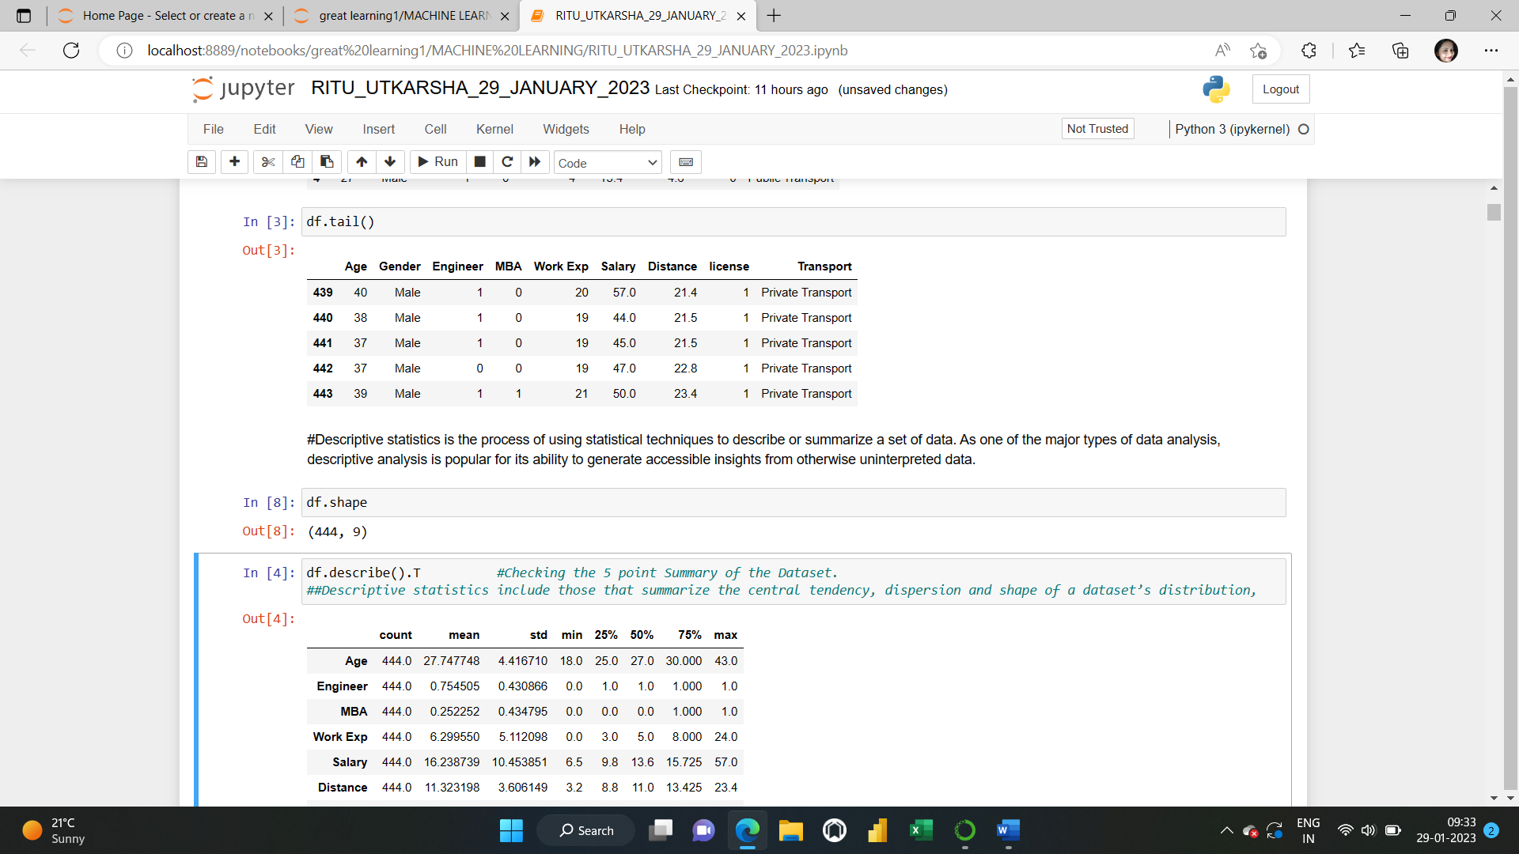

**INFO:** It is used to get a quick summary of the dataset. It comes handy when doing exploratory analysis of the data. To get a quick overview of the dataset, we use .info function.

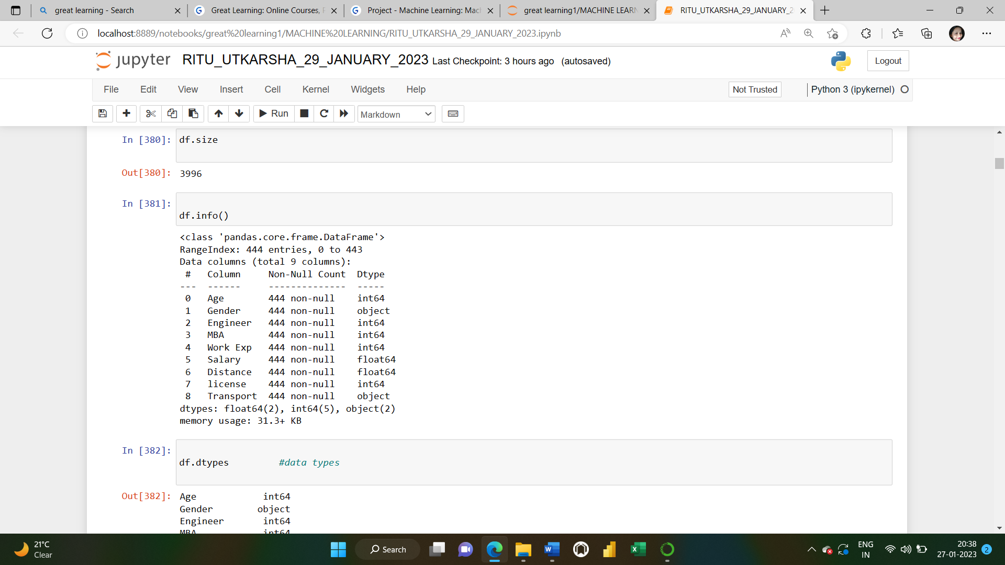

2 columns are of float data type,5 is of integer types and 2 are of object type. There are no missing values in any column. Memory used by the dataset: 31.3+KB.

**DESCRIPTIVE STATISTICS:**

Descriptive statistics is the process of using statistical techniques to describe or summarize a set of data. As one of the major types of data analysis, descriptive analysis is popular for its ability to generate accessible insights from otherwise uninterpreted data.

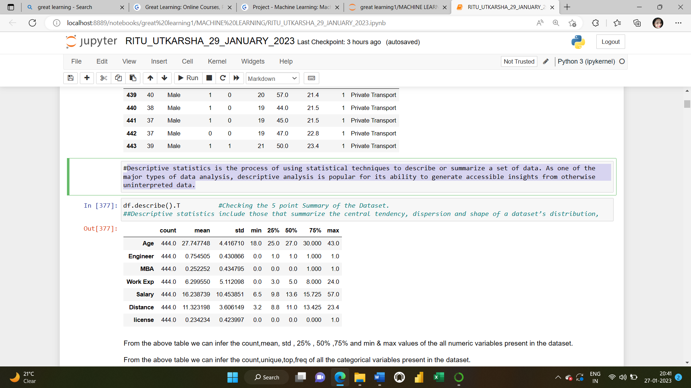

From the above table we can infer the count, mean, std, 25%, 50% ,75% and min & max values of all numeric variables present in the dataset.

From the above table we can infer the count, unique, top, freq of all the categorical variables present in the dataset. All the variables seem to be positively skewed except “Engineer”. If the [mean](https://www.statisticshowto.com/mean/)is greater than the mode, the distribution is positively skewed. If the mean is less than the [mode](https://www.statisticshowto.com/mode/), the distribution is skewed. The maximum Age is 43 and minimum is 18. The mean distance is 11.323 and median distance is 11.0.

**NULL VALUES**: A field with a NULL value is a field with no value. We have 0 missing values here.

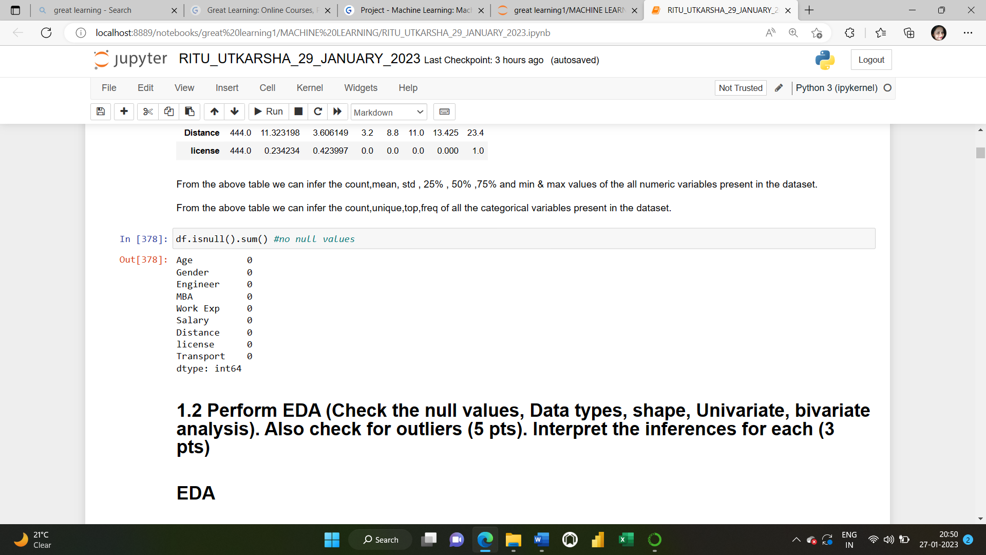

**1.2**. **Perform EDA (Check the null values, Data types, shape, Univariate, bivariate analysis). Also check for outliers (5 pts). Interpret the inferences for each (3 pts)**

**Solution:** Exploratory data analysis (EDA) is used to analyse and investigate data sets and summarize their main characteristics, often employing data visualization methods. It helps determine how best to manipulate data sources to get the answers we need, making it easier to discover patterns, spot anomalies, test a hypothesis, or check assumptions.

**DATATYPES OF EACH COLUMN IN THE GIVEN DATAFRAME**



**SHAPE OF THE DATASET:**

Shape attribute tells us number of observations and variables we have in the data set. It is used to check the dimension of data. This dataset has 444 observations (rows) and 9 variables (columns) in the dataset.



**NULL VALUE CHECK:** We have 0 missing values.



**CHECKING UNIQUE VALUES IN CATEGORICAL VARIABLE:**

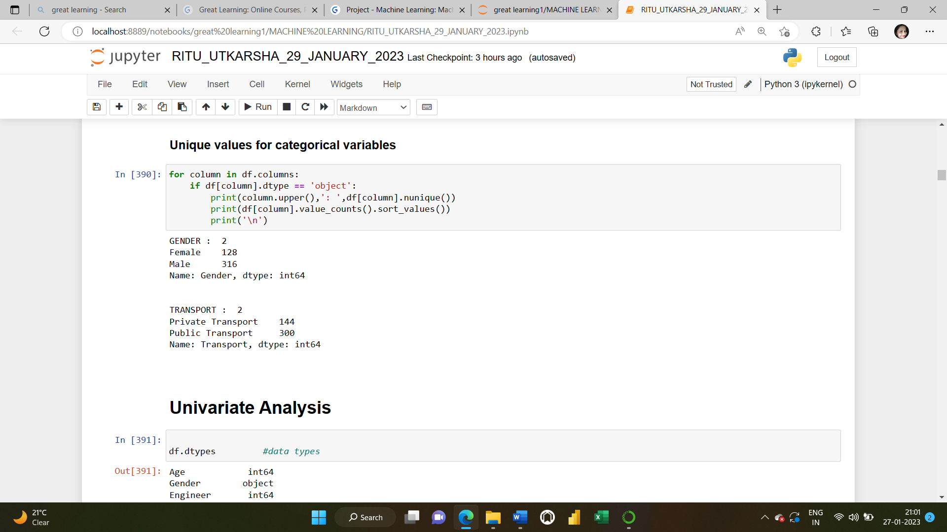

**SKEWNESS**

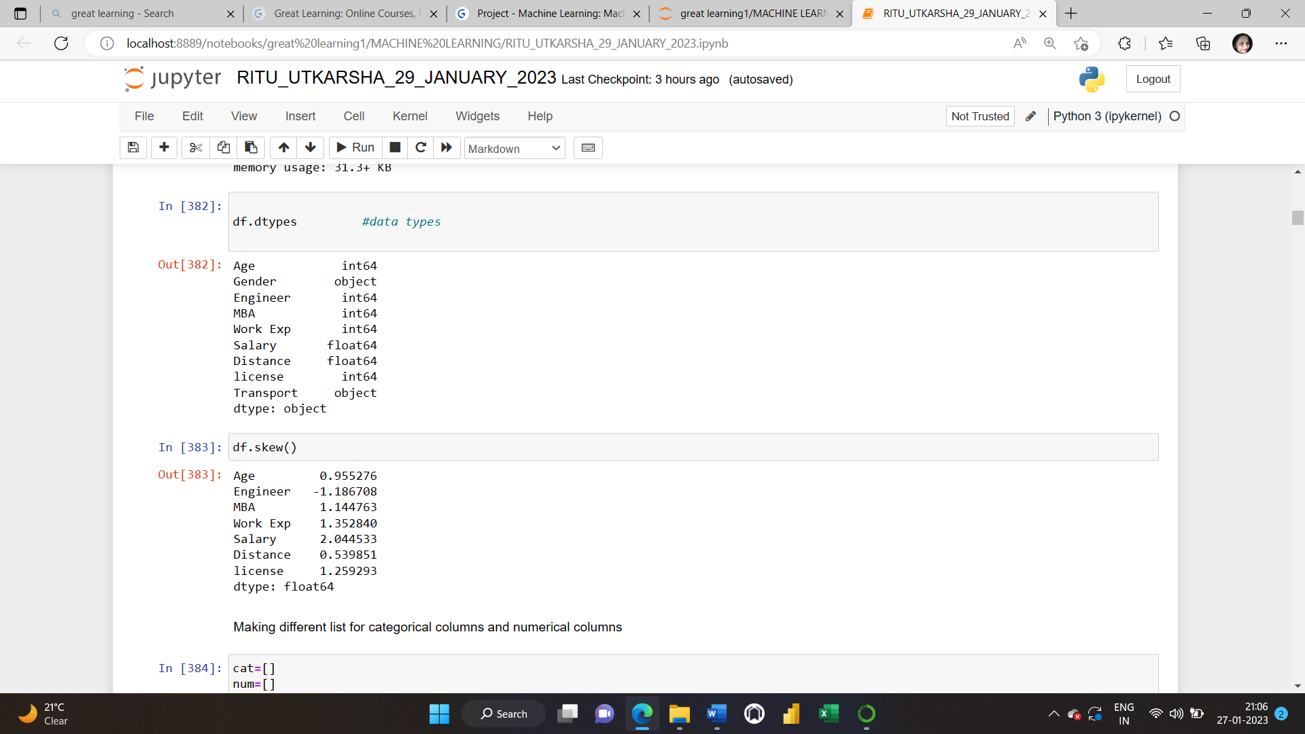

**checking for categorical data types:**

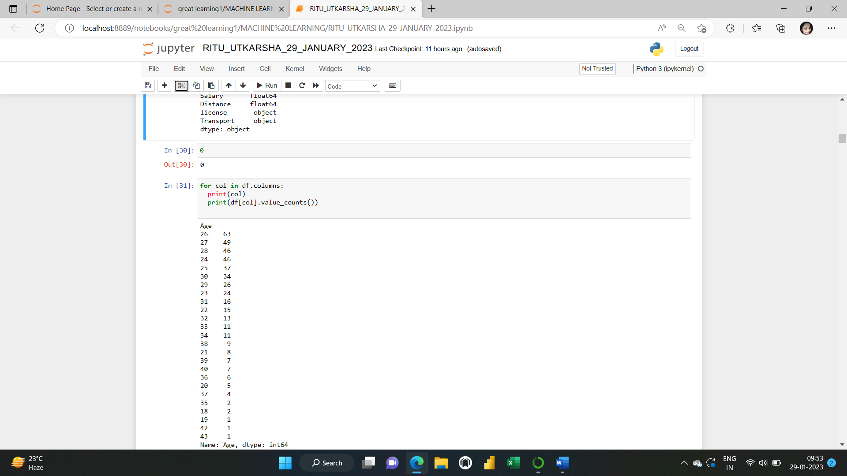

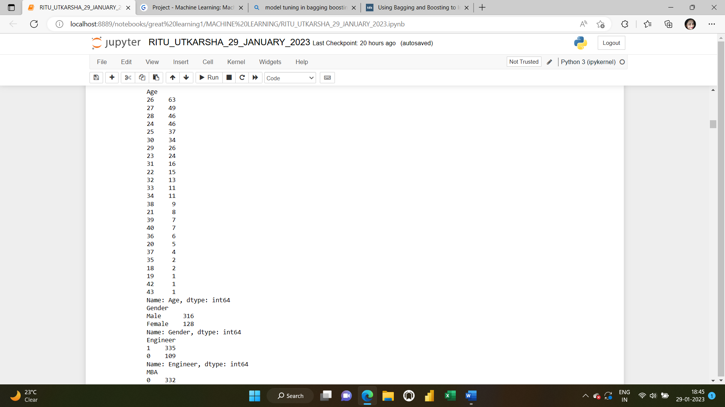

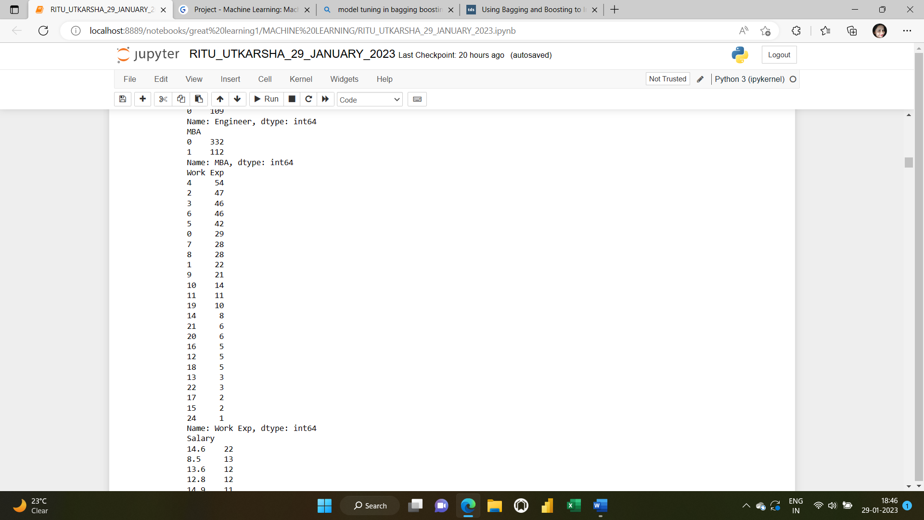

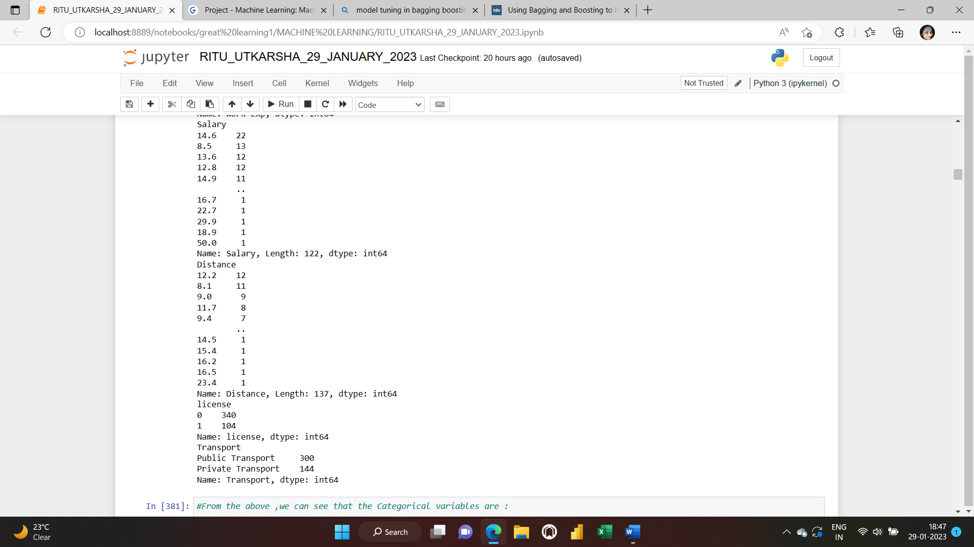

From the above, we can see that **“**Gender”, “Engineer”, “MBA”, “License”, “Transport” are all categorical variables, not numerical. So, we need to convert them from numerical to categorical.

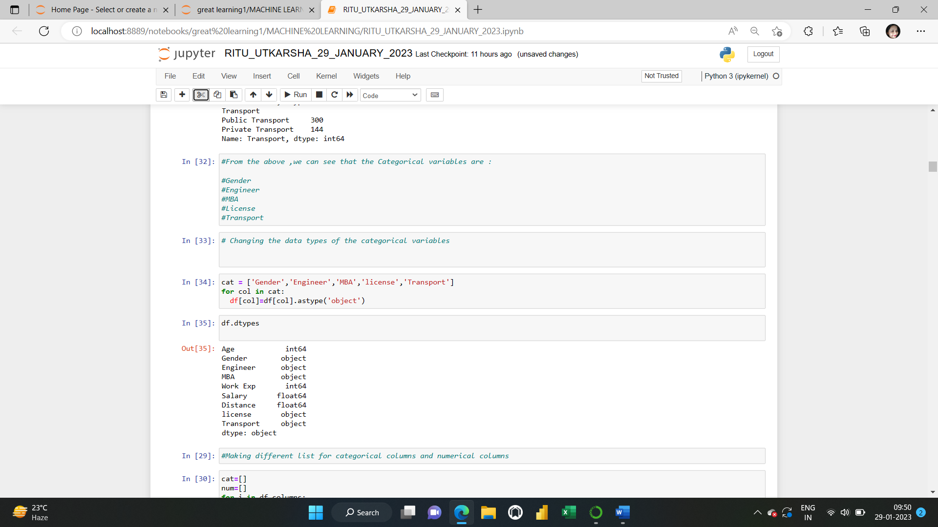

**Checking the changed data types of these variables**

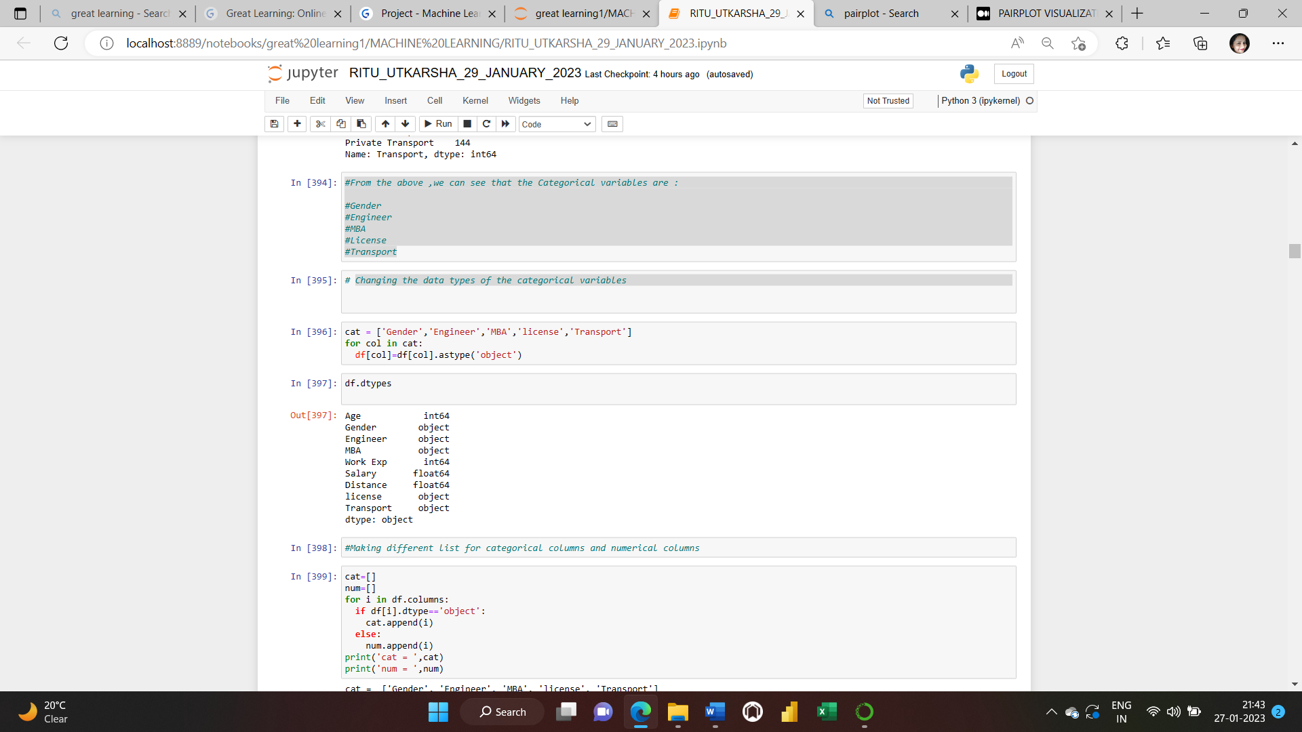

**UNIVARIATE AND BIVARIATE ANALYSIS:**

**Univariate analysis** is the simplest form of analysing data. “Uni” means “one”, so in other words your data has only one variable. It doesn’t deal with causes or relationships and its major purpose is to describe; It takes data, summarizes that data and finds patterns in the data.

We choose to perform univariate analysis on any of the individual variables in the dataset to gain a better understanding of its distribution of values.

[**Bivariate Analysis**](https://www.statology.org/bivariate-analysis/) **is th**e analysis of two variables.

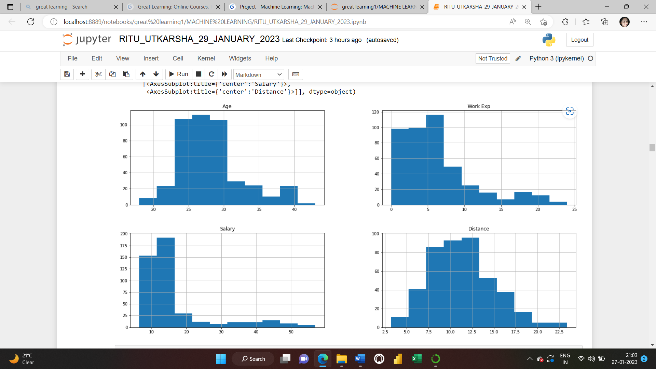

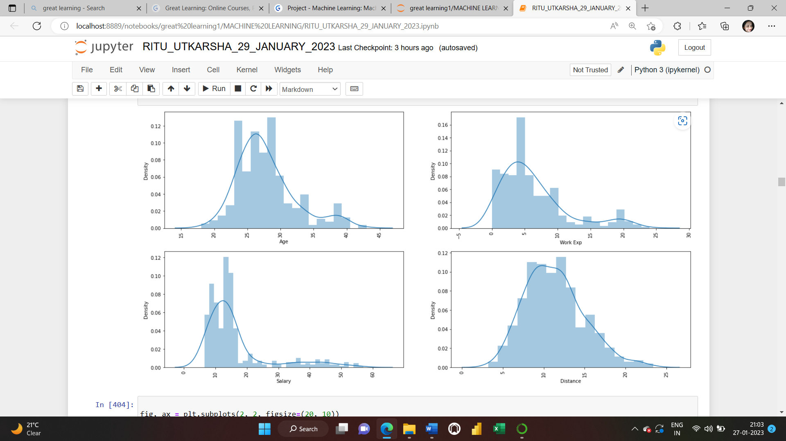

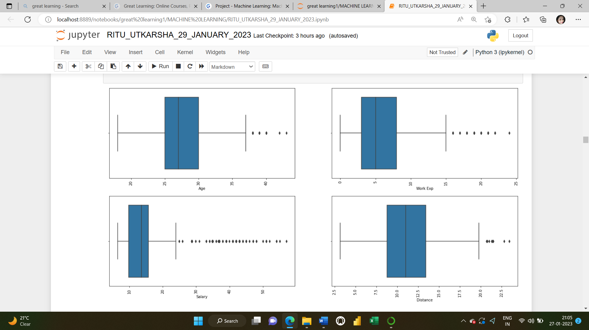

INSIGHTS: The distribution of data in “AGE”,” WORK EXP”,”SALARY”,”DISTANCE” seem to be positively skewed

Mean of “Age” is around 28 and maximum is around 43.Distance and Age seem to be very less skewed compared to Salary and Work Exp.

**CHECKING OUTLIERS:**

We’ve already plotted the boxplots of all the numerical variables and got the result that we’ve a lot of outliers in the data.

There seems to be outliers in all the numerical variables. “Salary “ has maximum number of outliers in the data.

**MULTIVARIATE ANALYSIS: Multivariate Analysis is** the analysis of two or more variables.

**Multivariate analysis** is required when more than two variables have to be analysed simultaneously. It is a tremendously hard task for the human brain to visualize a relationship among 4 variables in a graph and thus multivariate analysis is used to study more complex sets of data.

**CORRELATION:** data.corr() will give us the correlation matrix for the dataset. Correlation is a term that is a measure of the strength of a linear relationship between two quantitative variables.

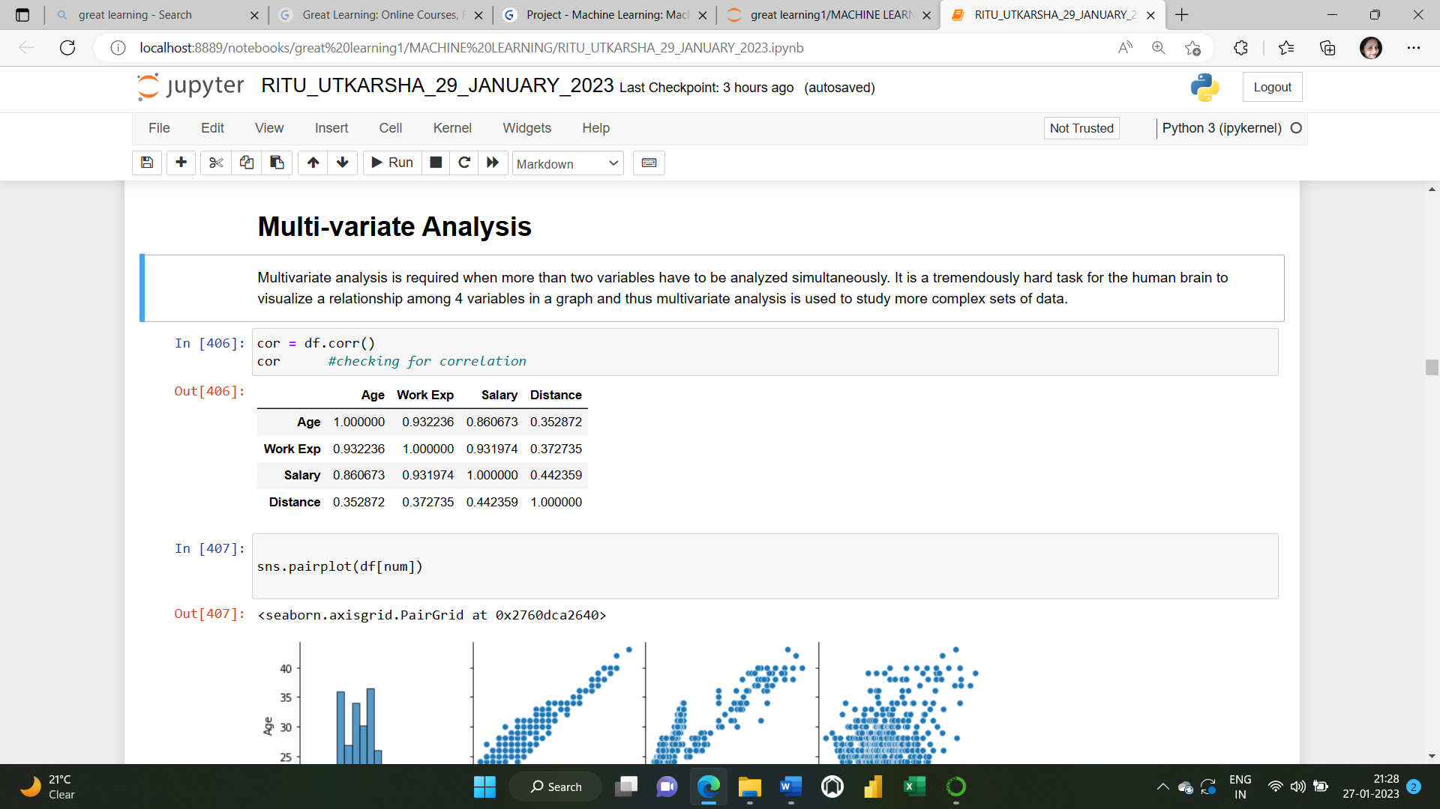

**PAIR PLOT:** It visualizes given data to find the relationship between them where the variables can be continuous or categorical. Plots pairwise relationships in a dataset. Pair plot is a module of **seaborn**library which provides a high-level interface for drawing attractive and informative statistical graphics.

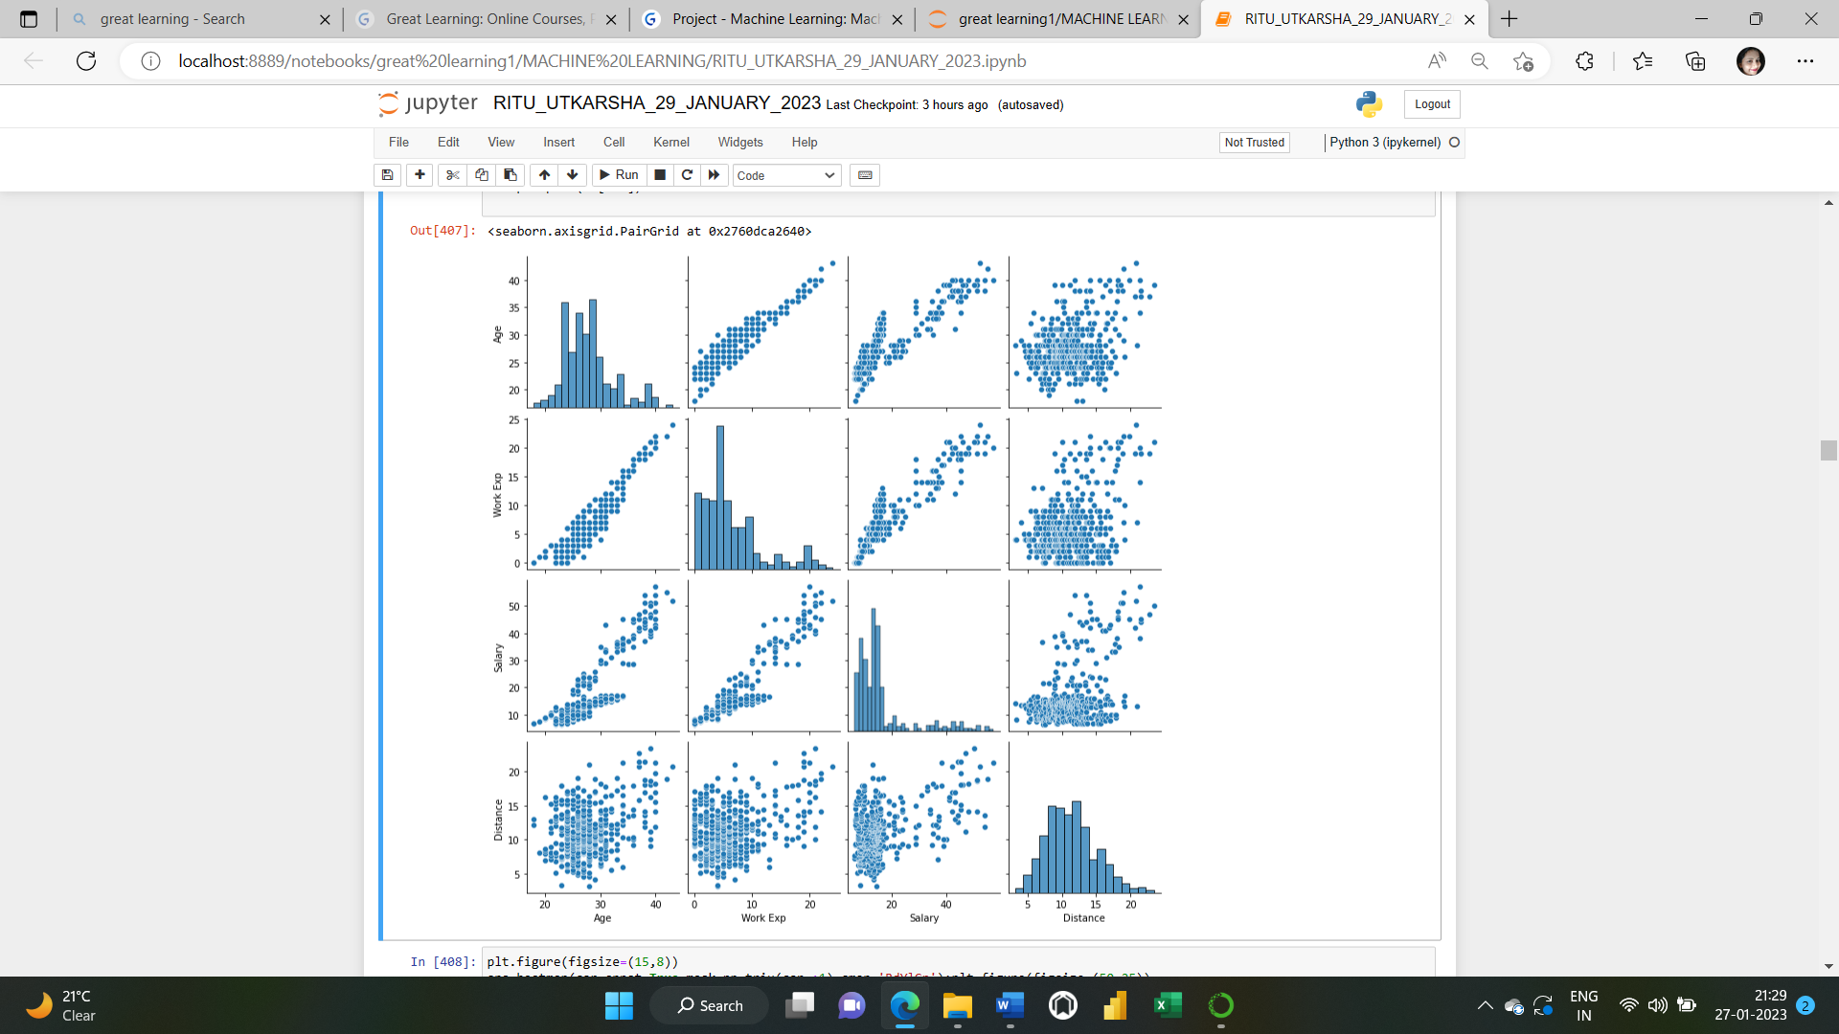

The distribution between Age and WorkExp seem to be very highly and linearly correlated. Age and Salary are slightly linear correlated whereas Age and Distance, Work Exp and Distance, Salary and Distance are very less correlated.

**HEATMAP:** A representation of data in the form of a map or diagram in which data values are represented as colours: A correlation coefficient quite close to 0, but either positive or negative, implies little or no relationship between the two variables. A correlation coefficient close to plus 1 means a positive relationship between the two variables, with increases in one of the variables being associated with increases in the other variable.

A correlation coefficient close to -1 indicates a negative relationship between two variables, with an increase in one of the variables being associated with a decrease in the other variable.

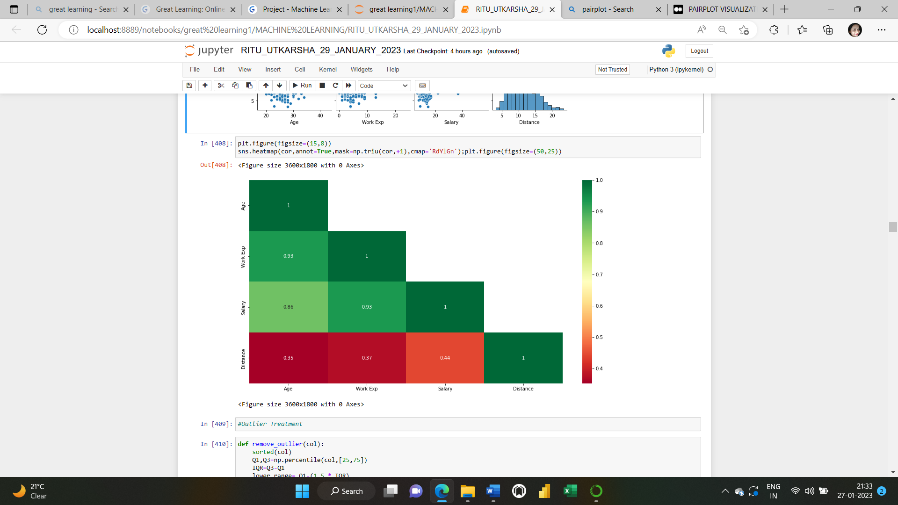

**OUTLIER TREATMENT:** [Outliers](https://www.neuraldesigner.com/learning/tutorials/data-set#Outliers) are data points that is distant from the rest. They may be due to variability in the measurement or may indicate experimental errors.

If possible, outliers should be excluded from the [data set](https://www.neuraldesigner.com/learning/tutorials/data-set). However, detecting that anomalous [instances](https://www.neuraldesigner.com/learning/tutorials/data-set#Instances) might be difficult, and is not always possible.

Outliers can be detected by implementing mathematical formulas, using statistical approaches or by using visualization tools such as boxplot, scatterplot, z score, IQR etc.

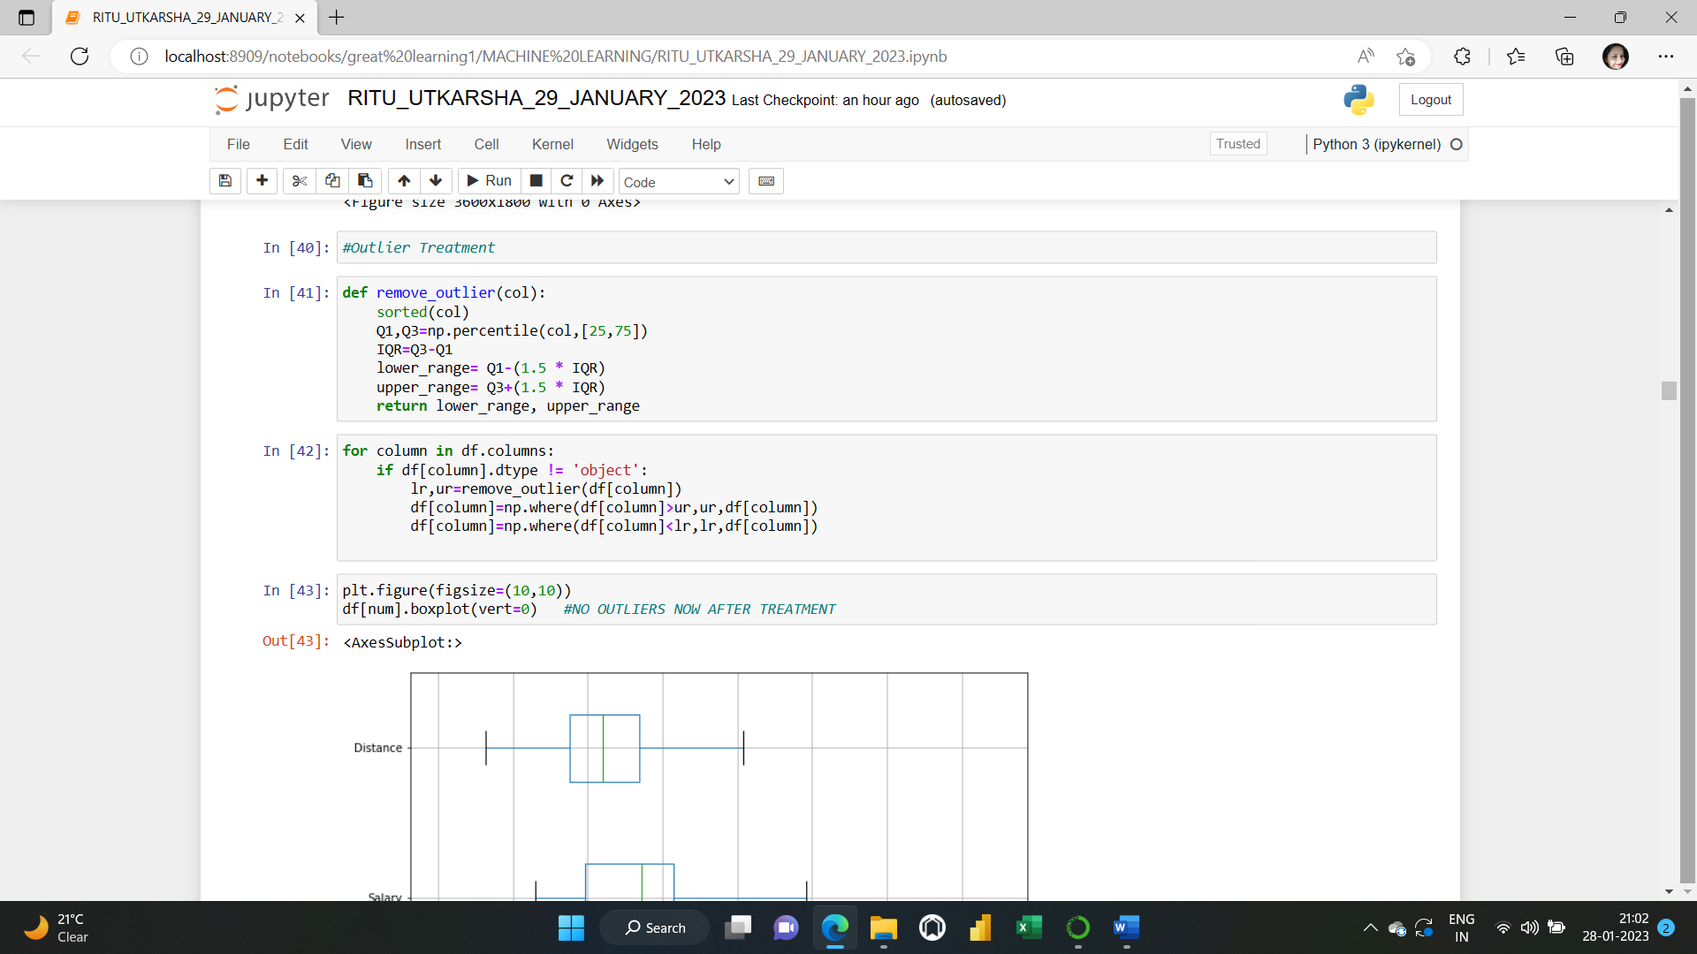

The outliers are removed now .

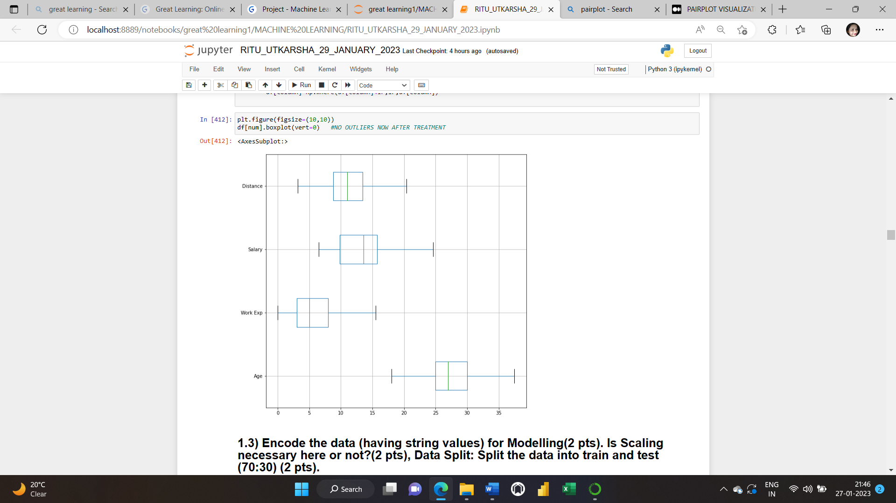

**1.3) Encode the data (having string values) for Modelling (2 pts). Is Scaling necessary here or not? (2 pts), Data Split: Split the data into train and test (70:30) (2 pts).**

**Solution: Encoding the data for modelling:**

To encode the data (having string value), we’ll perform one hot encoding here as our variables to be encoded are nominal in nature, not ordinal.

**One hot encoding** is one method of **converting data** to prepare it for an algorithm and get a better prediction. With one-hot, we convert each categorical value into a new categorical column and assign a binary value of 1 or 0 to those columns. Each integer value is represented as a binary vector. All the values are zero, and the index is marked with a 1.

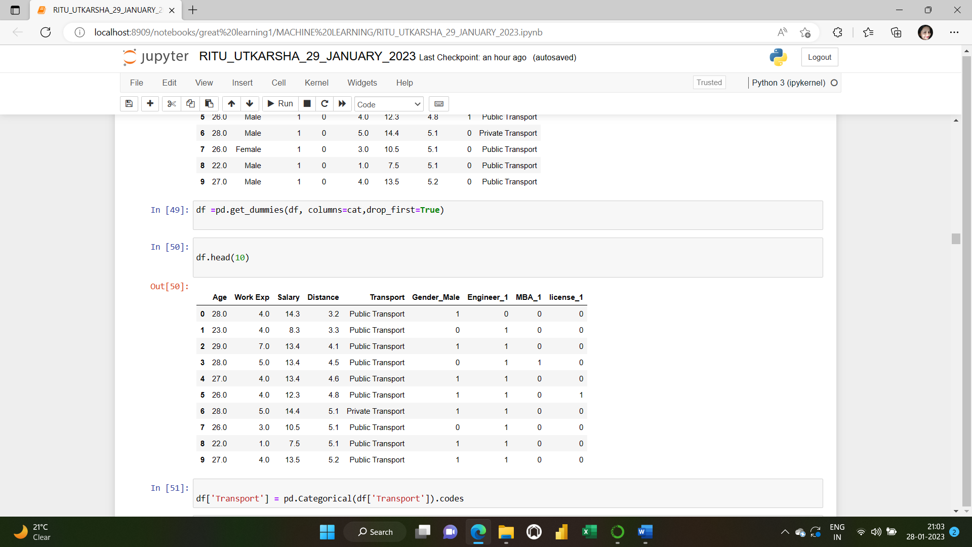

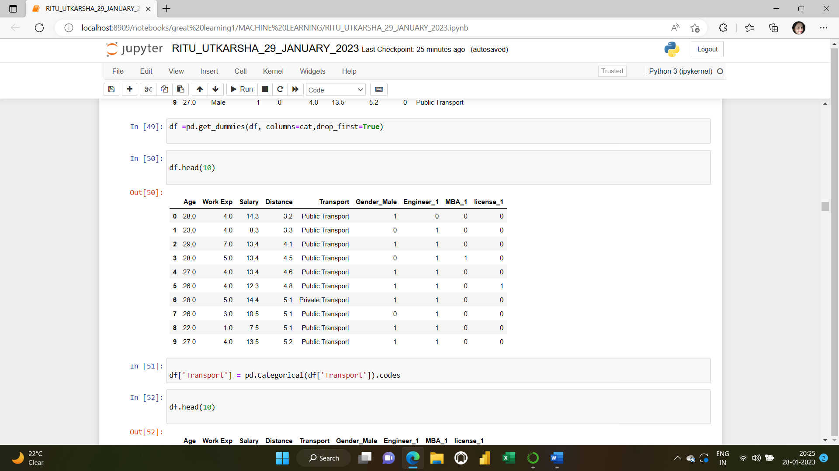**Fig: Encoded dataframe**

**Scaling the data:**

As the values of the variables are different, we should do scaling otherwise "Age", "WorkExp",” Salary” are in different range.

I have used minmax scaling to standardise the data to relative same scale -3 to +3

We will use the default configuration and scale values to the range 0 and 1. First, a MinMaxScaler instance is defined with default hyperparameters. Once defined, we can call the fit_transform() function and pass it to our dataset to create a transformed version of our dataset. Values and this may get more weightage than the other variables. Scaling will have all the values in the relative same range.

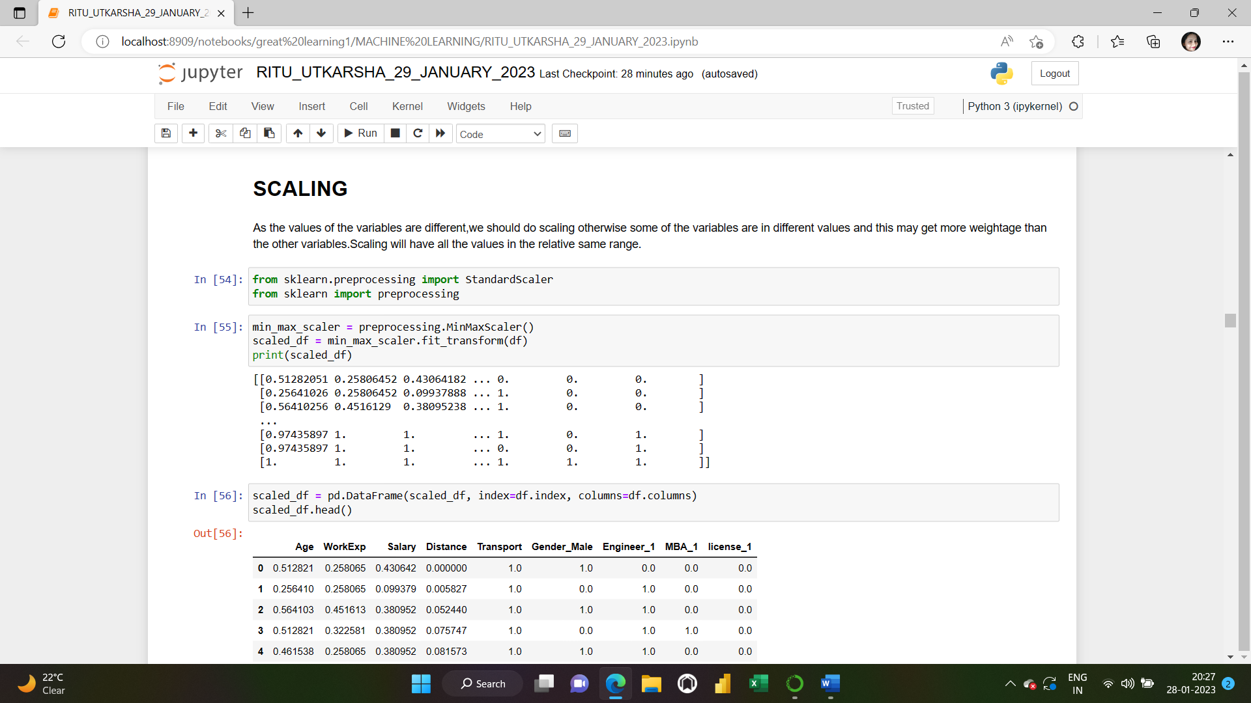

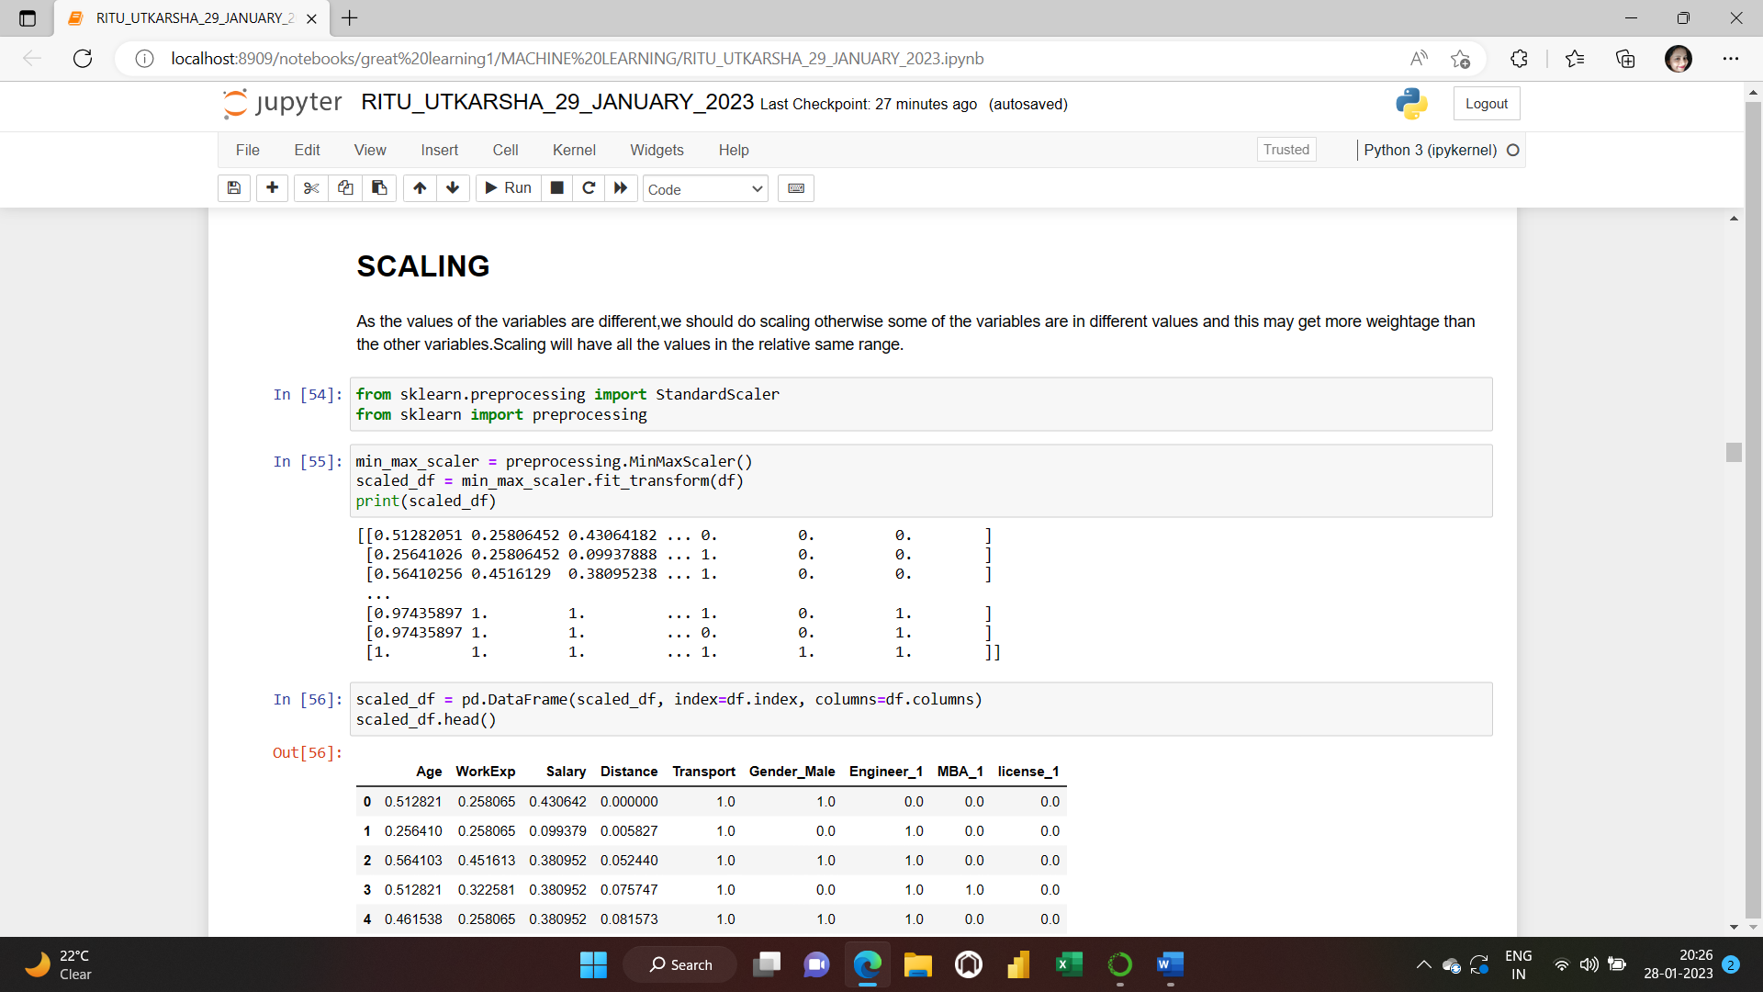

**Splitting the data into train and test (70:30):**

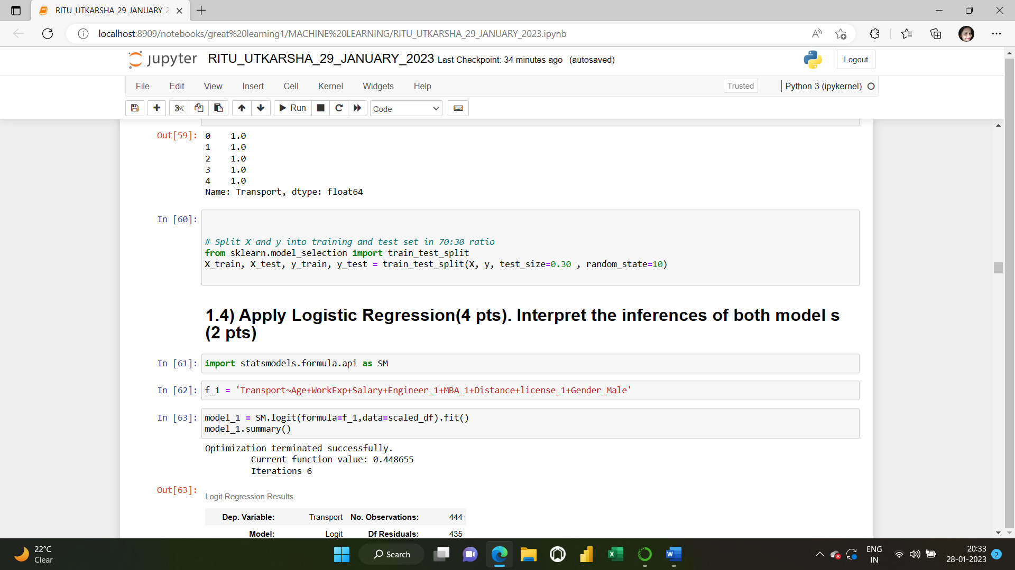

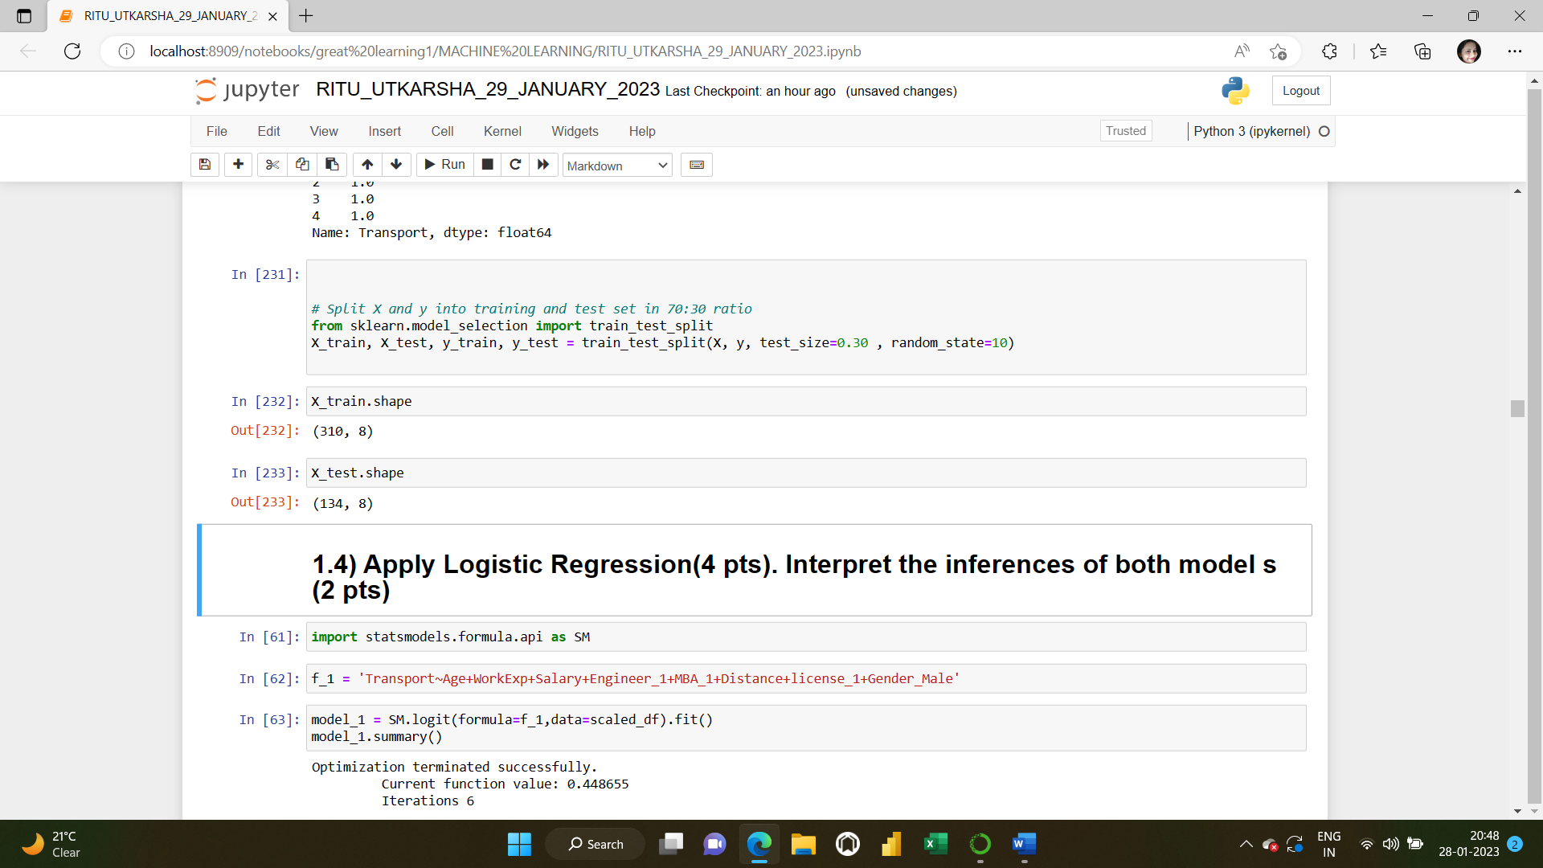

**1.4) Apply Logistic Regression (4 pts). Interpret the inferences of both models (2 pts)**

**Solution:** Logistic regression is a classification algorithm. It is used to predict a binary outcome based on a set of independent variables.

**BUILDING BASE MODEL USING ALL THE INDEPENDENT VARIABLES:**

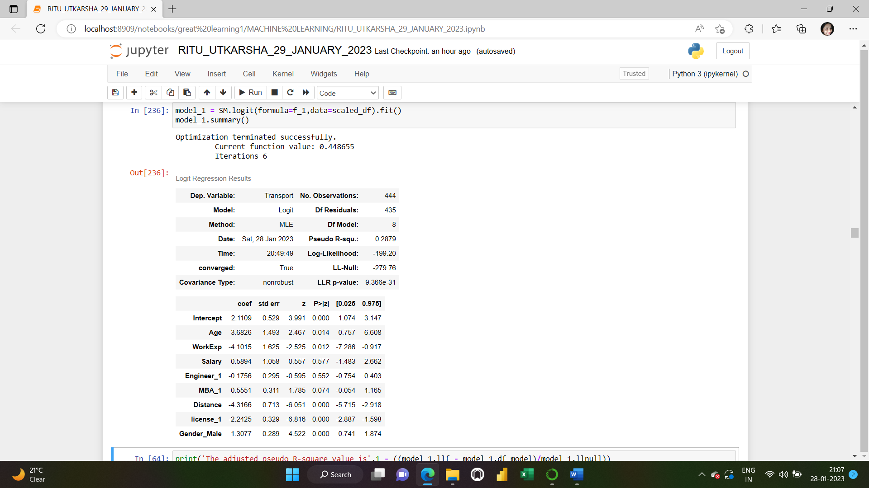

**ADJUSTED R square for the base model f_1:**

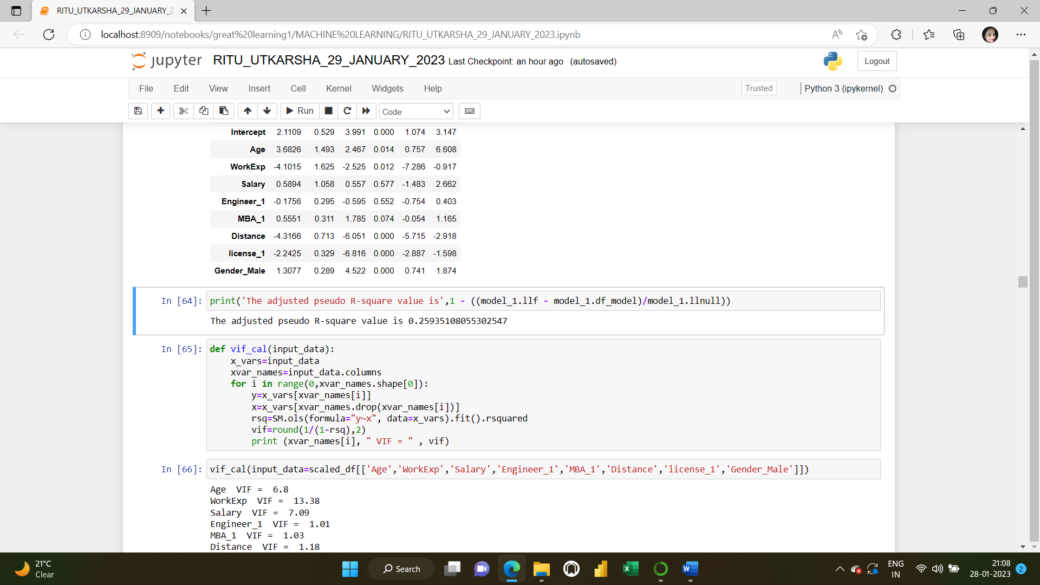

We will keep watch on adjusted pseudo-R-square as we drop variables in the following iterations. Like its ordinary least squares analog, the **adjusted McFadden** **Pseudo R square** penalizes the McFadden pseudo-R square as more terms are added to the model. More the value of adjusted pseudo-R square, the better the model is.

**CHECKING VIF: Multicollinearity** is the occurrence of high intercorrelations among two or more independent variables in a multiple regression model. Multicollinearity can lead to skewed or misleading results when a researcher or analyst attempts to determine how well each independent variable can be used most effectively to predict or understand the dependent variable in a statistical model.

To check multicollinearity, we’ll check VIF score for each of the columns. A variance inflation factor (VIF) is a measure of the amount of multicollinearity in regression analysis. [Multicollinearity](https://www.investopedia.com/terms/m/multicollinearity.asp) exists when there is a correlation between multiple independent variables in a multiple regression model. This can adversely affect the [regression](https://www.investopedia.com/terms/r/regression.asp) results. Thus, the variance inflation factor can estimate how much the variance of a regression coefficient is inflated due to multicollinearity.

Now, we will calculate the Variance Inflation Factor (VIF). We will calculate the Variance Inflation Factor by a user defined function.

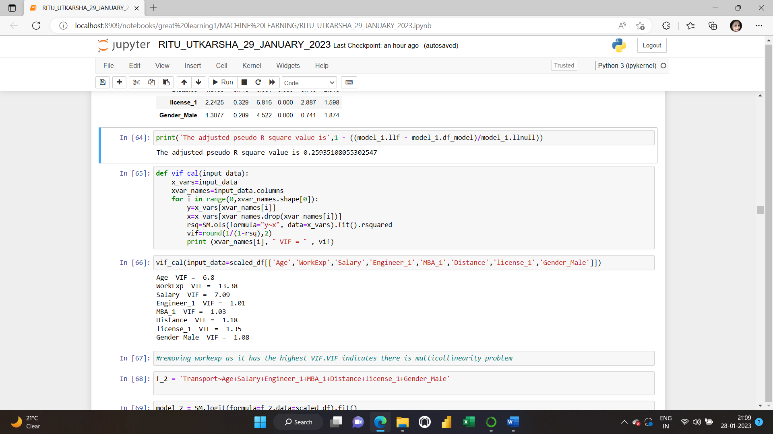

The **Variance Inflation Factor (VIF)** measures the severity of multicollinearity in [regression analysis](https://corporatefinanceinstitute.com/resources/knowledge/finance/regression-analysis/). It is a statistical concept that indicates the increase in the variance of a regression coefficient as a result of collinearity. In ordinary least square (OLS) regression analysis, multicollinearity exists when two or more of the [independent variables](https://corporatefinanceinstitute.com/resources/knowledge/modeling/independent-variable/) demonstrate a linear relationship between them.

VIF indicates there is Multicollinearity problem.

Based on 'VIF', let's drop “WORKEXP” as its VIF is very high.

In the same way, we’ll build multiple and keep a check on VIF and p value.

***Refer to the jupyter notebook for the codes.***

**FINAL MODEL BUILT:**

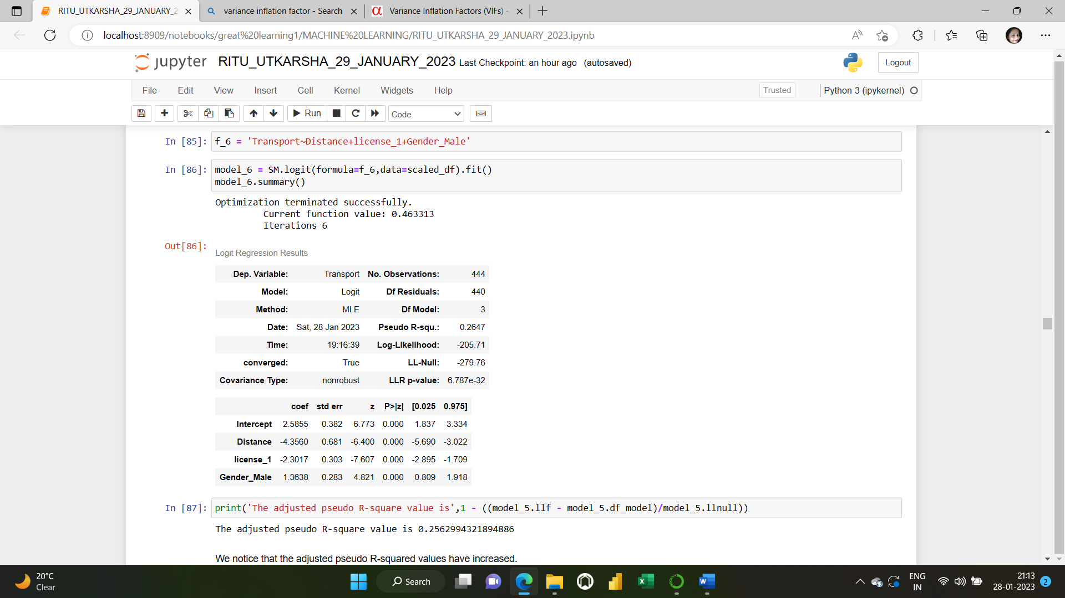

As we can see from the p values now that all the independent variables are significant now.

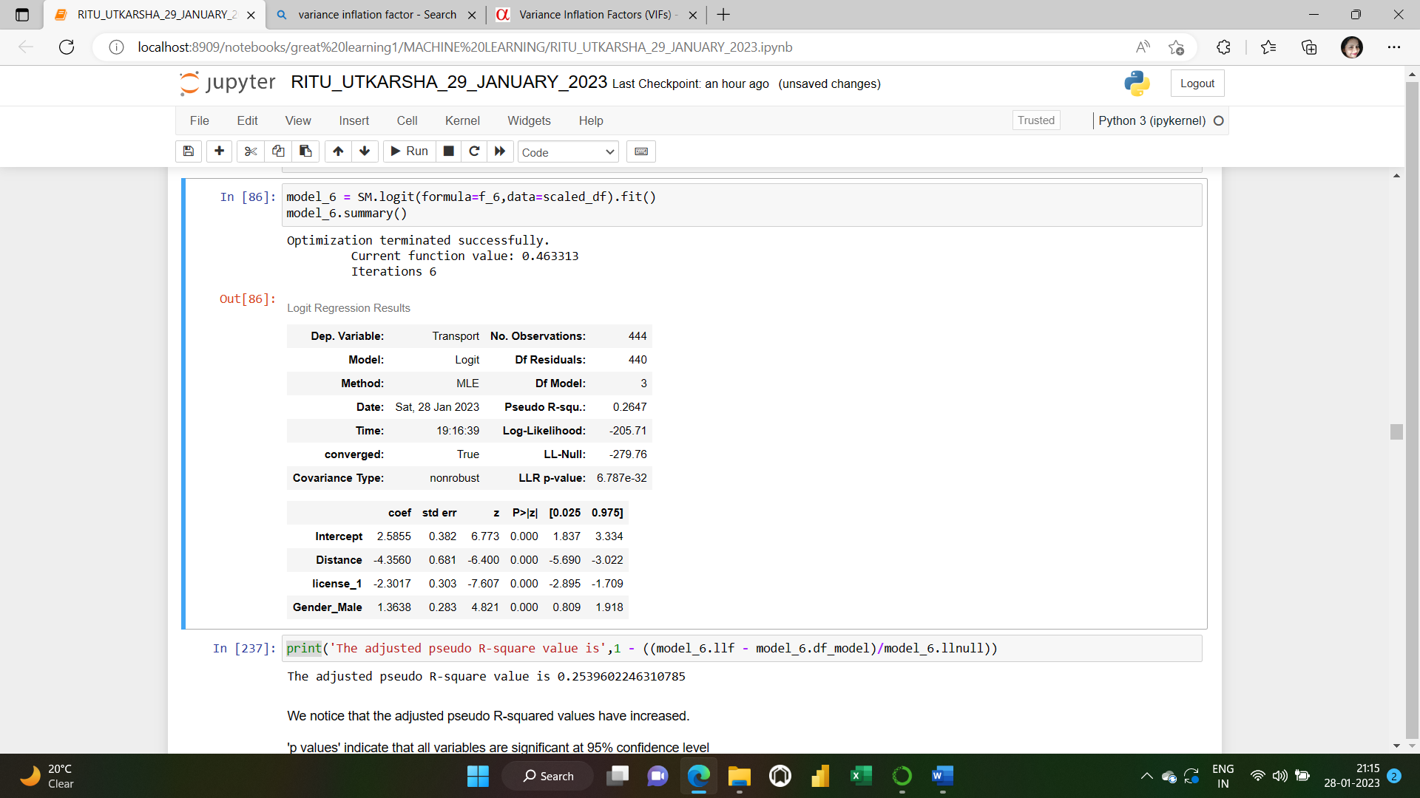

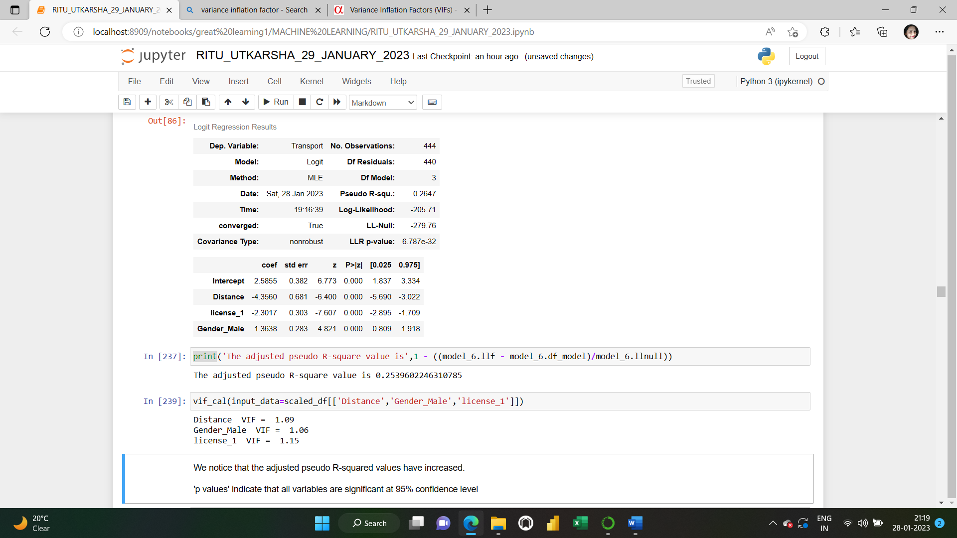

The adjusted pseudo-R-squared values have remained approximately the same. P values indicate that all variables are significant at 95% confidence level. VIF<5 for all the columns now.

**PREDICTION ON THE DATA:**

Let’s see the predicted probability values. These are the probabilities of preferred mode of transport (1=Public and 0=Private)

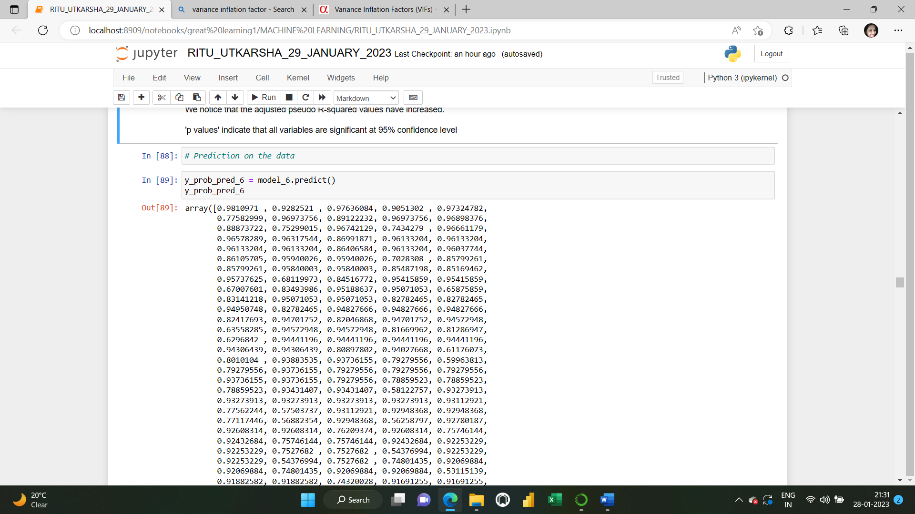

**BOXPLOT OF PREDICTED VALUES:**

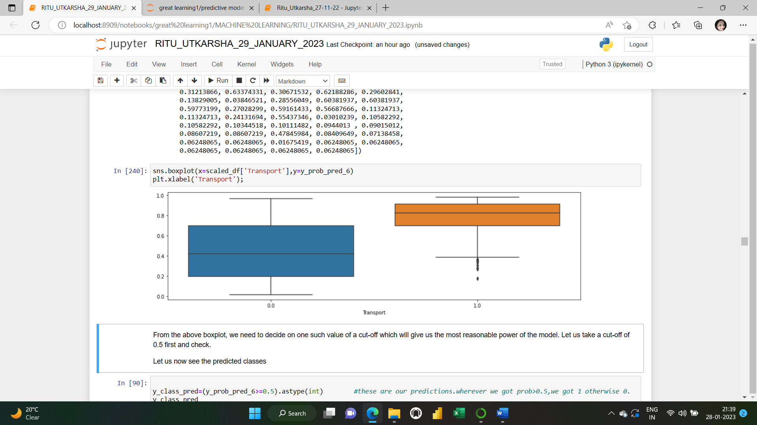

From the above boxplot, we need to decide on one such value of a cut-off which will give us the most reasonable power of the model. Let us take a cut-off of 0.5 first and check.

Let us now see the predicted classes.

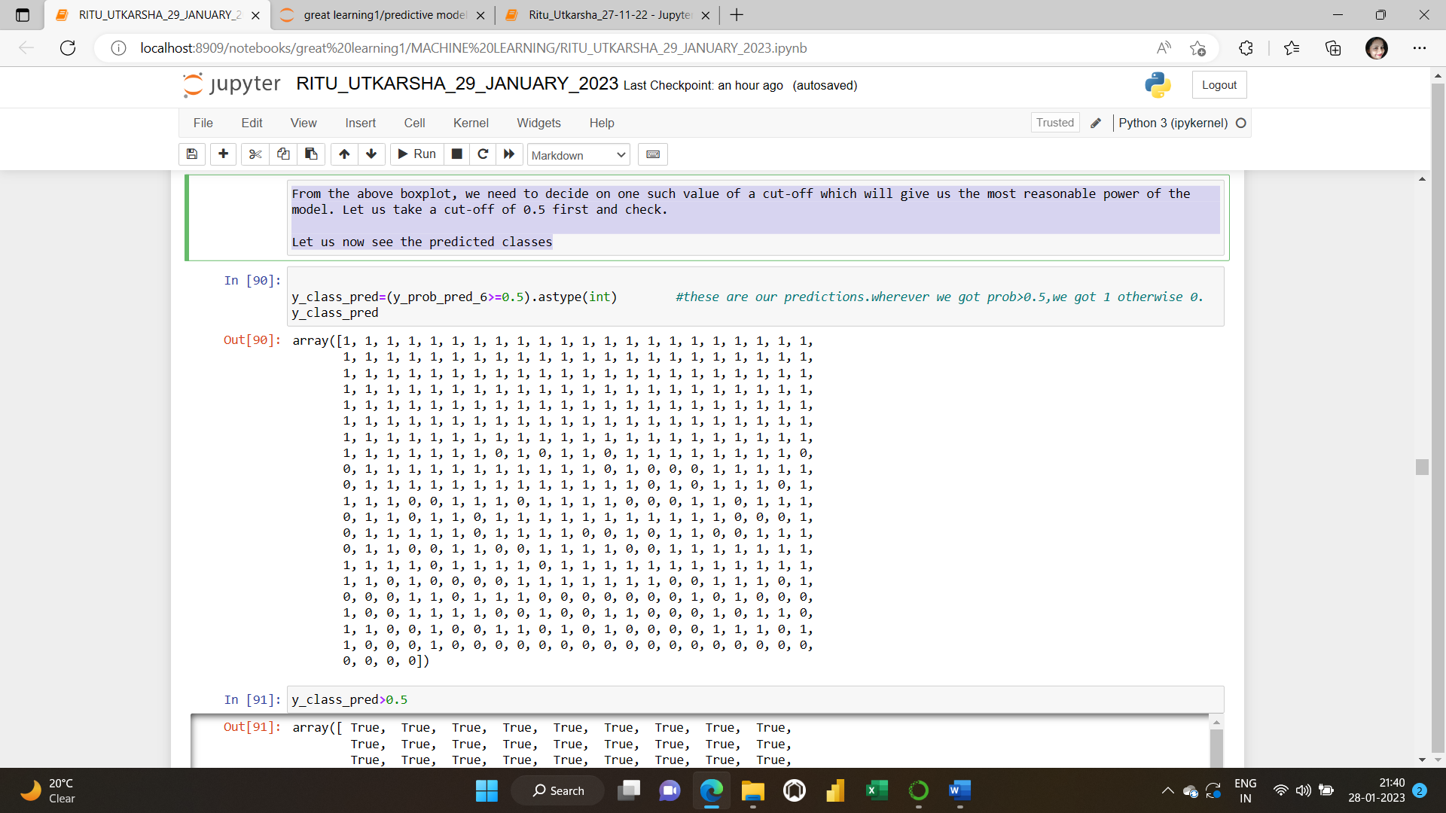

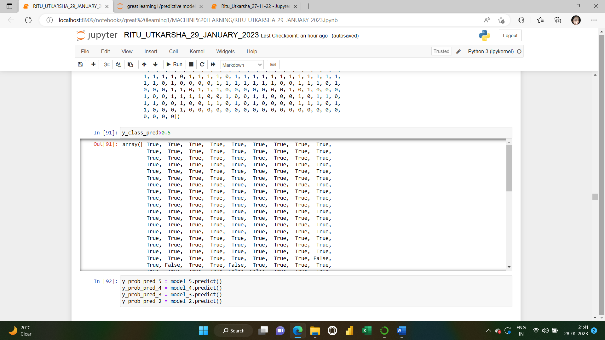

**MODEL EVALUATION ON THE DATA:**

**Let us now check the confusion matrix and the classification report followed by the AUC and the AUC-ROC curve.**

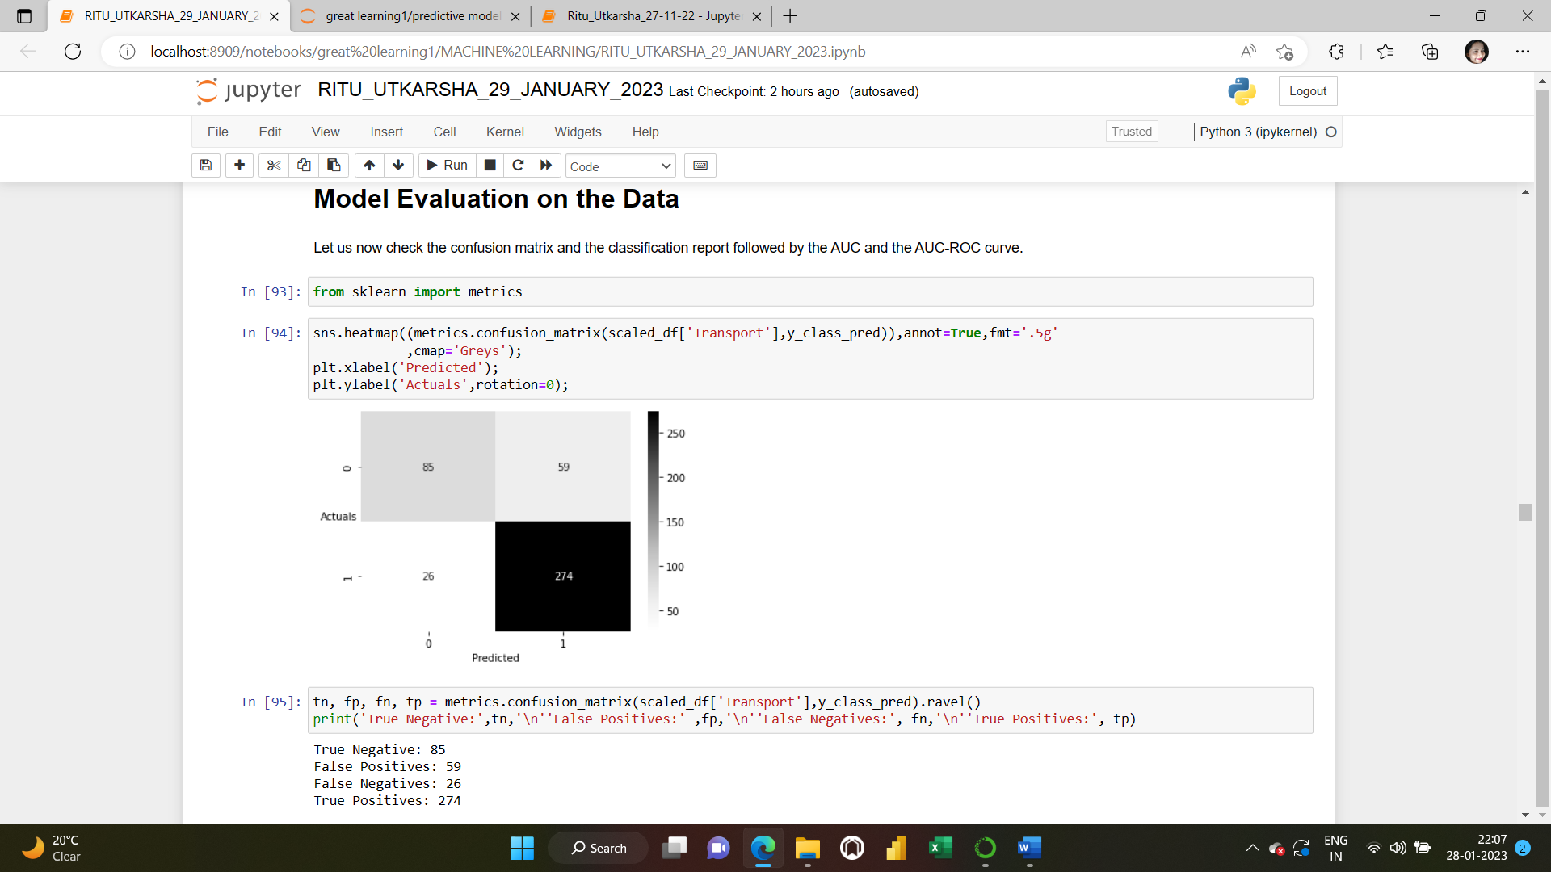

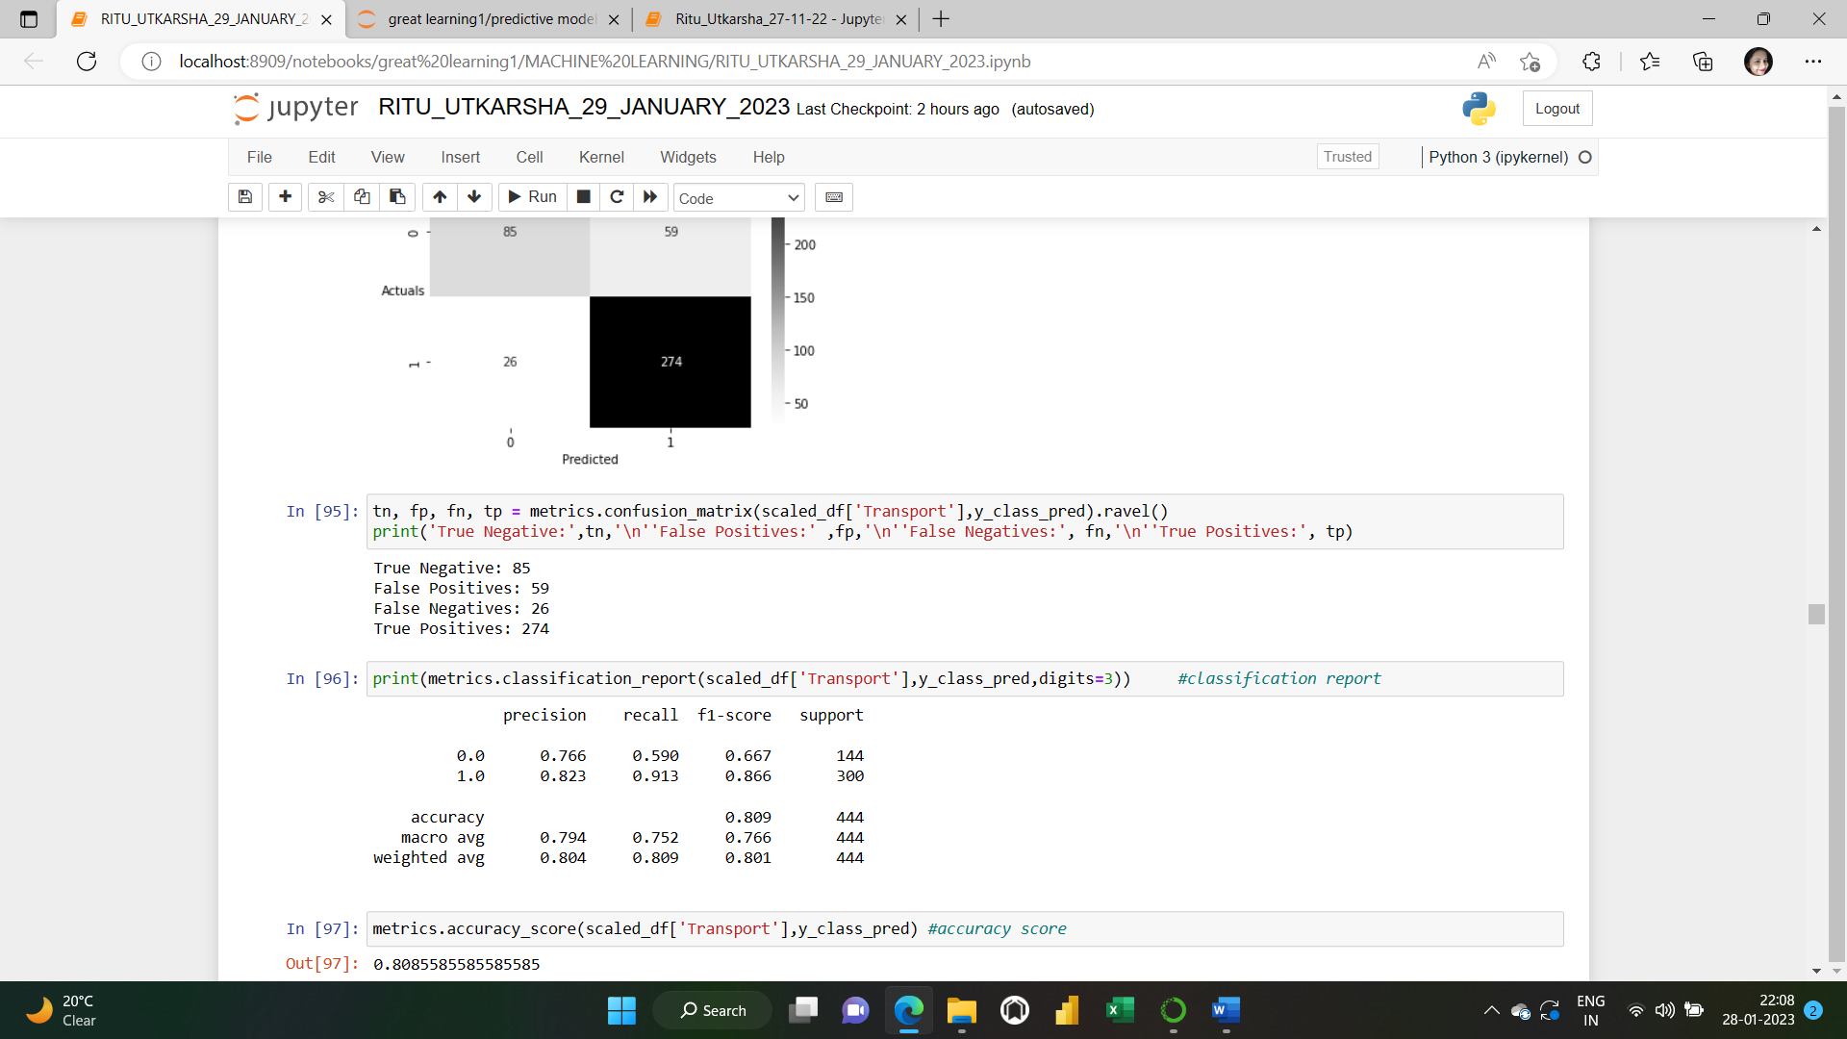

Let us now go ahead and print the classification report to check the various other parameters.

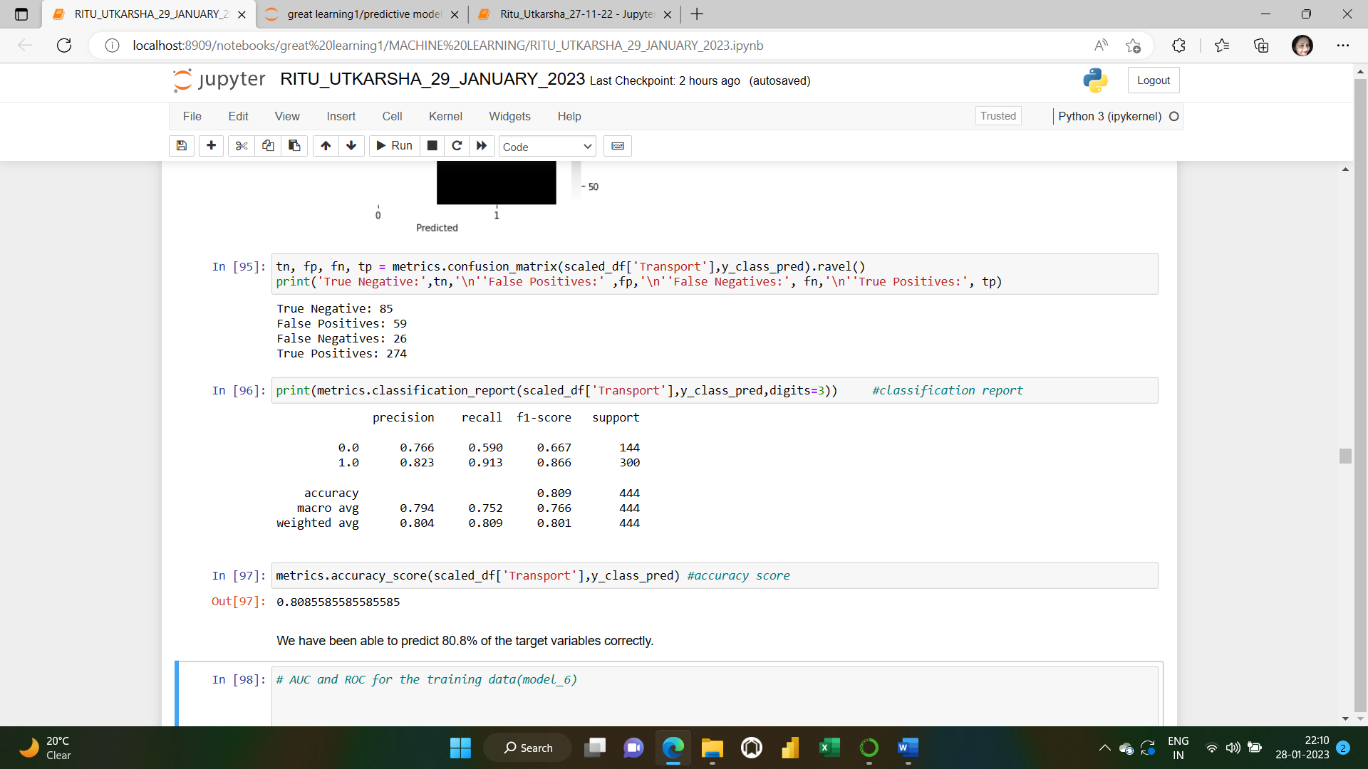

**We have been able to predict 80.8% of the target variables correctly.**

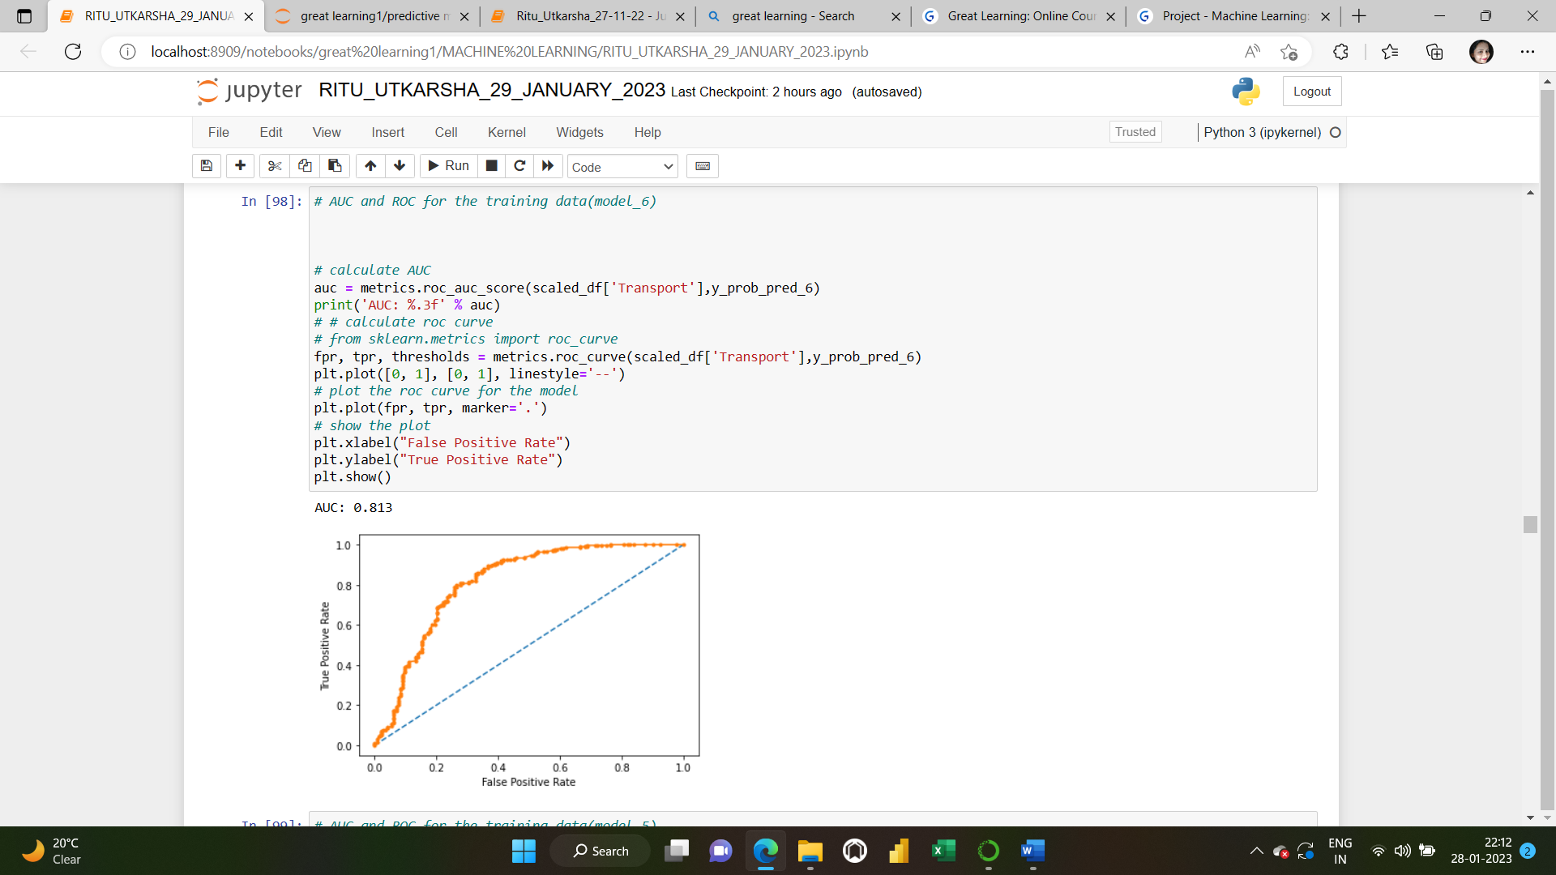Only for Predictive purposes of Logistic Regression

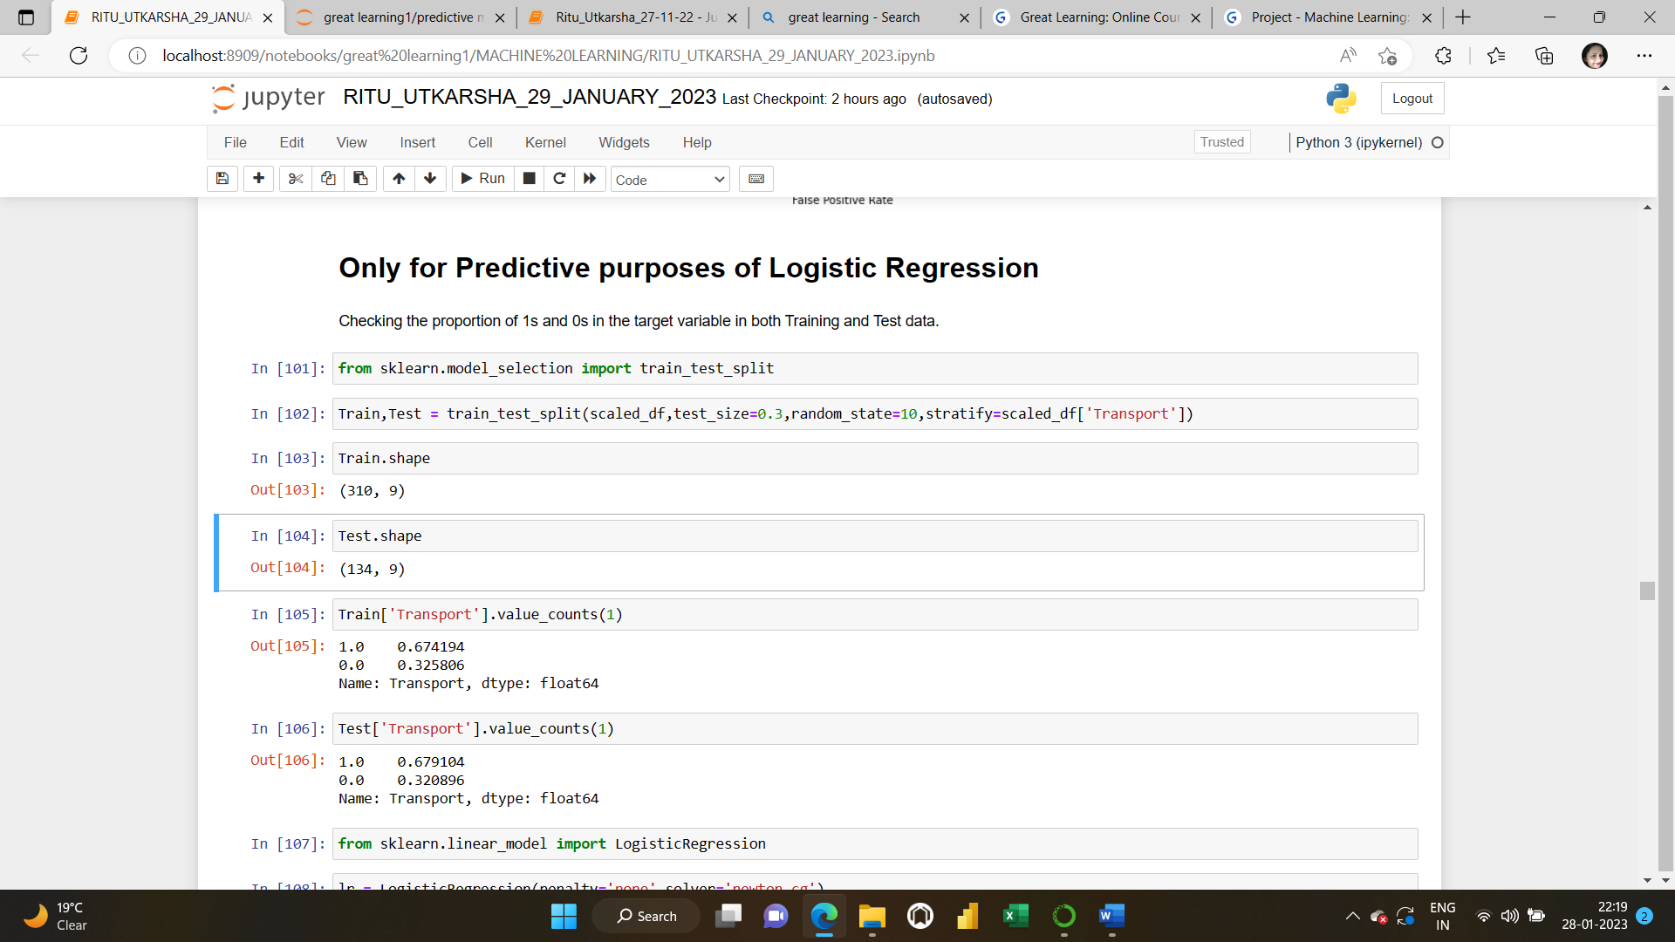

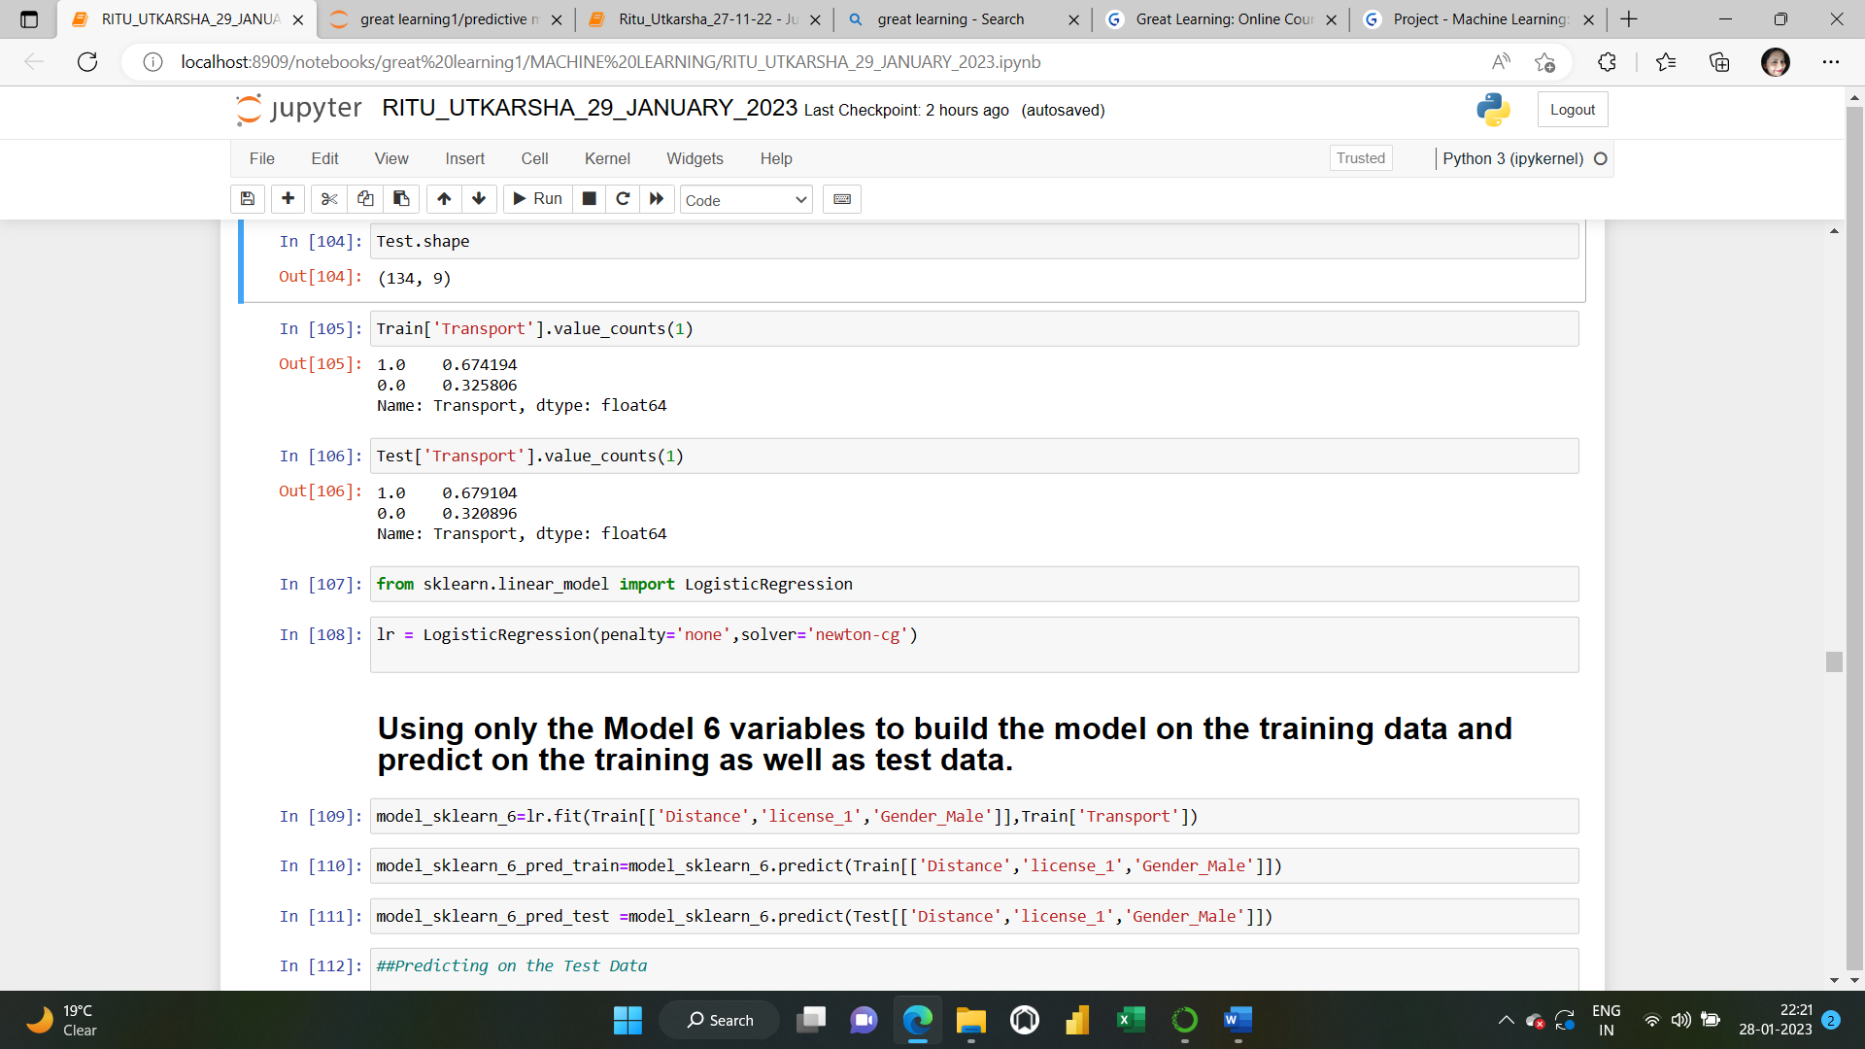

**Using only the Model 6 variables to build the model on the training data and predict on the training as well as test data.**

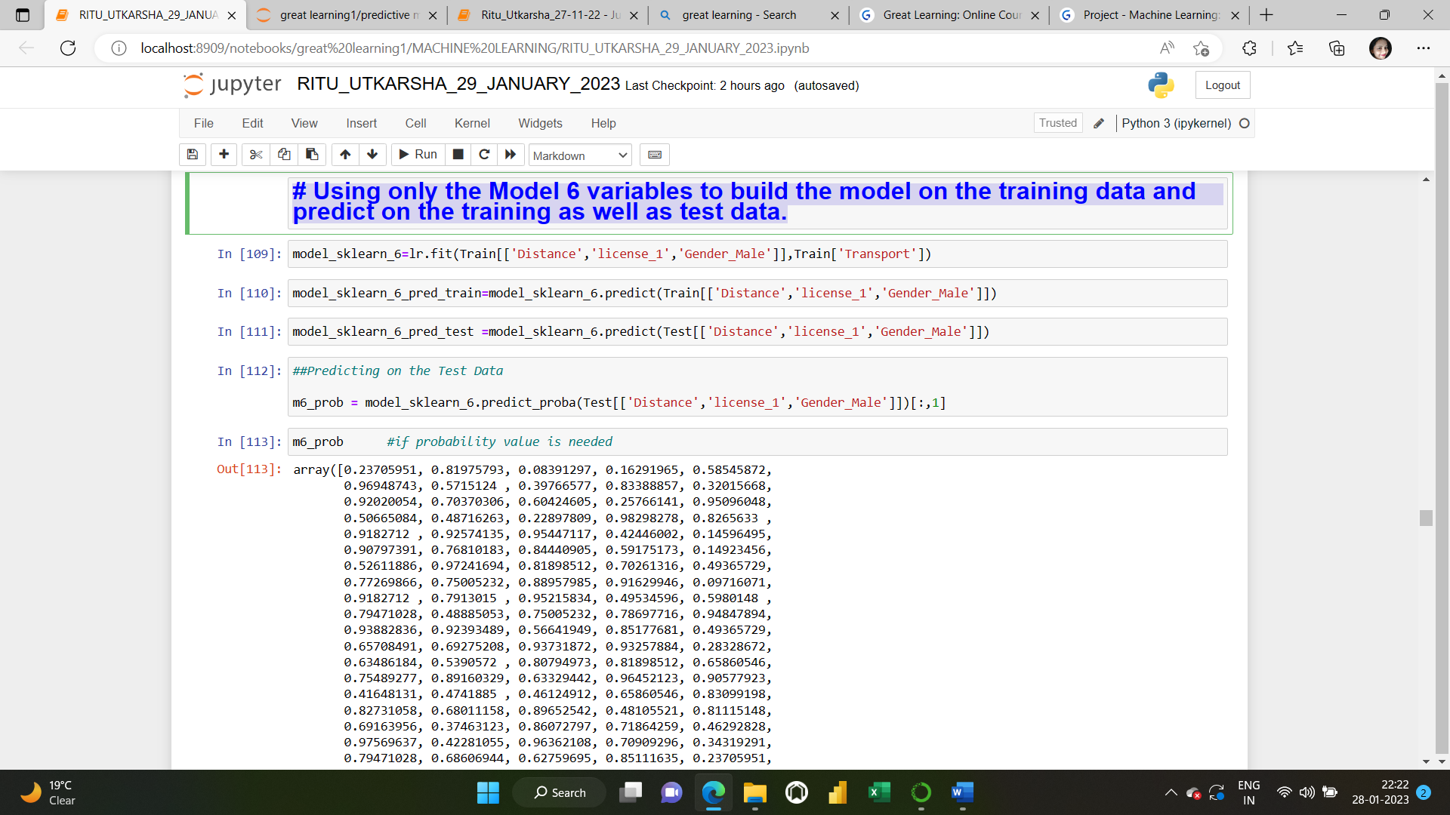

**1.5) Apply KNN Model (4 pts). Interpret the inferences of each model (2 pts)**

**Solution:** K-Nearest Neighbour is one of the simplest Machine Learning algorithms based on Supervised Learning technique that assumes the similarity between the new case/data and available cases and put the new case into the category that is most like the available categories. KNN algorithm stores all the available data and classifies a new data point based on the similarity. This means when new data appears, then it can be easily classified into a well-suited category by using KNN algorithm. KNN algorithm can be used for Regression as well as for Classification but mostly it is used for the Classification problems.

**Step1: Arranging the data into independent and dependent variables.**

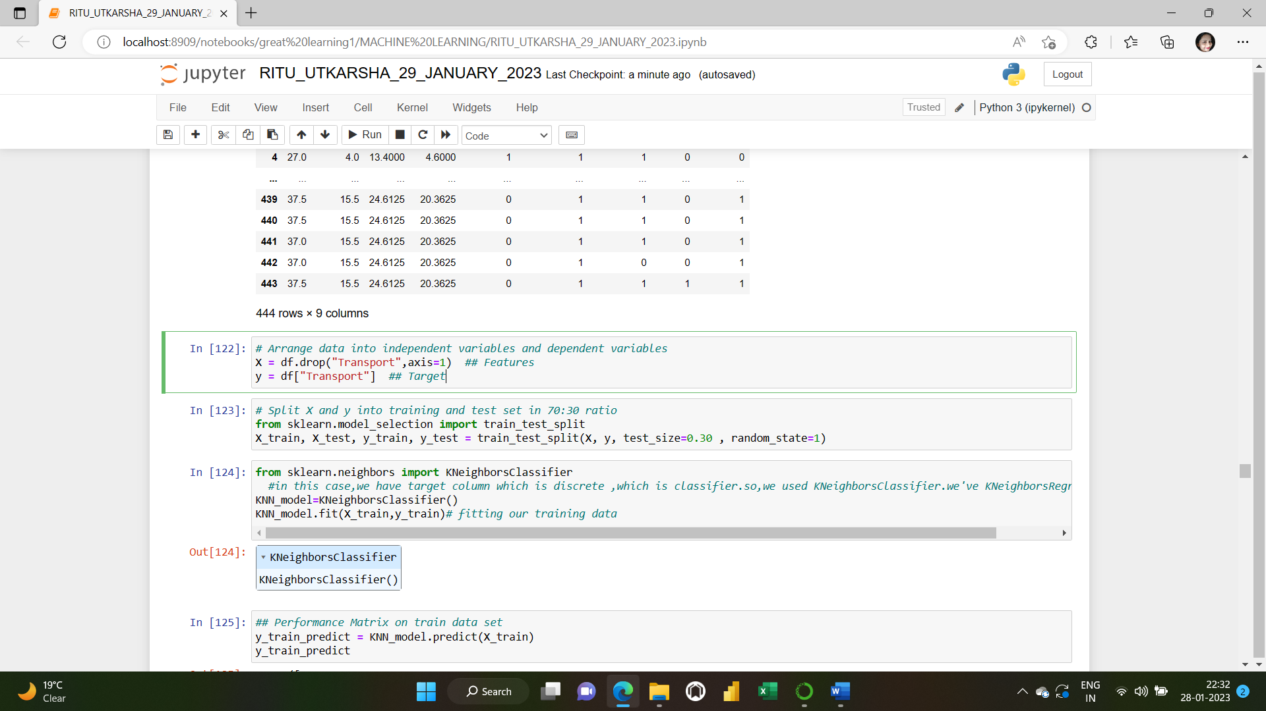

**Step 2: Splitting X and y into training and test set in 70:30 ratio.**

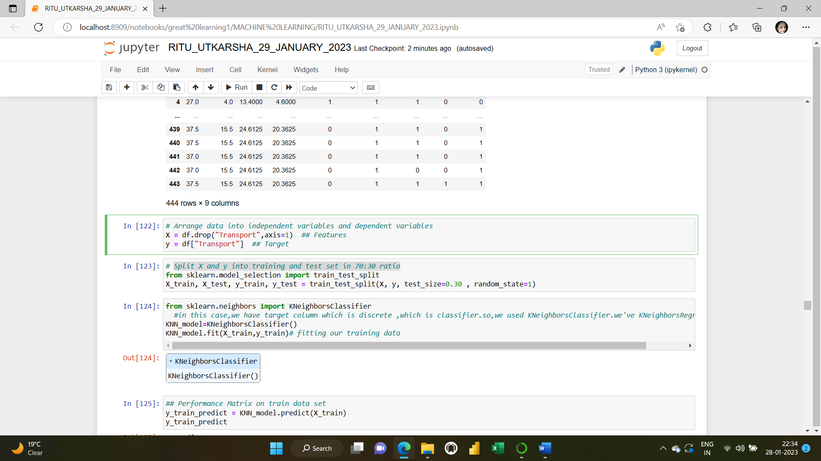

**Step 3: Applying KNN Algorithm:**

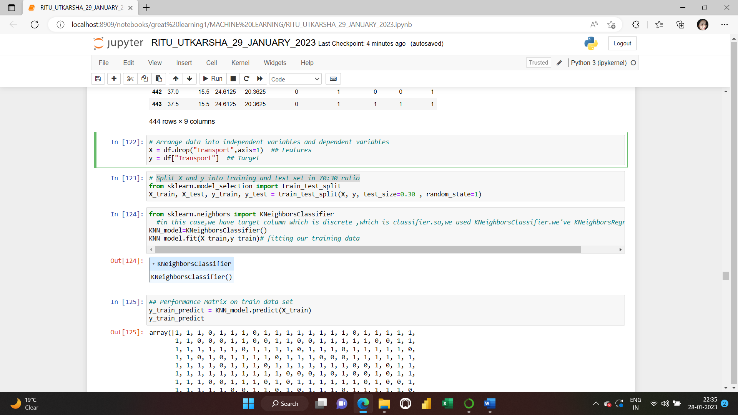

**Step 4: Performance matrix on train and test data set**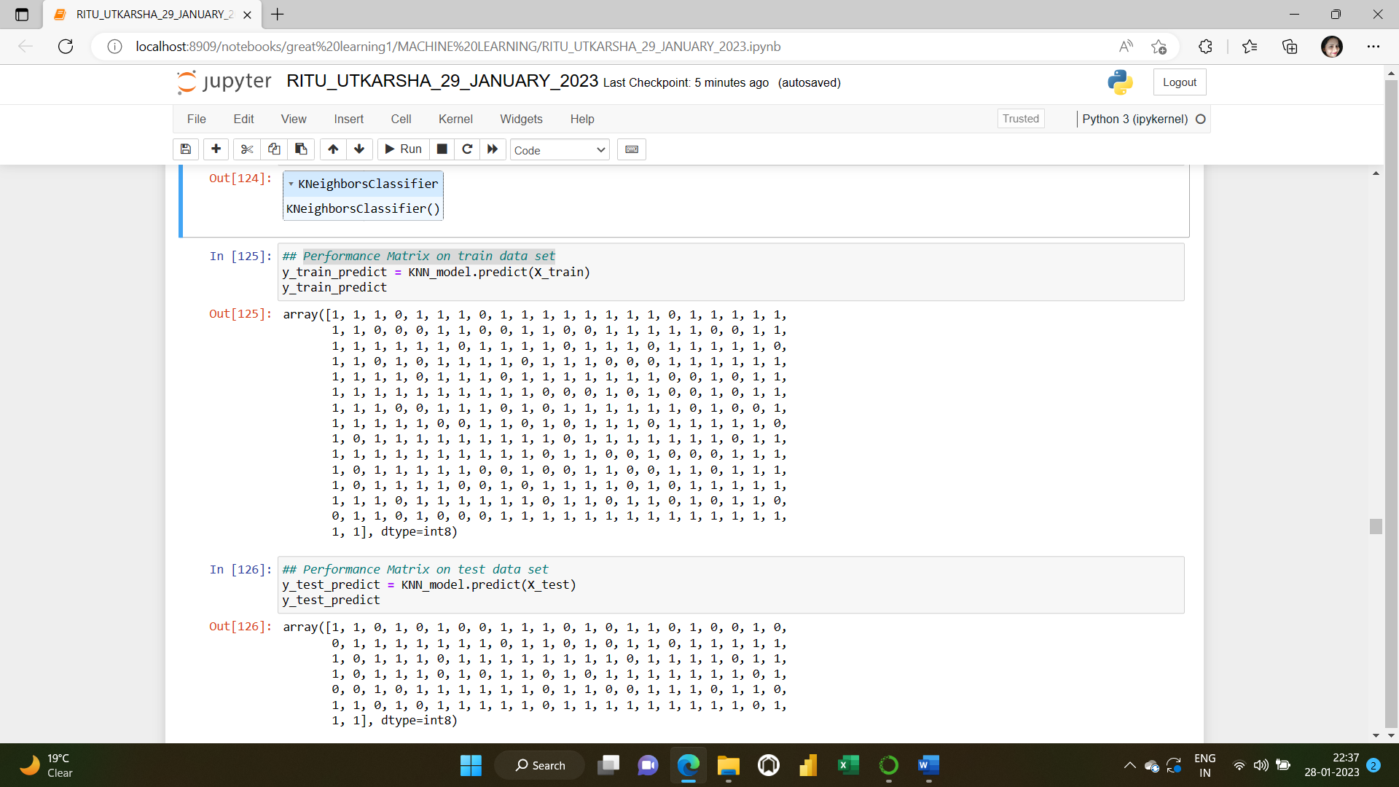

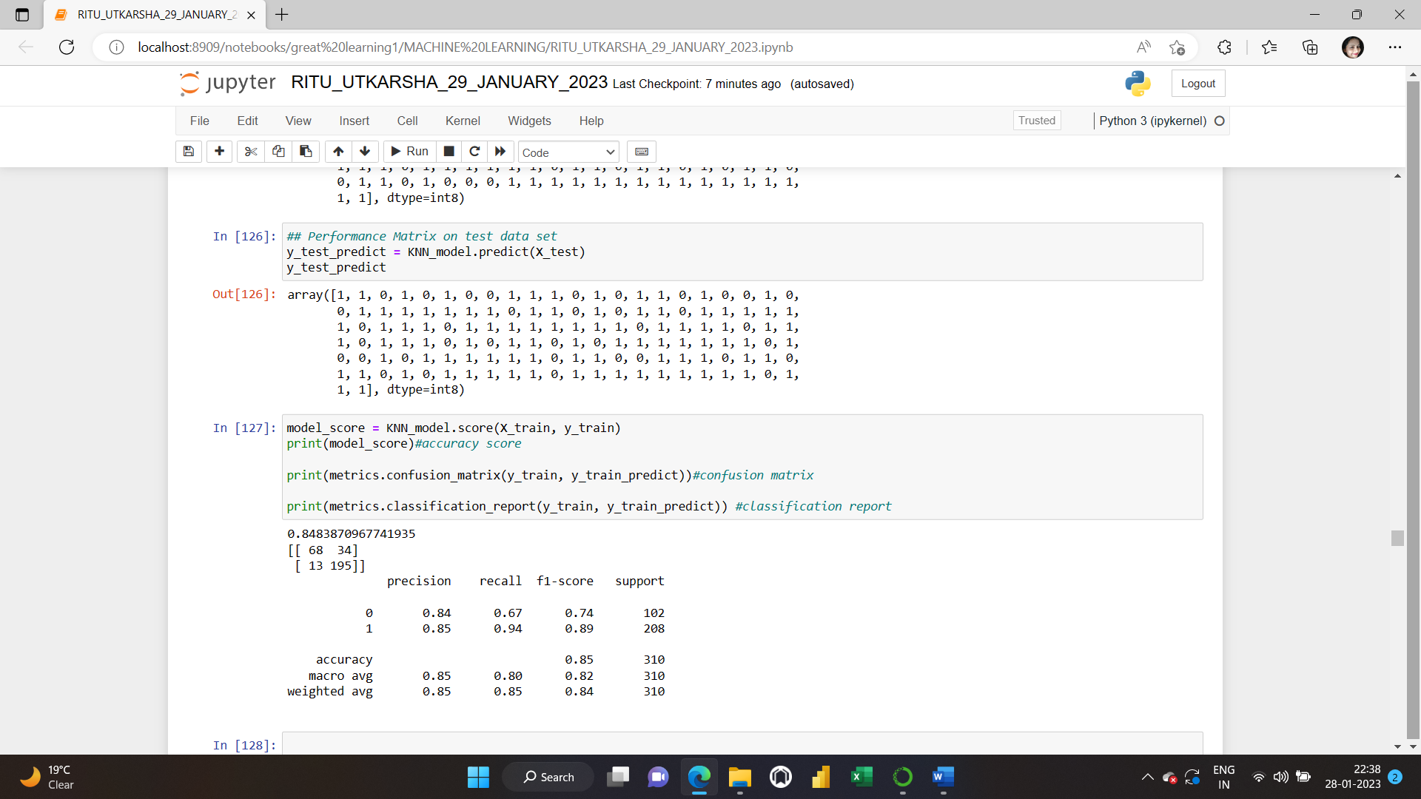

**Step 5: Accuracy score, Confusion Matrix and Classification report for the train and test data sets:**

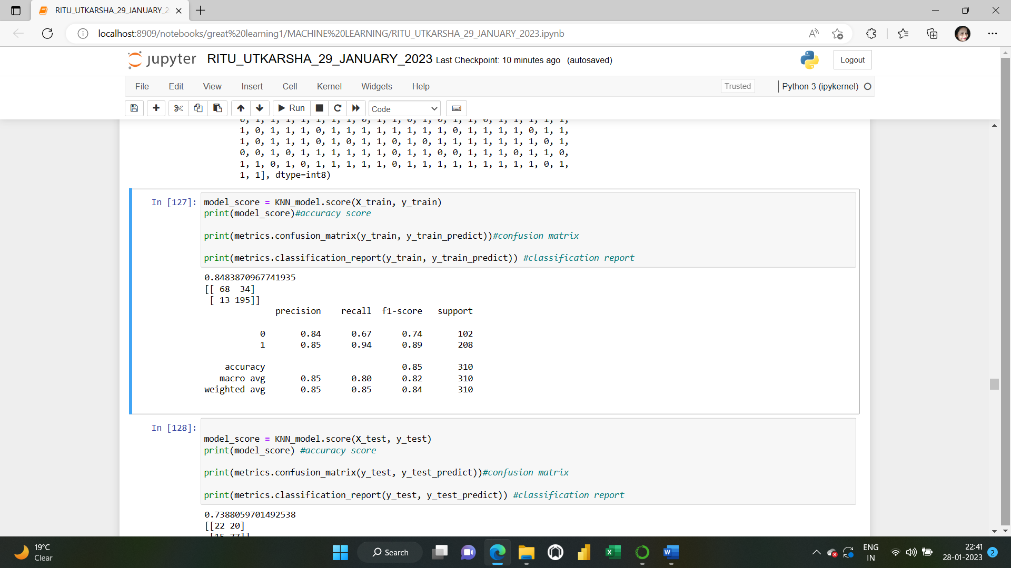

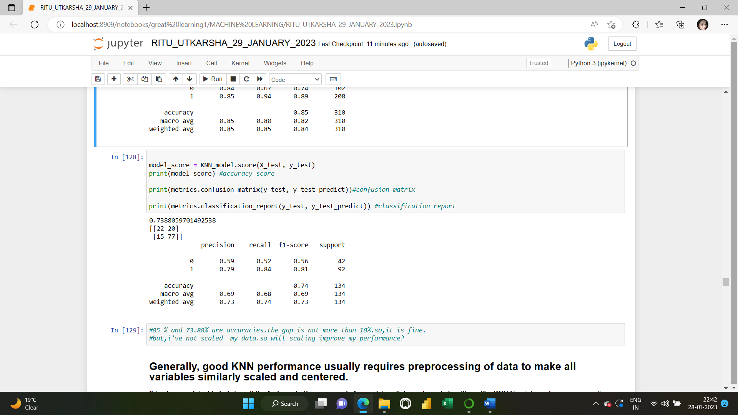

**85 % and 74% are accuracies for train and test data sets respectively. The gap is not more than 10%.so, it is fine.**

**But I’ve not scaled my data.so will scaling improve my performance?**

**Generally, a good KNN performance usually requires pre-processing of data to make all variables similarly scaled and centred.**

**It is always advisable to bring all the features to the same scale for applying distance-based algorithms like KNN.**

**Now let’s apply z-score on continuous columns and see the performance for KNN.**

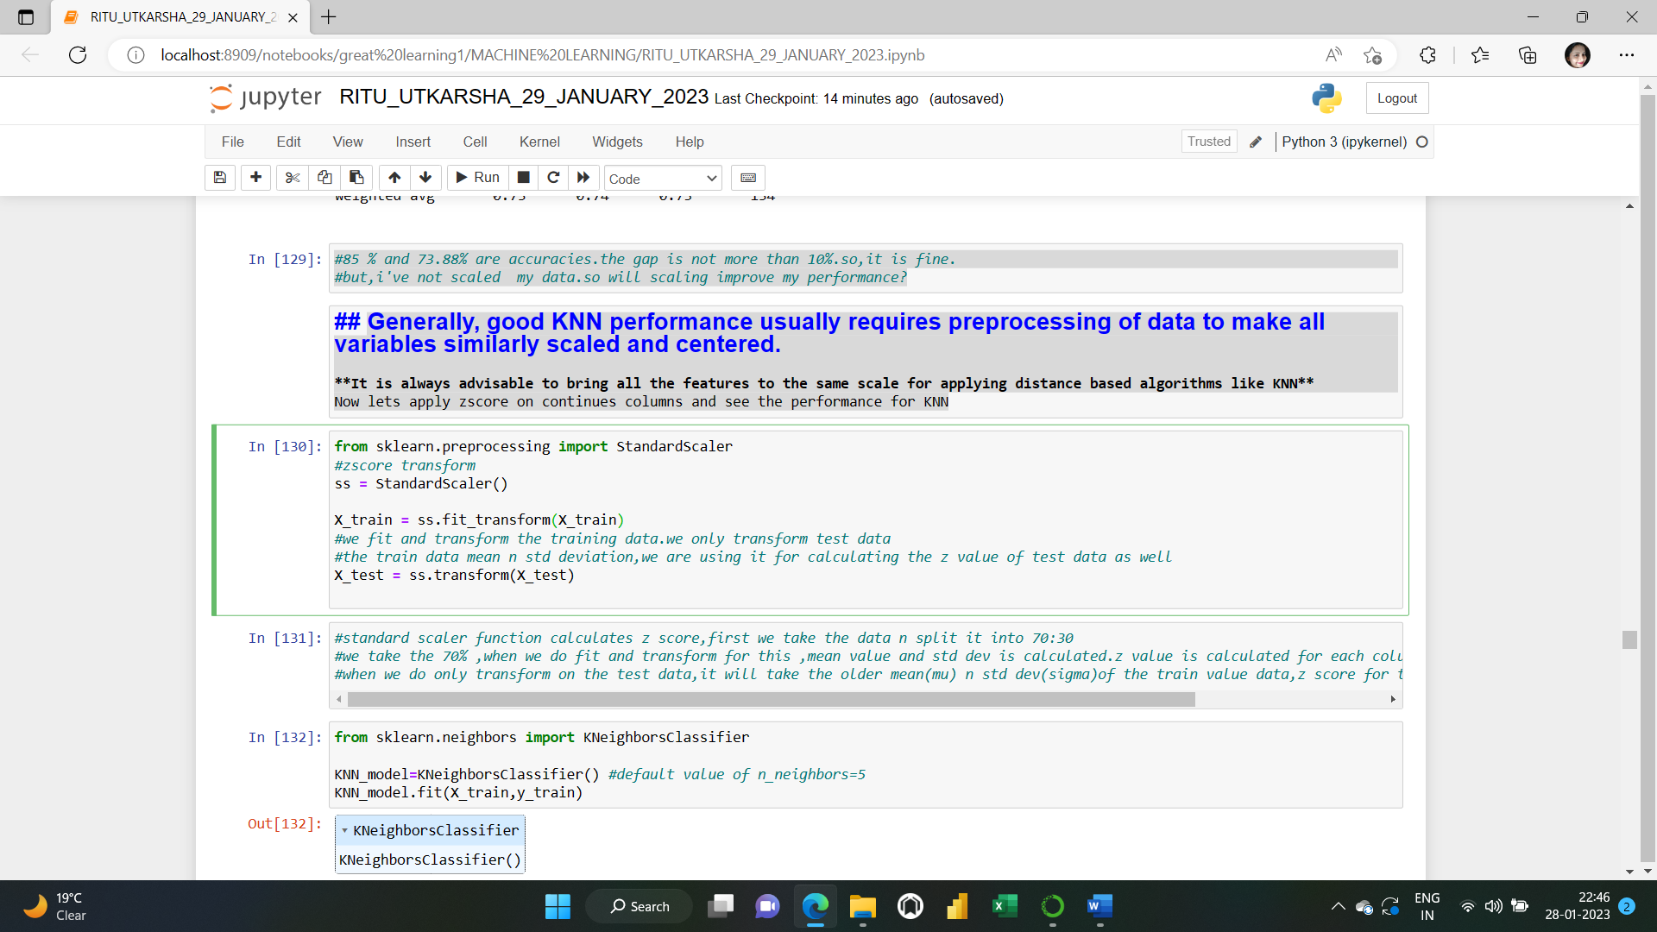

**Applying KNN ALGORITHM again on the scaled data:**

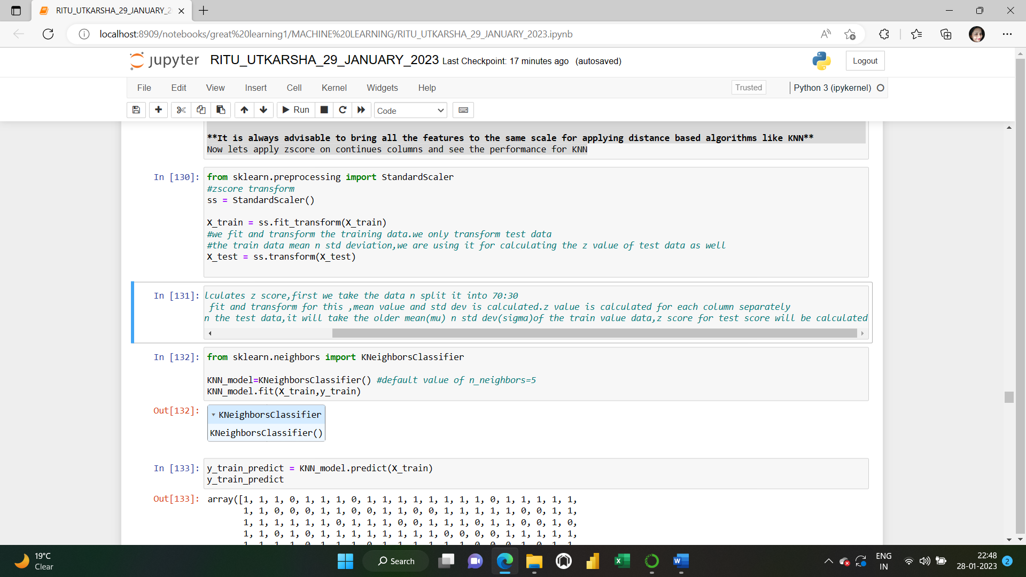

**Performance matrix again on the new scaled data:**

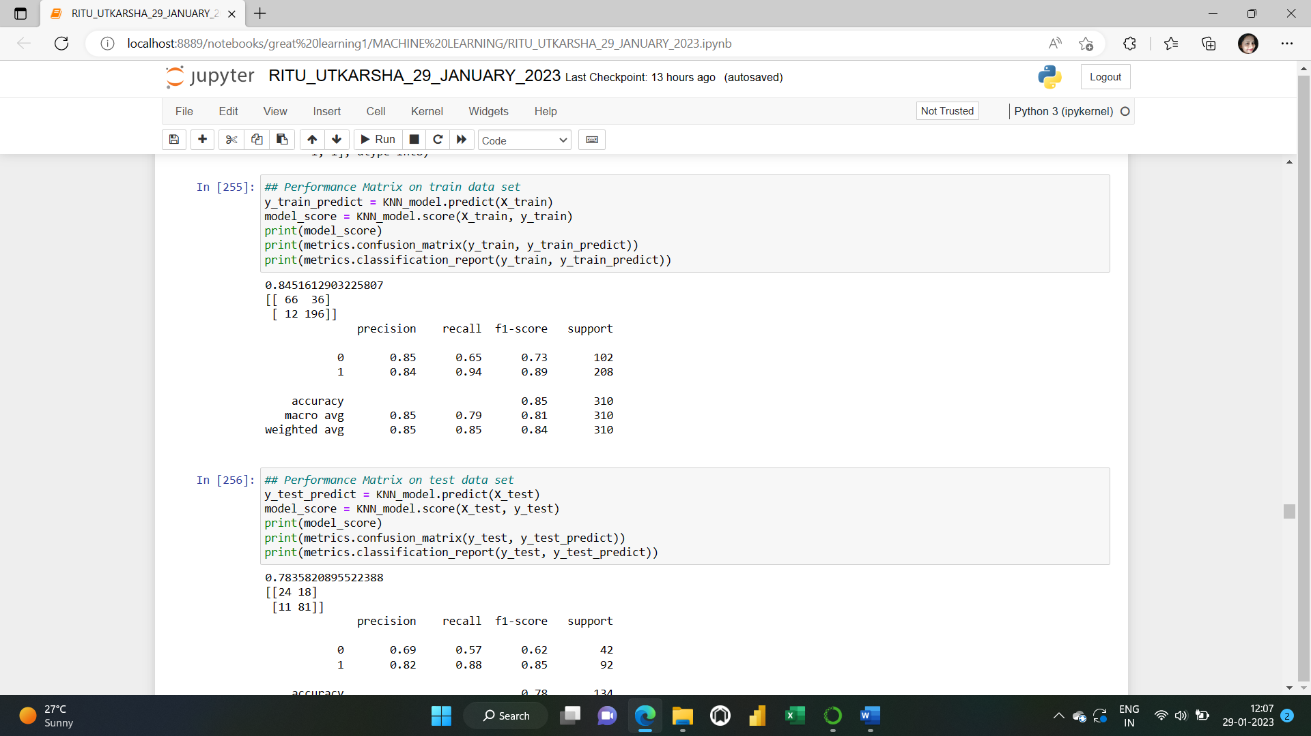

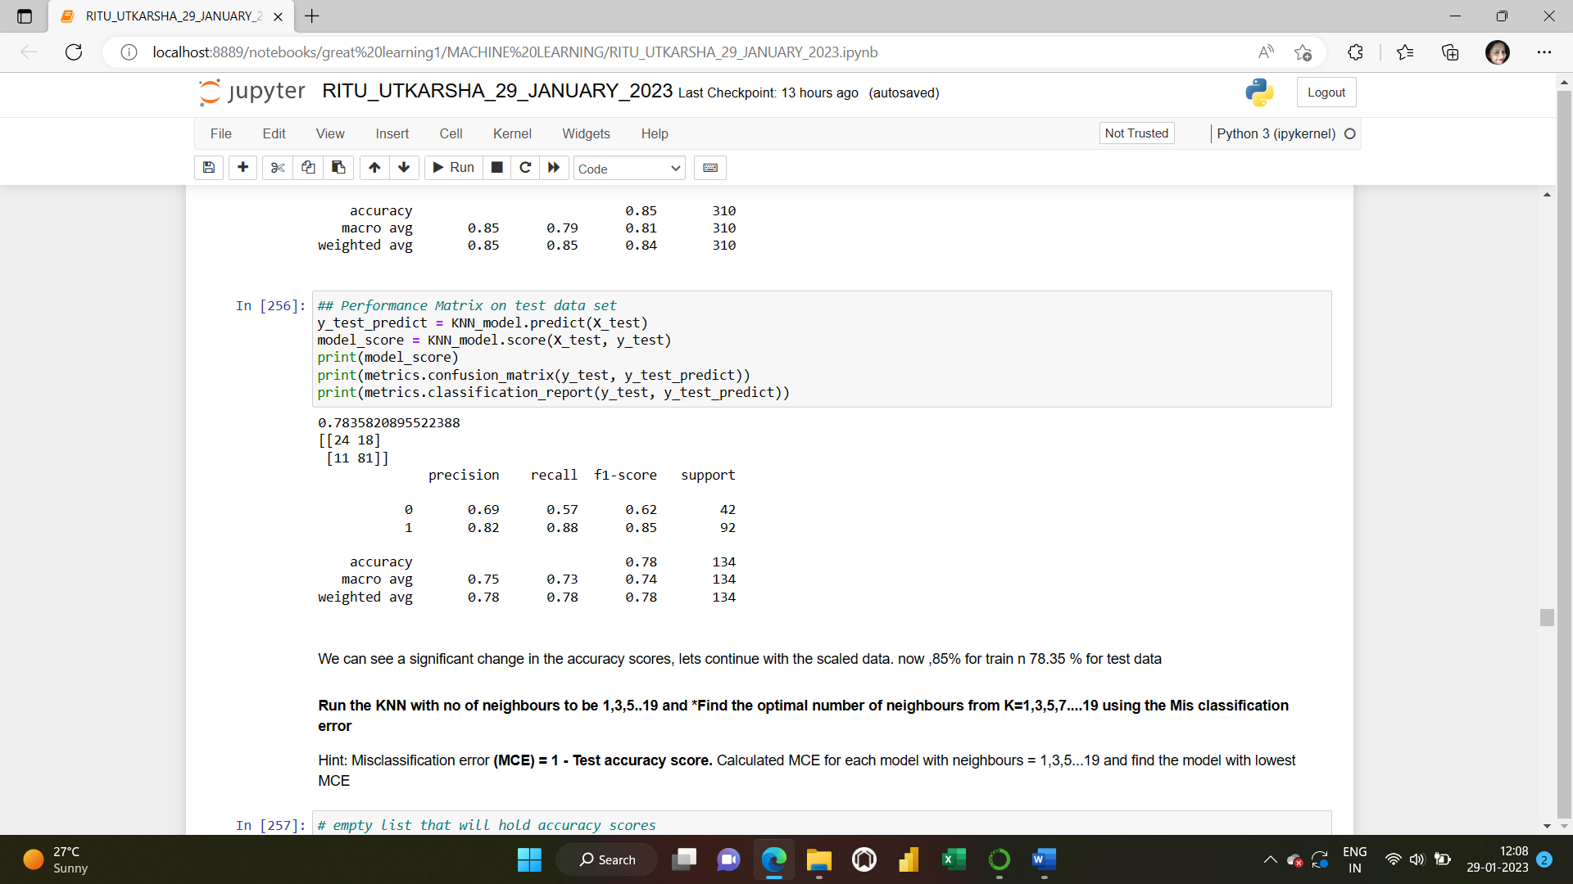

**We can see a significant change in the accuracy scores(85% for train n 78.35 % for test data), lets continue with the scaled data now.**

**Run the KNN with no of neighbours to be 1,3, 5..19 and find the optimal number of neighbours from K=1,3,5,7....19 using the Misclassification error.**

**Misclassification error (MCE) = 1 - Test accuracy score. Calculated MCE for each model with neighbours = 1,3,5...19 and find the model with lowest MCE.**

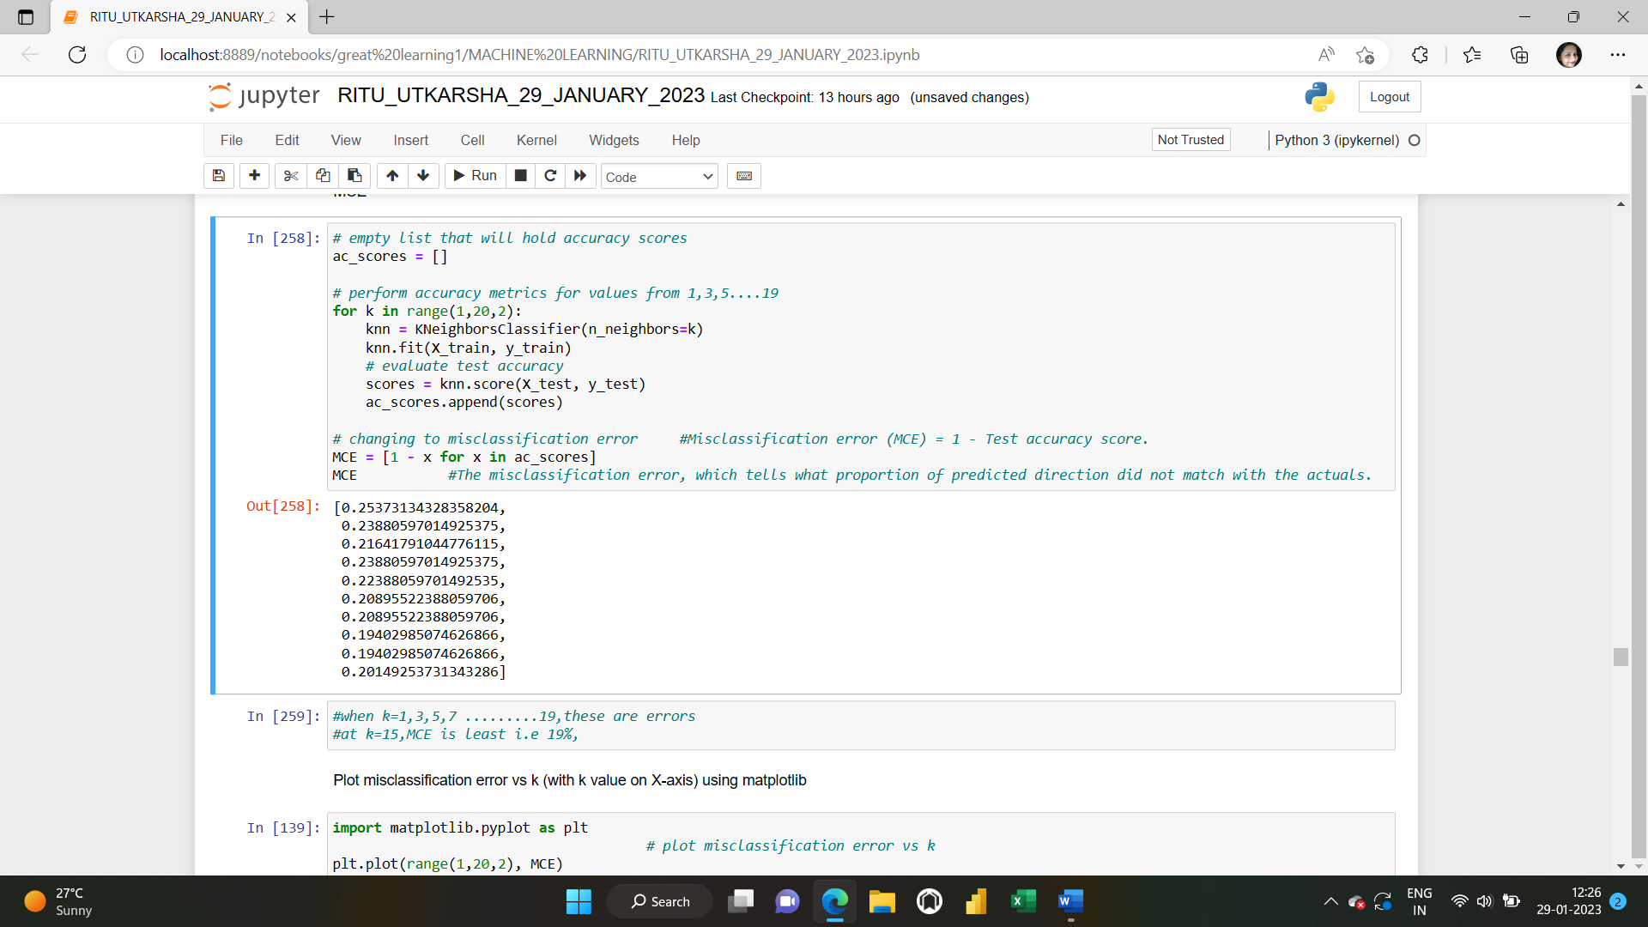

**when k=1,3,5,7 .........19, these are errors.at k=15, MCE is least i.e., 19%,**

**Plot misclassification error vs k (with k value on X-axis):**

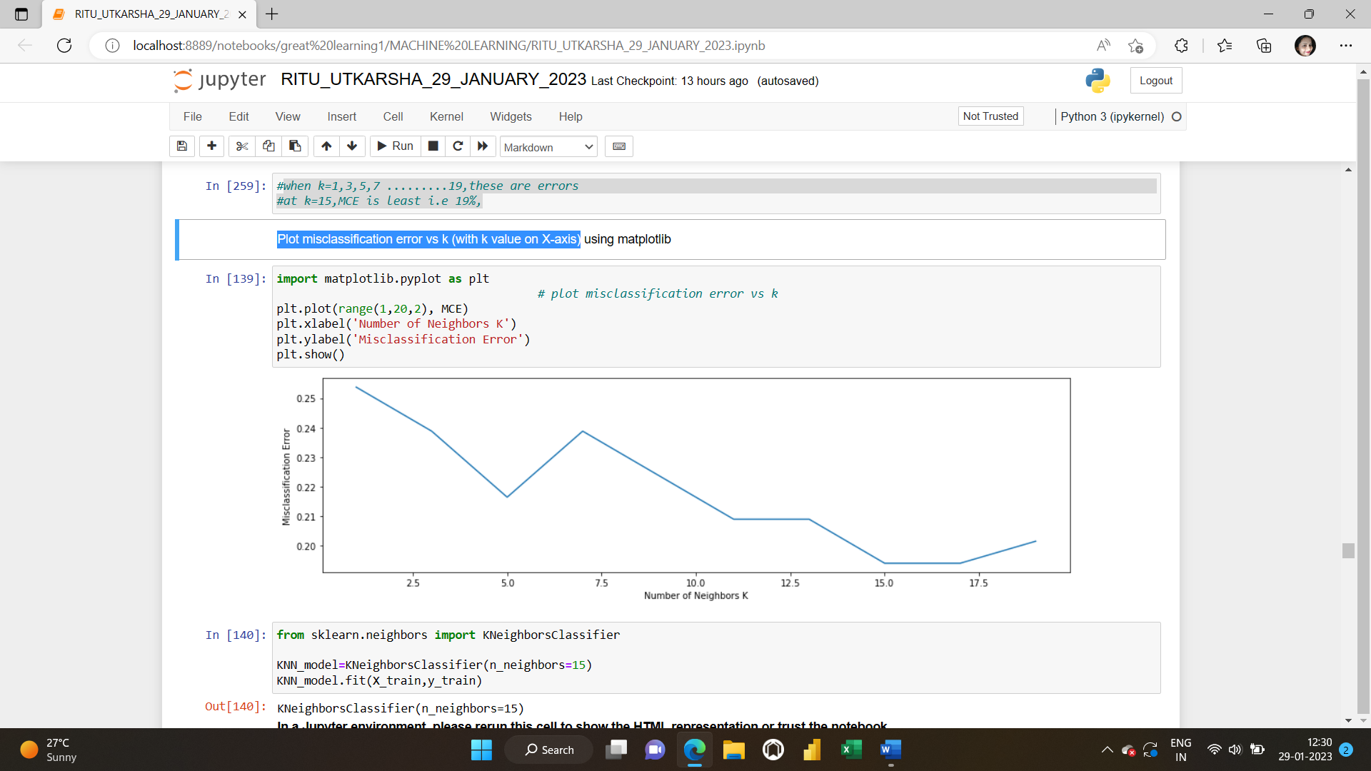

**MAKING NEW KNN MODEL APPLYING k=15:**

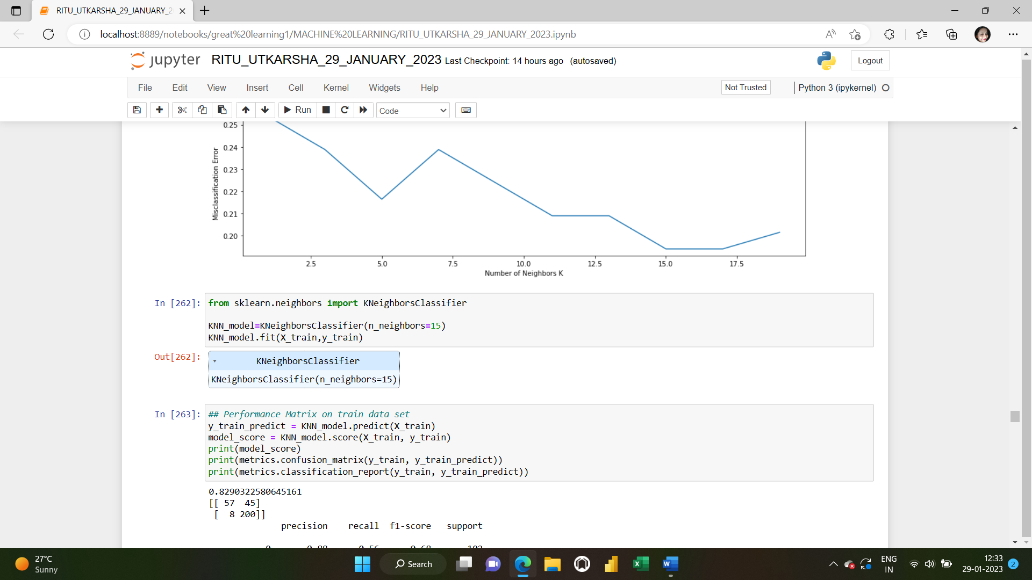

**PERFORMANCE MATRICES ON THE NEW KNN MODEL TAKING K=15**

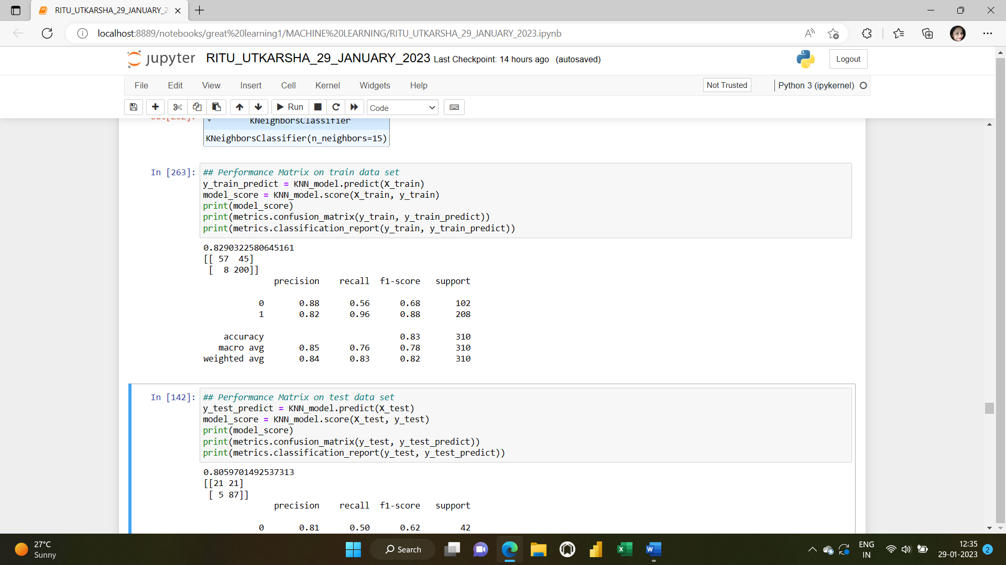

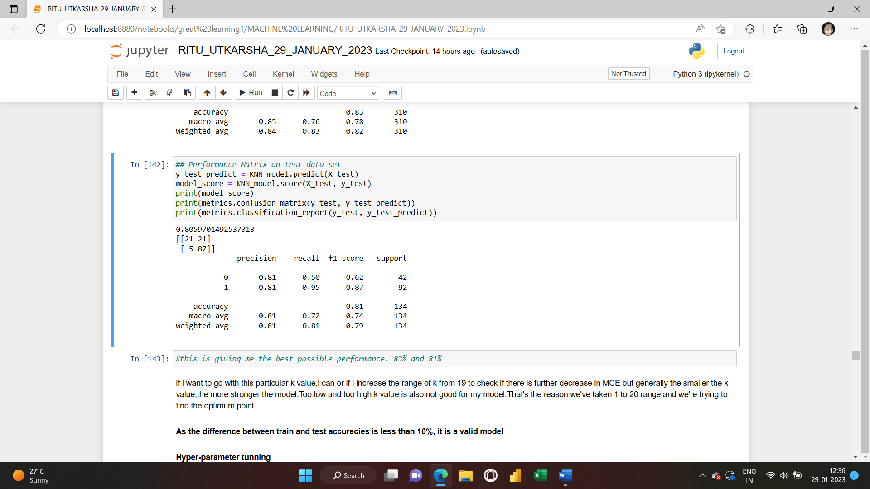

This is giving me the best possible performance. 83% and 81% for the train and test data sets respectively. if I want to go with this k value, I can or if I increase the range of k from 19 to check if there is further decrease in MCE but generally the smaller the k value, the stronger the model. Too low and too high k value is also not good for my model. That’s the reason we've taken 1 to 20 range and we're trying to find the optimum point**.**

As the difference between train and test accuracies is less than 10%, it is a valid model.

**Hyperparameter Tuning:**

**Hyperparameter Tuning K** is a hyperparameter of the KNN algorithm (a hyperparameter is a property of the model provided by the user). You can apply tuning methods such as a grid search to find the optimal value. Let’s check the model performance after tuning my model.

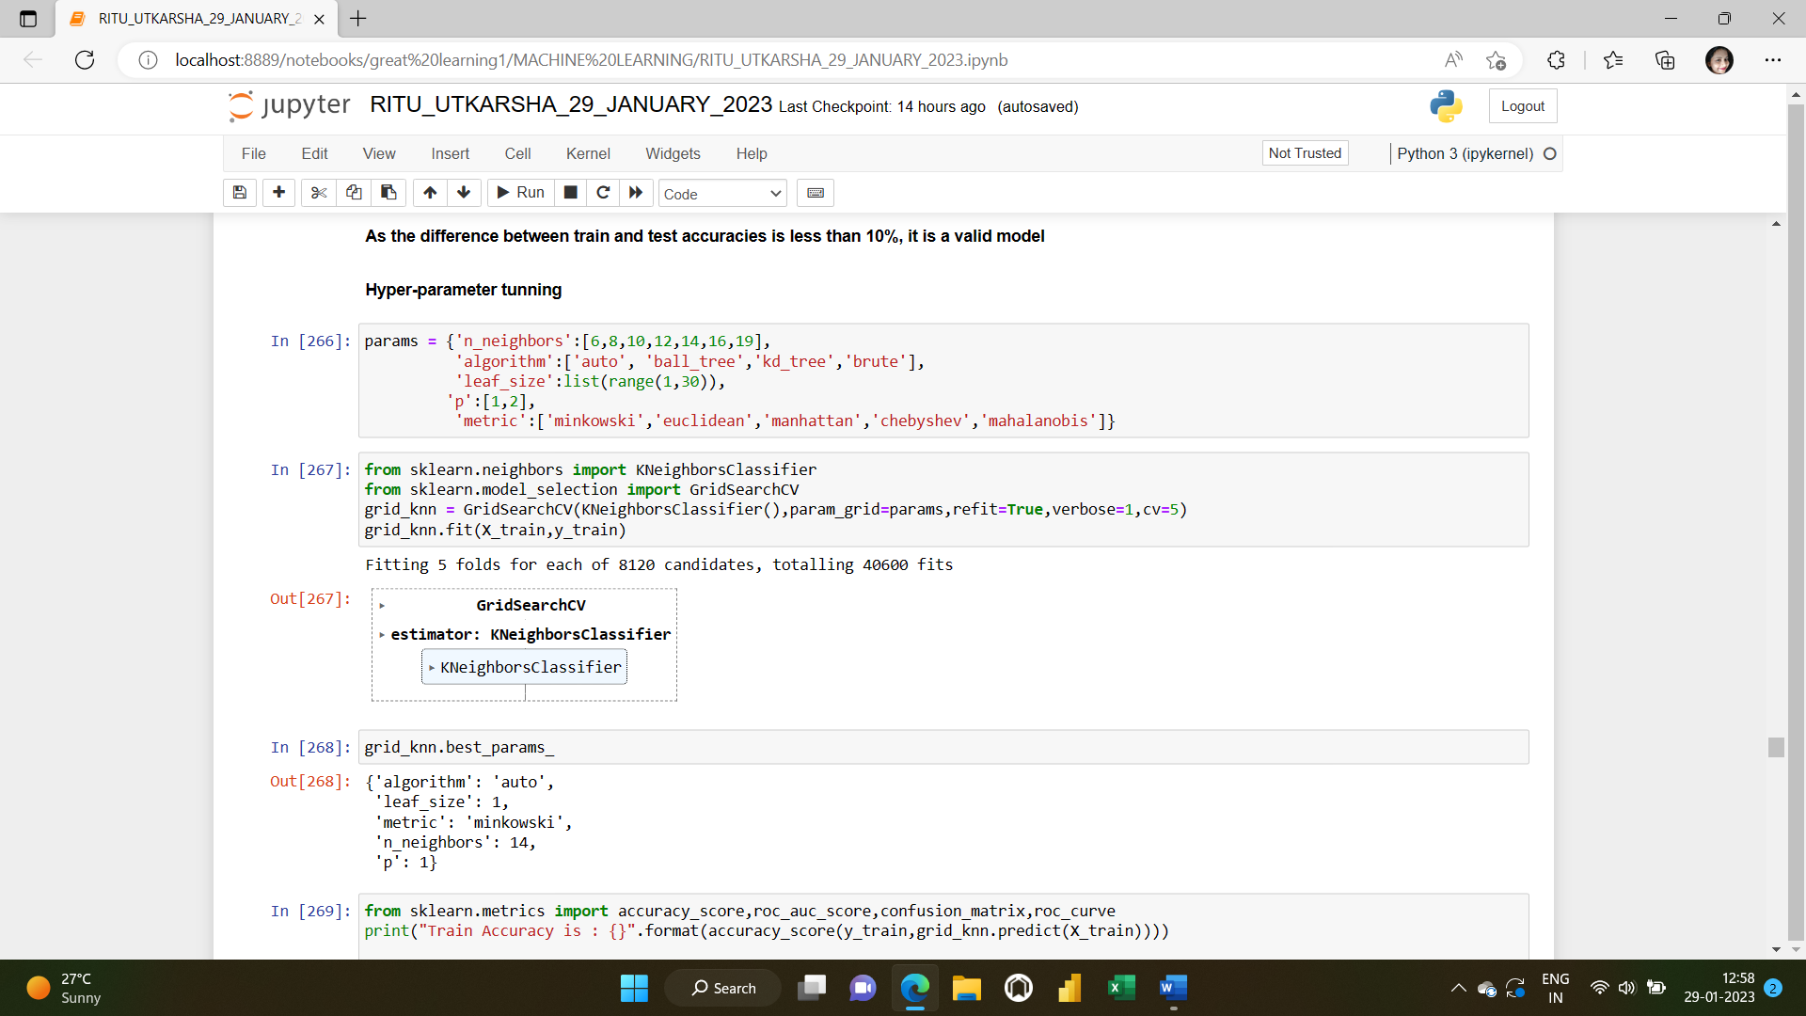

**MAKING NEW MODEL AFTER HYPERPARAMETER TUNING:**

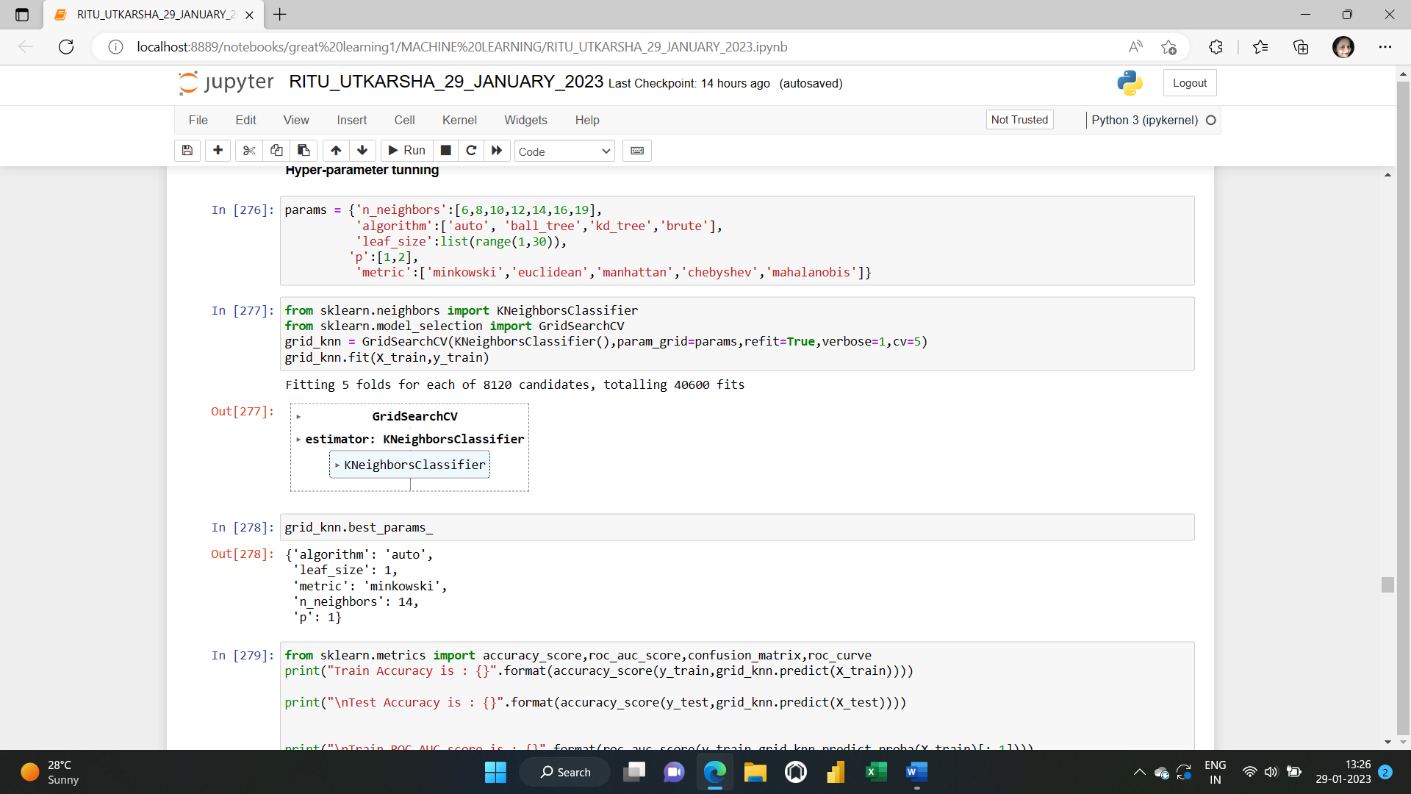

**THE BEST OPTION OF PARAMETERS SELECTED BY GridSearchCV HyperParameter Tuning:**

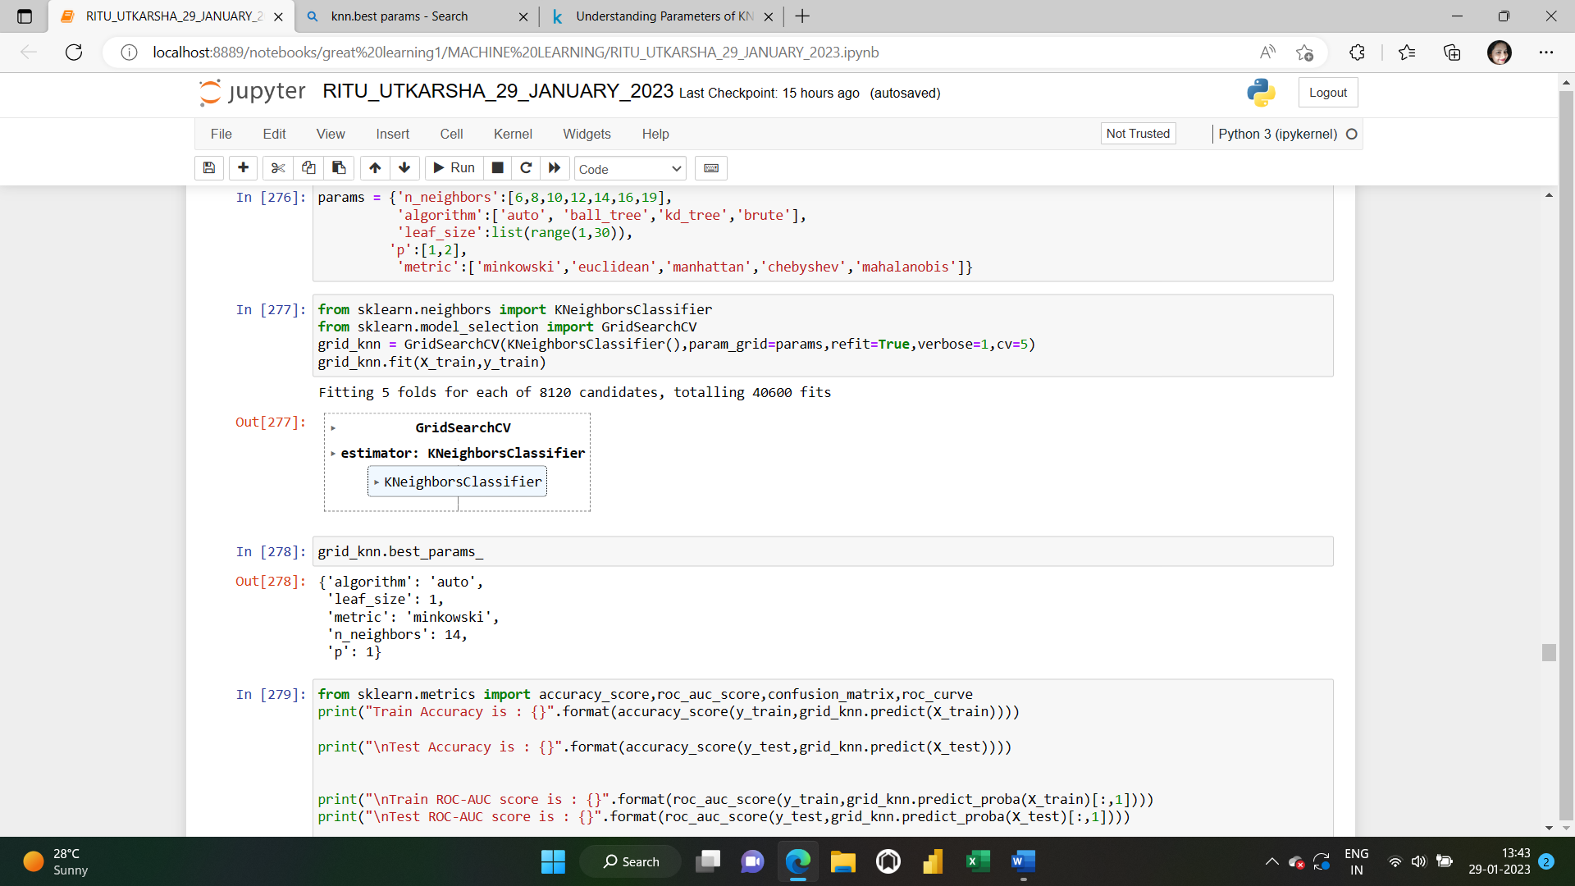

# Parameters Description and Observation of Effects

In this part, each parameter is analysed separately. Each parameter is tried by using different values and effects of these changes are examined**.**

**n_neighbours** parameter is one of the most important parameters for KNN Algorithm. KNN means K - Nearest Neighbours and n_neighbors parameter is this K value. It means that if n_neighbors is selected 3, algorithm finds 3 nearest points and classify the new point according to majority of these 3 points.

P parameter: Different distance metrics are available which use for the tree (like KDtree or Ball Tree). One of them is Minkowski metric. This p parameter is power parameter for Minkowski metric.

* If p = 1, this is equivalent to using **Manhattan distance(l_1)**
* If p = 2, this is equivalent to using **Euclidean distance(l_2)**
* If p > 2, It is **Minkowski distance(l_p)**.
* EuclideanDistance => sqrt(sum((x - y)^2))
* ManhattanDistance => sum(|x - y|)
* MinkowskiDistance => sum(|x - y|^p)^(1/p)

# Algorithm:

Algorithm parameter sets the algorithm which uses to compute nearest neighbors. There are 3 algorithms but 4 option for this parameter. Algorithms which can be used, are listed below .BallTree ,KDTree, Brute Force.Fourth option is auto. Auto option attempt to decide best algorithm for best result.

**ACCURACY SCORE,AOC SCORE AND CONFUSION MATRIX OF TRAIN AND TEST DATA SETS AFTER HYPERPARAMETER TUNING:**

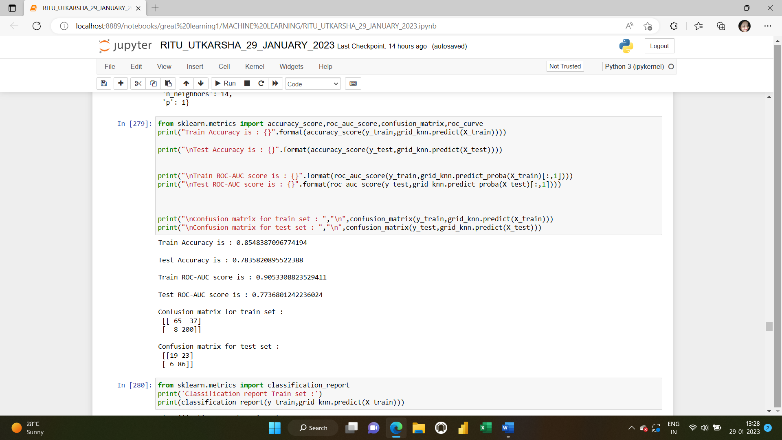

**CLASSIFICATION REPORT OF TRAIN AND TEST DATA SETS AFTER HYPERPARAMETER TUNING:**

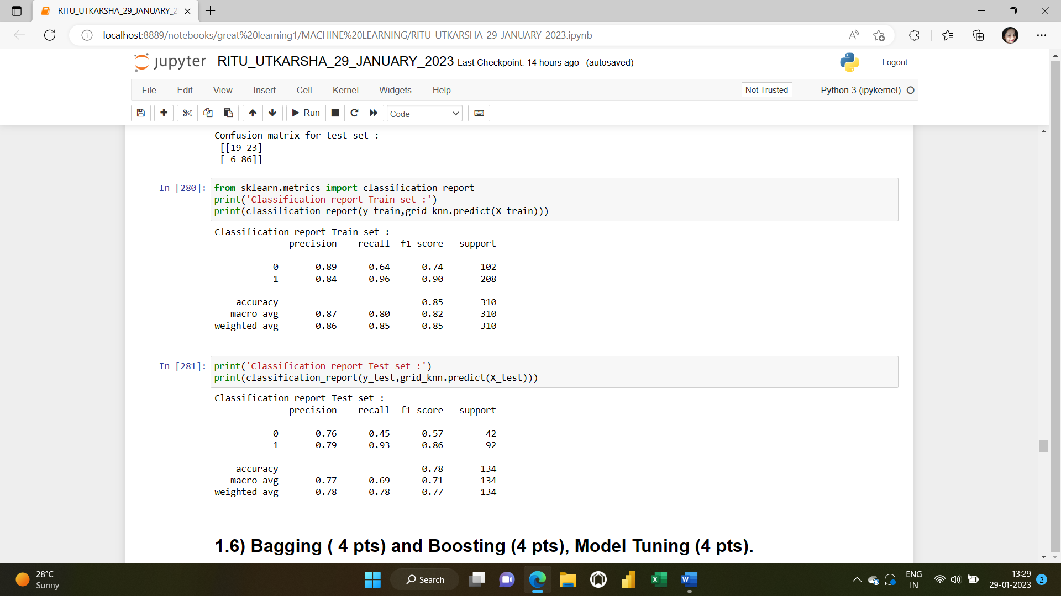

**1.6) Bagging ( 4 pts) and Boosting (4 pts), Model Tuning (4 pts).**

**Solution: Adaptive Boosting (or AdaBoost),** a supervised ensemble learning algorithm. Adaptive Boosting helps to reduce the error of any classification learning algorithm (like Decision Trees or Support Vector Machines) by sequentially turning many weak classifiers into one strong classifier. This can be accomplished with sequential weight adjustments, individual voting powers and a weighted sum of the final algorithm classifiers.

**Separating the independent and dependent variables:**

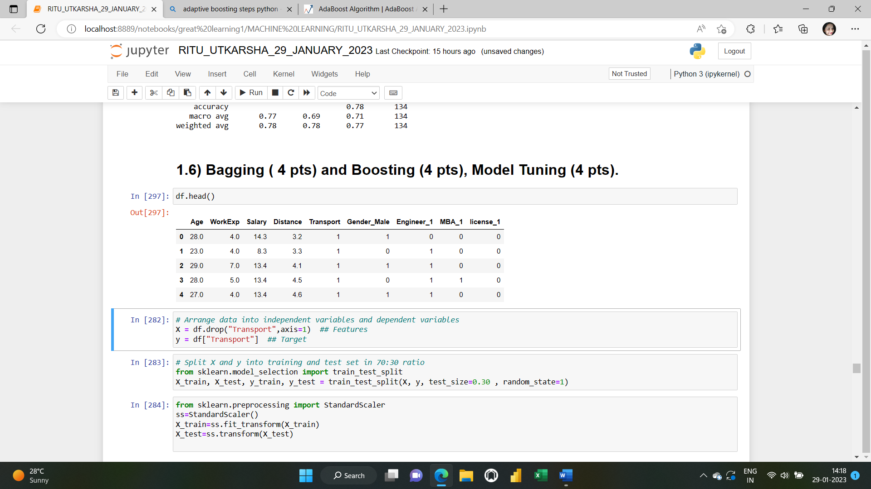

**Creating the train and the test datasets:**

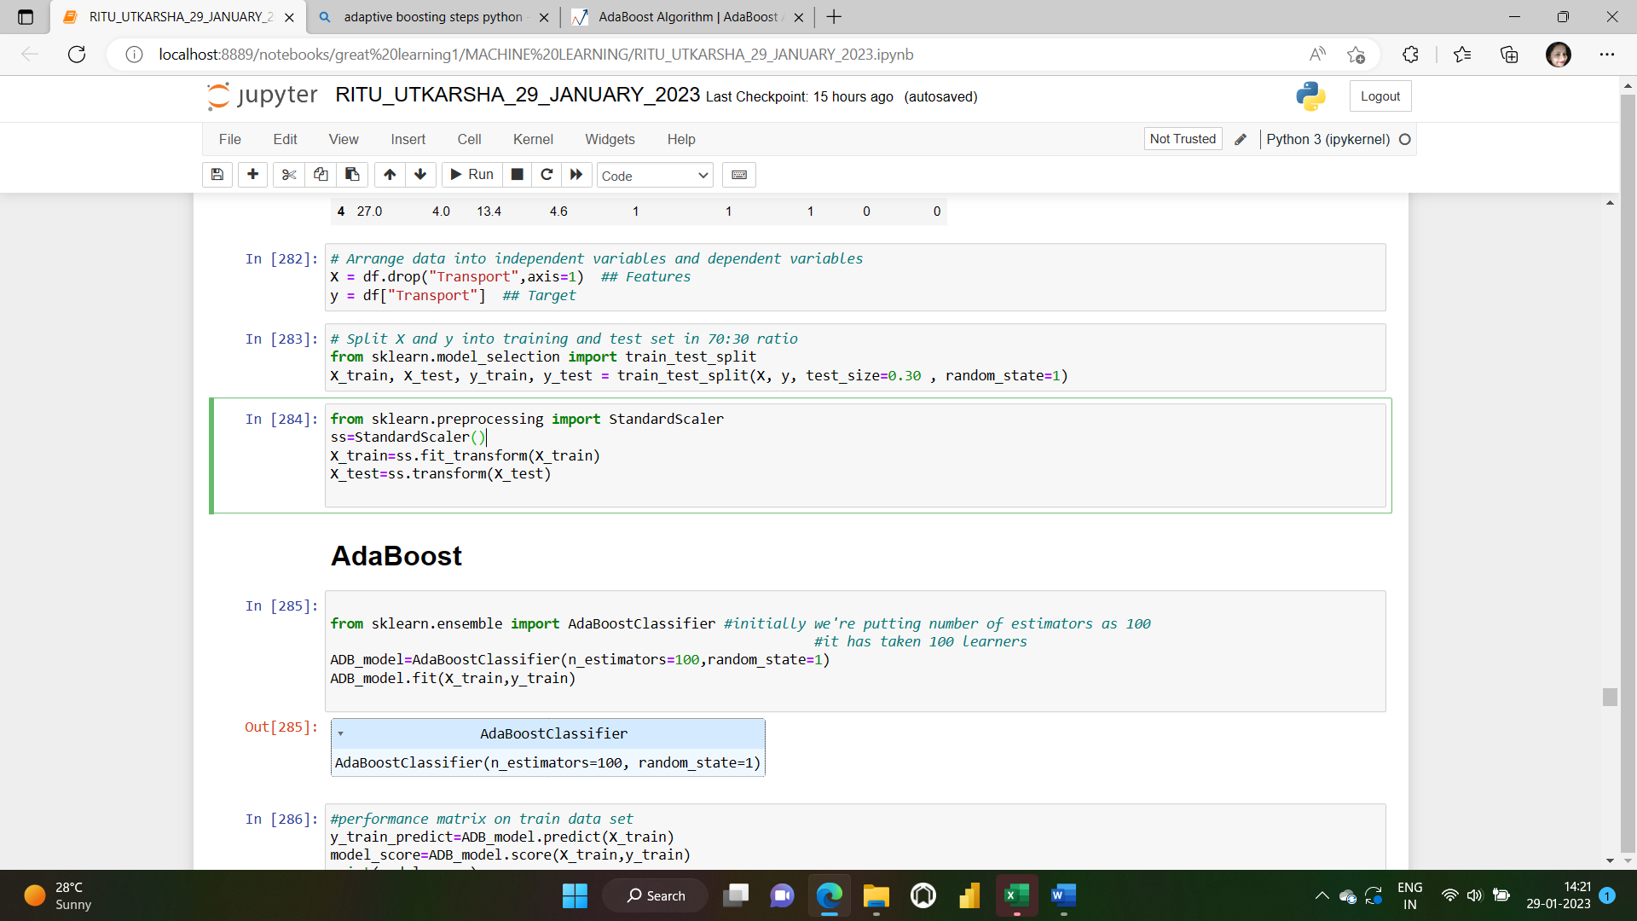

**Scaling our data:**

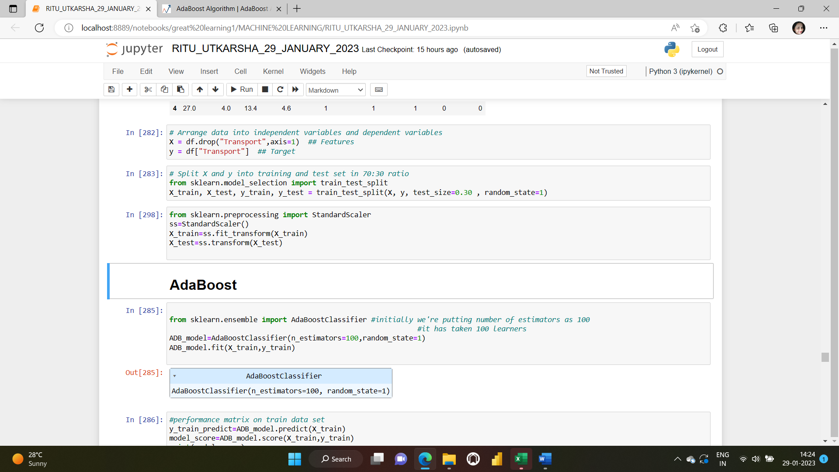

**Importing AdaBoost Classifier and training the model**

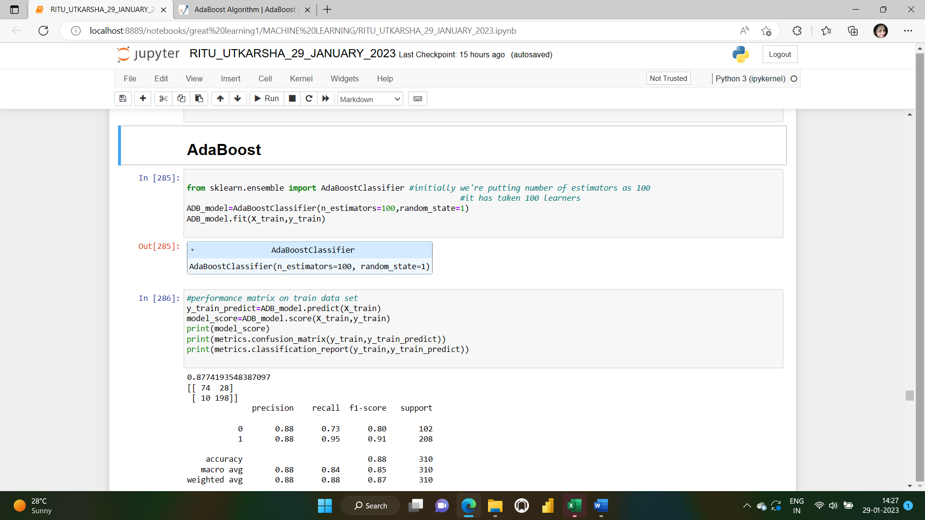

**Performance matrices on the train and the test data sets:**

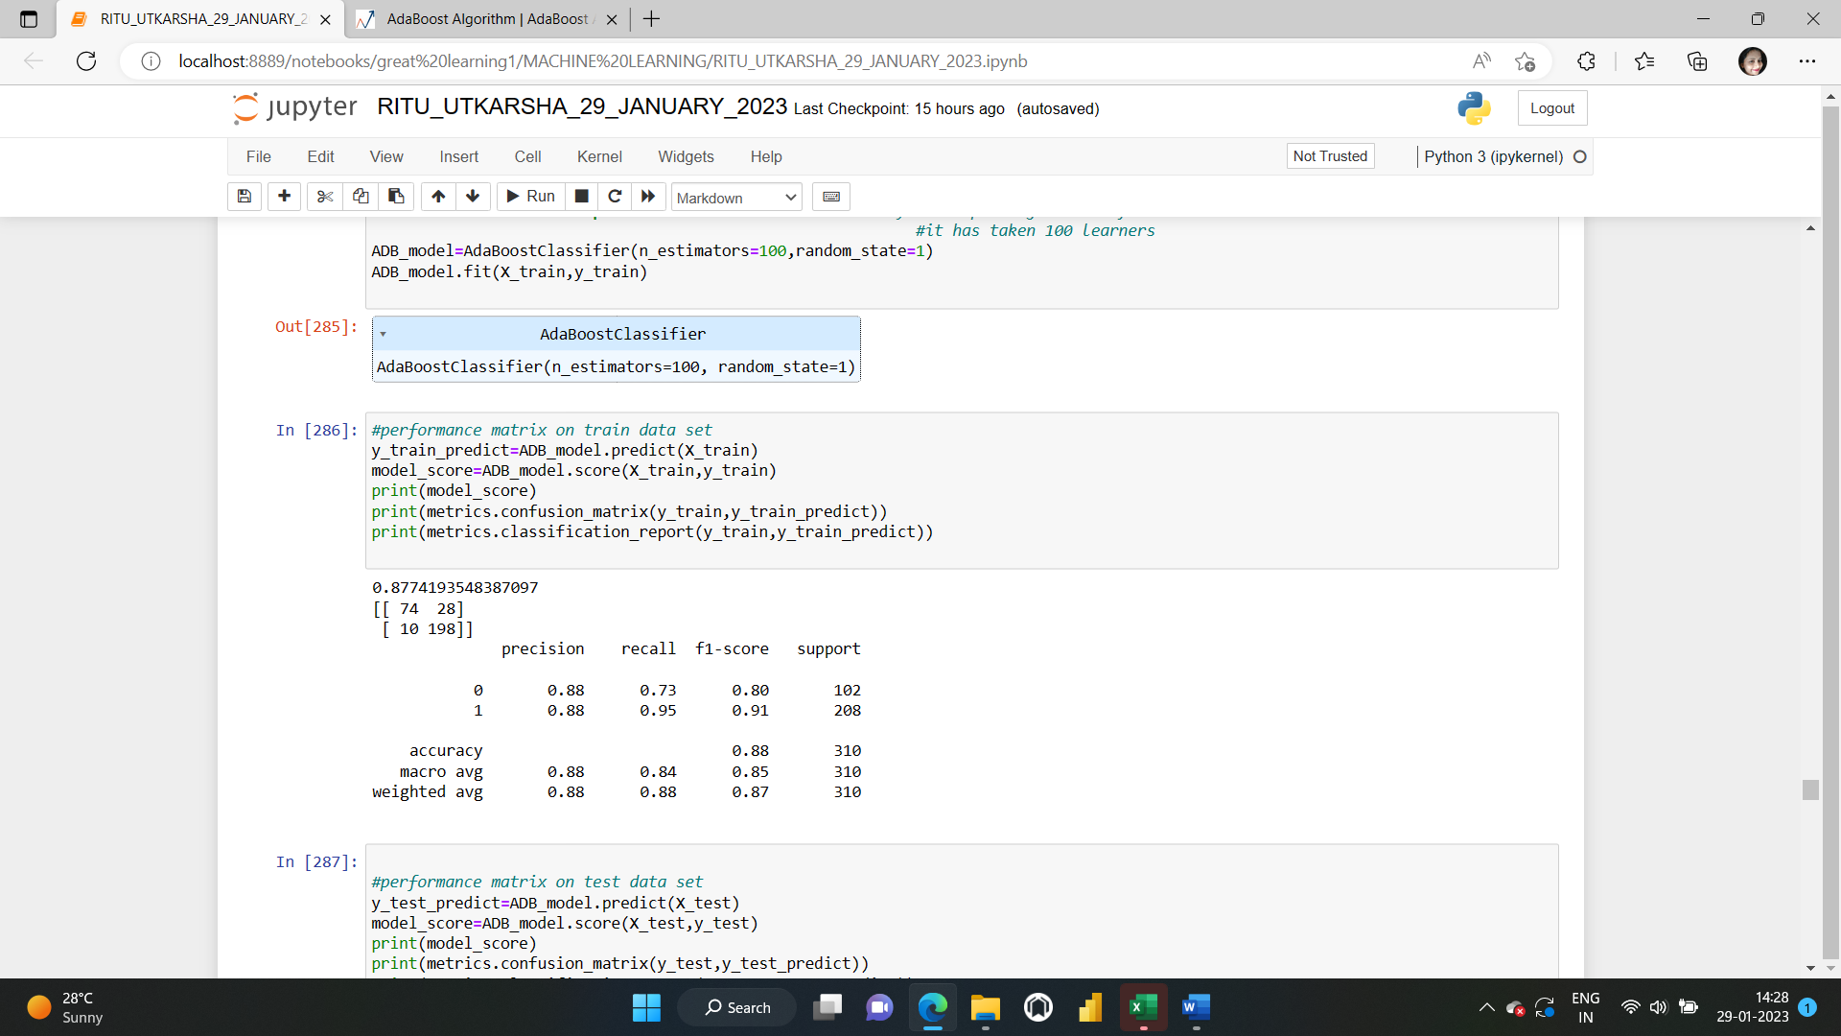

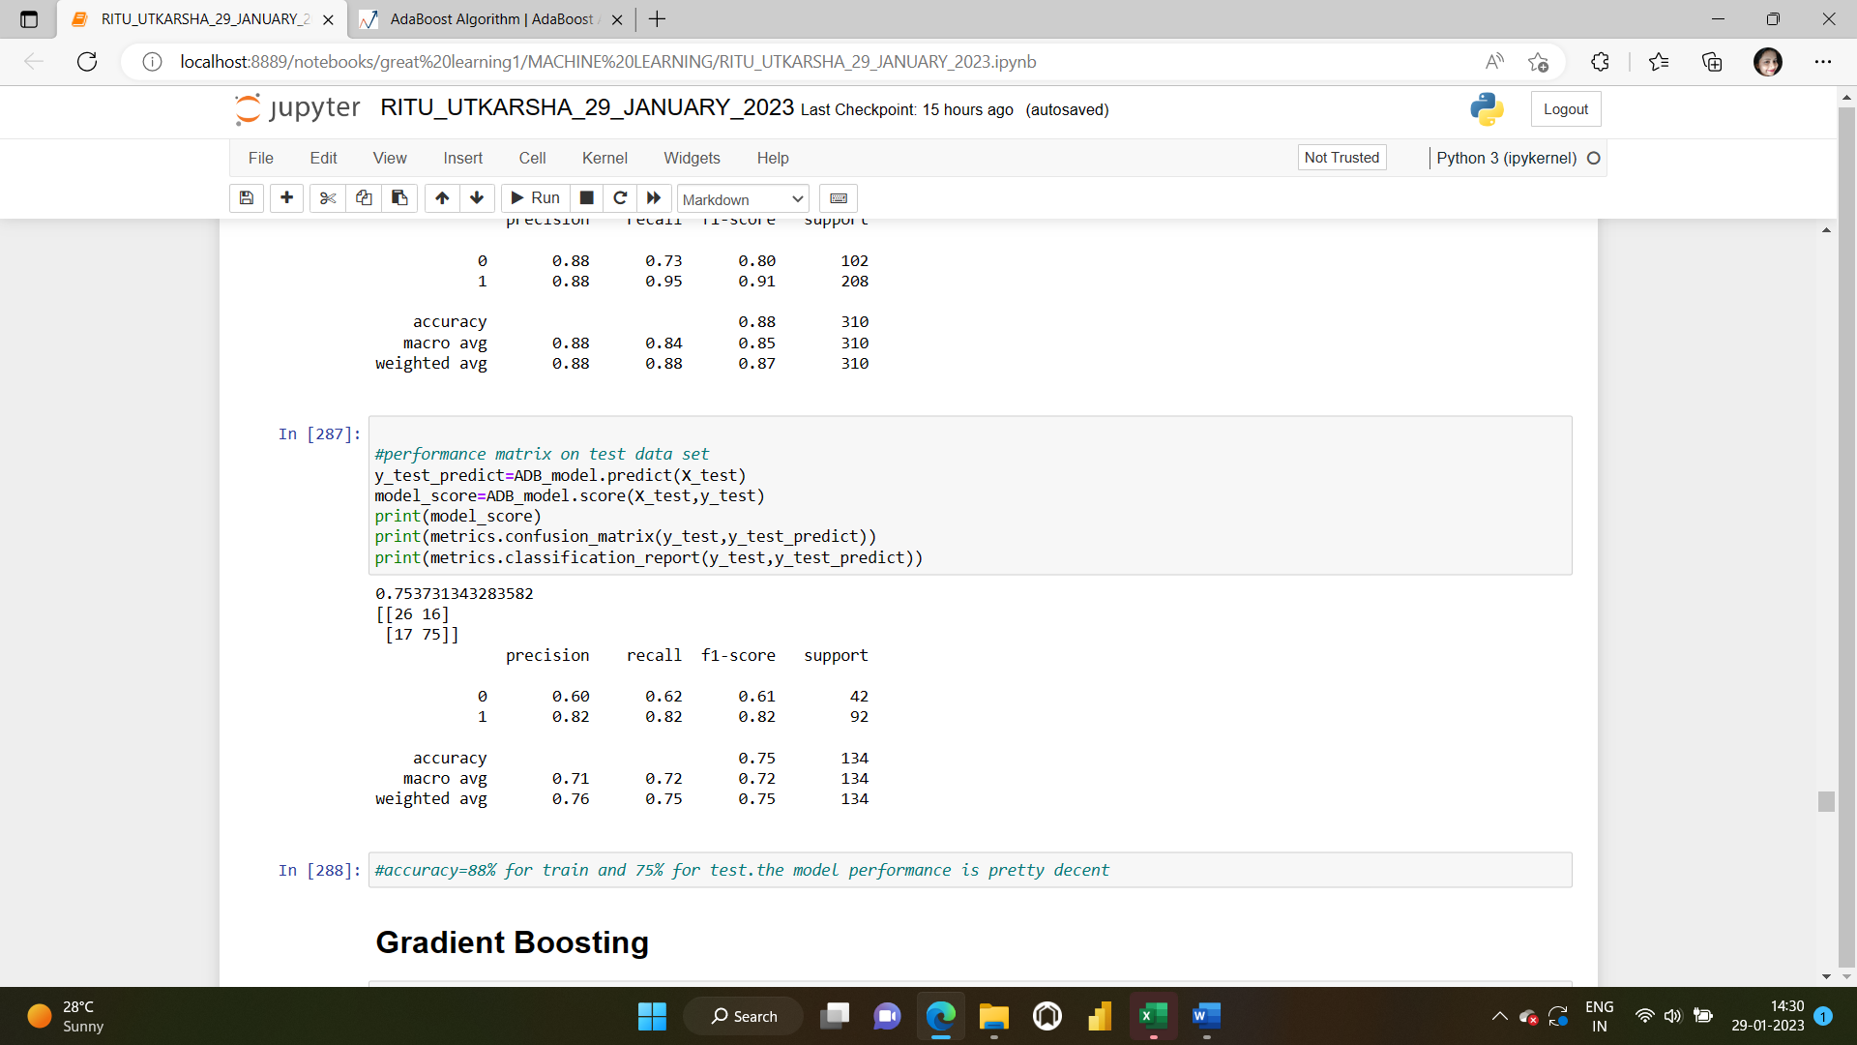

**accuracy=88% for train and 75% for test datasets. The model performance is pretty decent.**

**Gradient Boosting:** Gradient boosting works by building simpler (weak) prediction models sequentially where each model tries to predict the error left over by the previous model.  The objective is to minimise the loss function of the model by adding weak learners using gradient descent. Gradient boosting is a method standing out for its prediction speed and accuracy, particularly with large and complex datasets.

**Importing Gradient Boosting Classifier and training the model:**

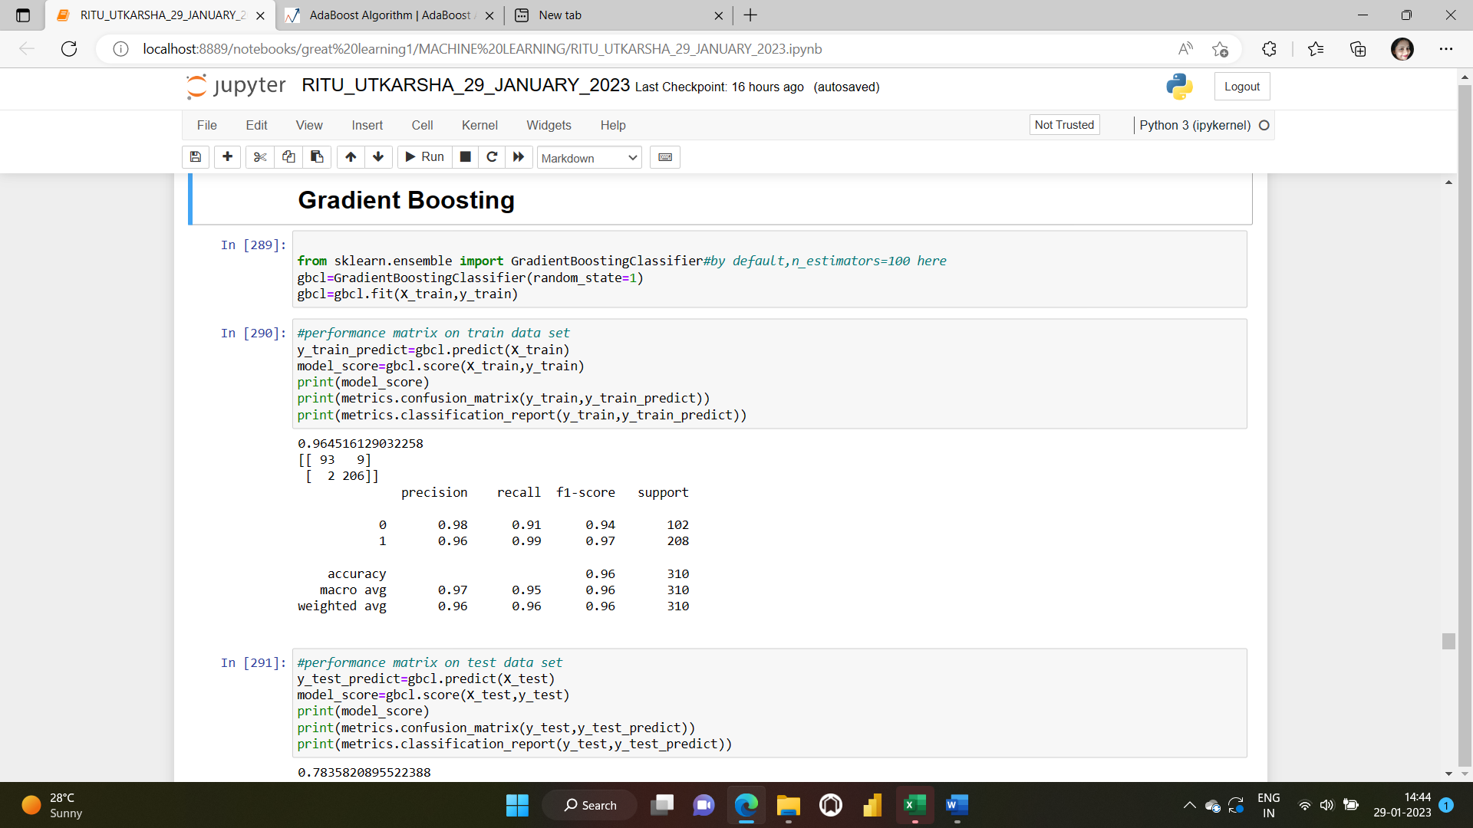

**Performance matrices on the train and the test data sets:**

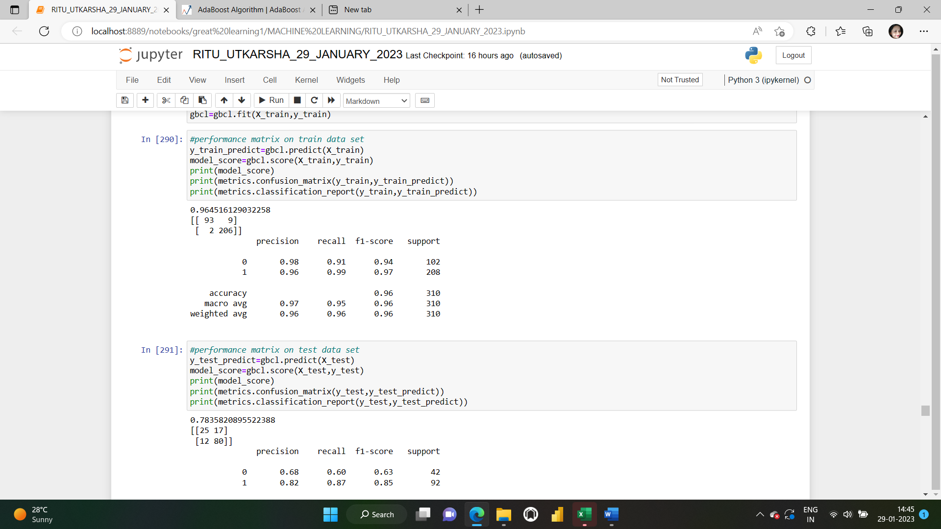

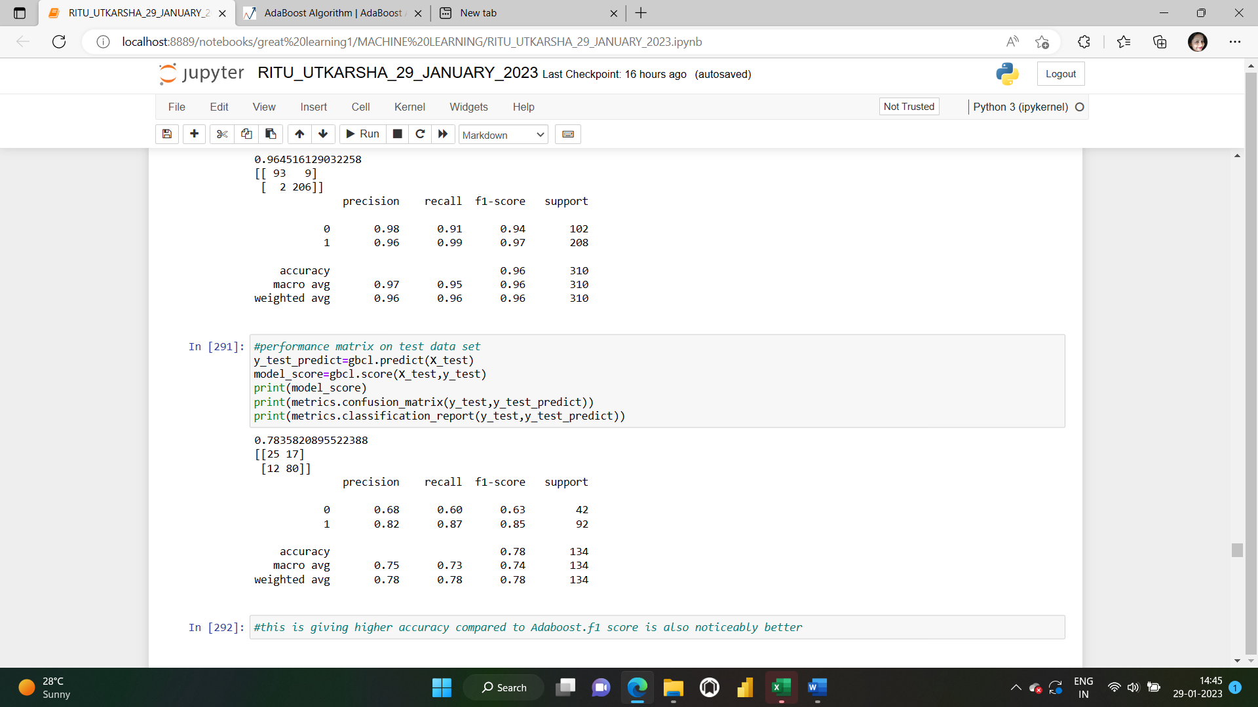

This is giving higher accuracy compared to Ada boost(96% and 78% for the train and test datasets).f1 score is also noticeably better.

Bagging: Bagging, also known as bootstrap aggregation, is the ensemble learning method that is commonly used to reduce variance within a noisy dataset. In bagging, a random sample of data in a training set is selected with replacement—meaning that the individual data points can be chosen more than once. After several data samples are generated, these weak models are then trained independently, and depending on the type of task—regression or classification, for example—the average or majority of those predictions yield a more accurate estimate.

**Importing BAGGING Classifier and decision tree classifier and training the model**

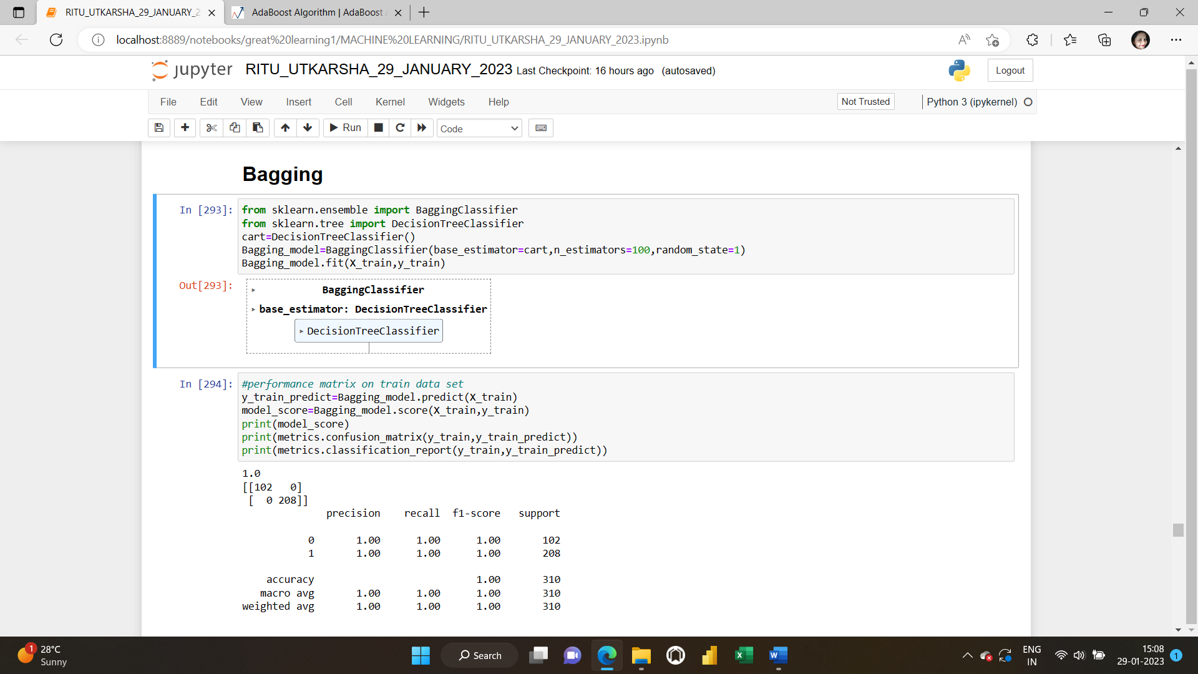

**Performance matrices on the train and the test data sets:**

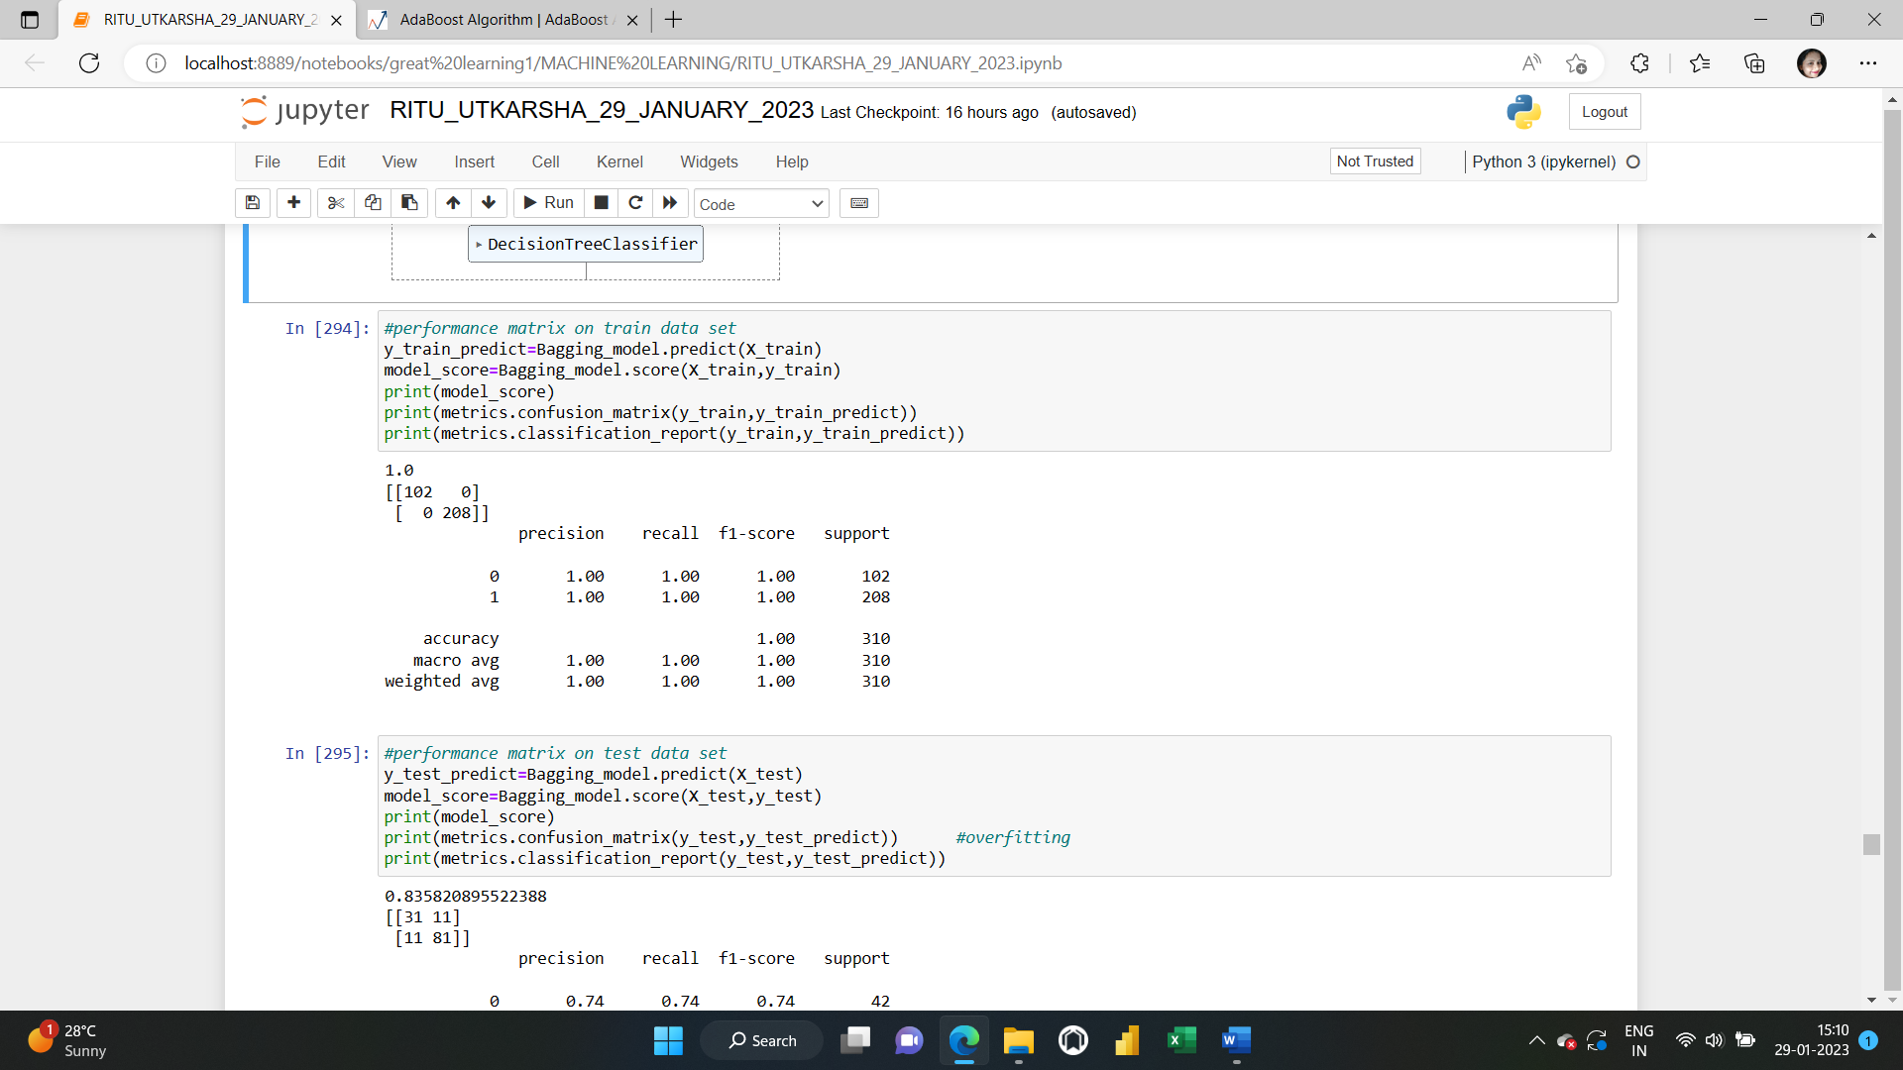

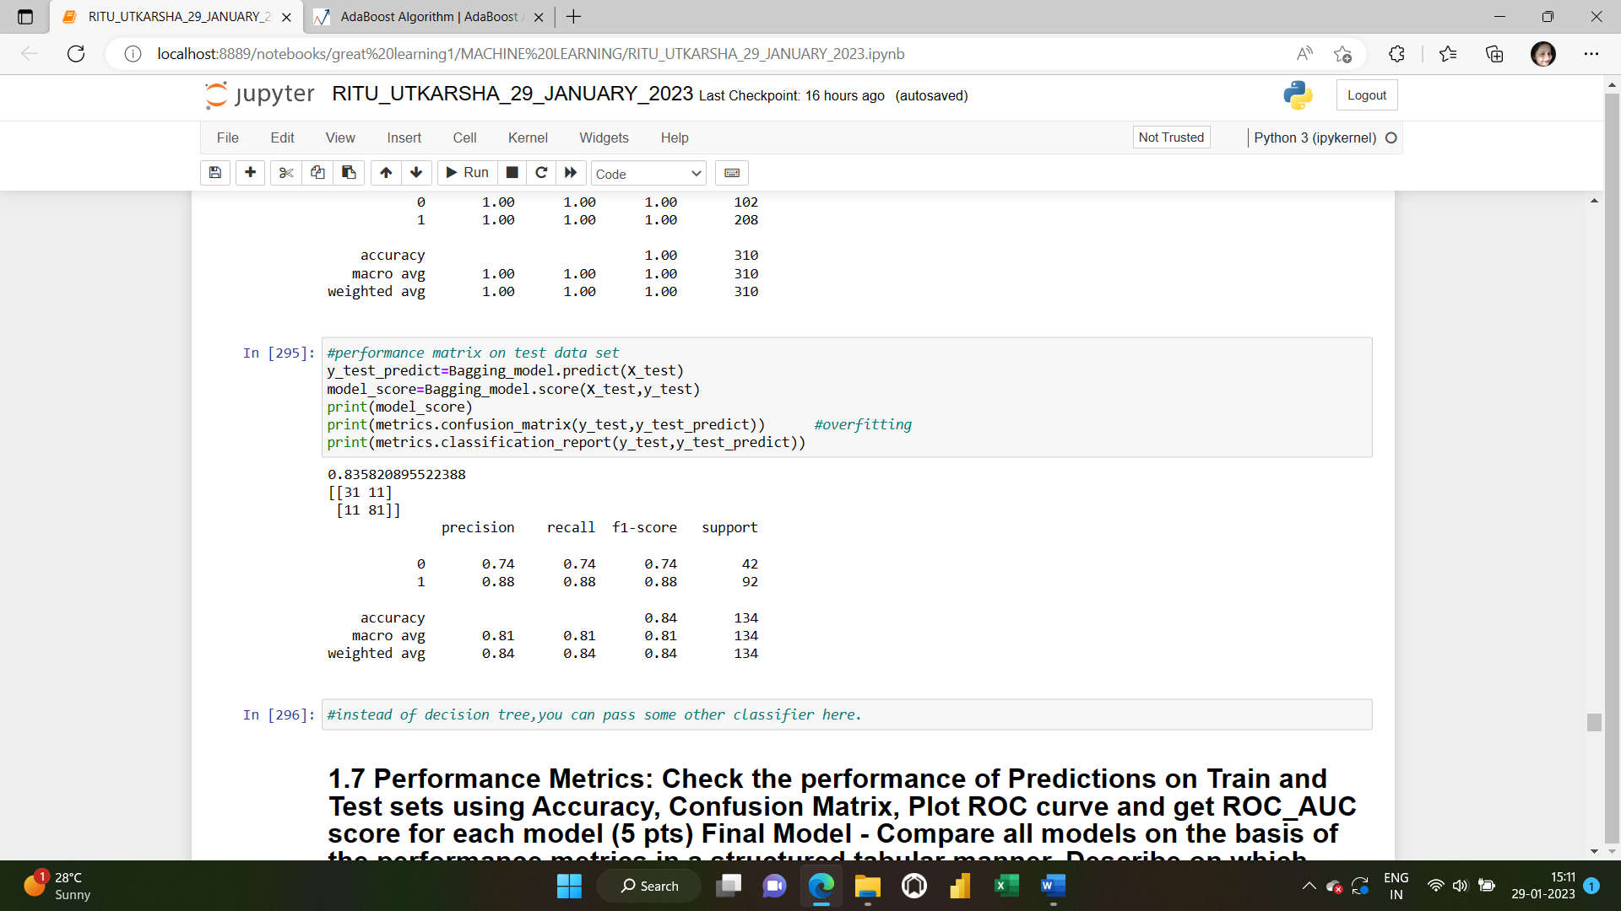

HYPERPARAMETER TUNING IN BAGGING AND BOOSTING: - An AdaBoost classifier is a meta-estimator that begins by fitting a classifier on the original dataset and then fits additional copies of the classifier on the same dataset but where the weights of incorrectly classified instances are adjusted such that subsequent classifiers focus more on difficult cases.

- Some important hyperparameters are:

base_estimator: The base estimator from which the boosted ensemble is built. By default the base estimator is a decision tree with max_depth=1

n_estimators: The maximum number of estimators at which boosting is terminated. Default value is 50.

learning_rate: Learning rate shrinks the contribution of each classifier by learning_rate. There is a trade-off between learning_rate and n_estimators.

Gradient Boosting Classifier:

- Most of the hyperparameters available are same as random forest classifier.

- init: An estimator object that is used to compute the initial predictions. If ‘zero’, the initial raw predictions are set to zero. By default, a DummyEstimator predicting the classes priors is used.

- There is no class_weights parameter in gradient boosting.

Refer to the jupyter notebook for the codes.

**1.7 Performance Metrics: Check the performance of Predictions on Train and Test sets using Accuracy, Confusion Matrix, Plot ROC curve and get ROC_AUC score for each model (5 pts) Final Model - Compare all models based on the performance metrics in a structured tabular manner. Describe on which model is best/optimized (3 pts)**

Solution:

**Separating the independent and dependent variables**



**Creating the train and the test datasets:**



**Scaling our data:**



**1) LOGISTIC REGRESSION MODEL:**

**IMPORTING AND FITTING THE LOGISTIC REGRESSION MODEL**

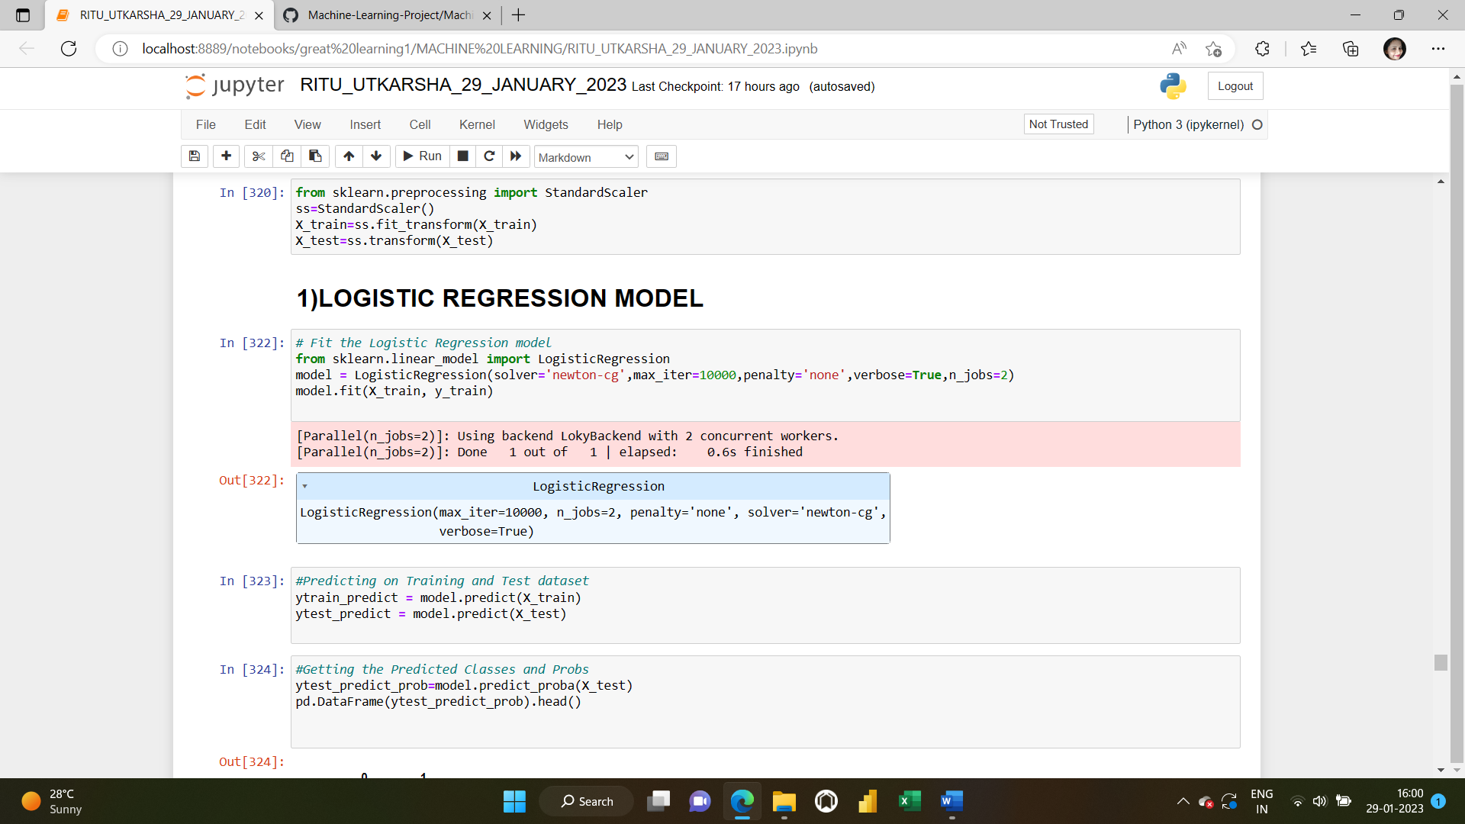

**PREDICTION ON TRAIN AND TEST DATASET**

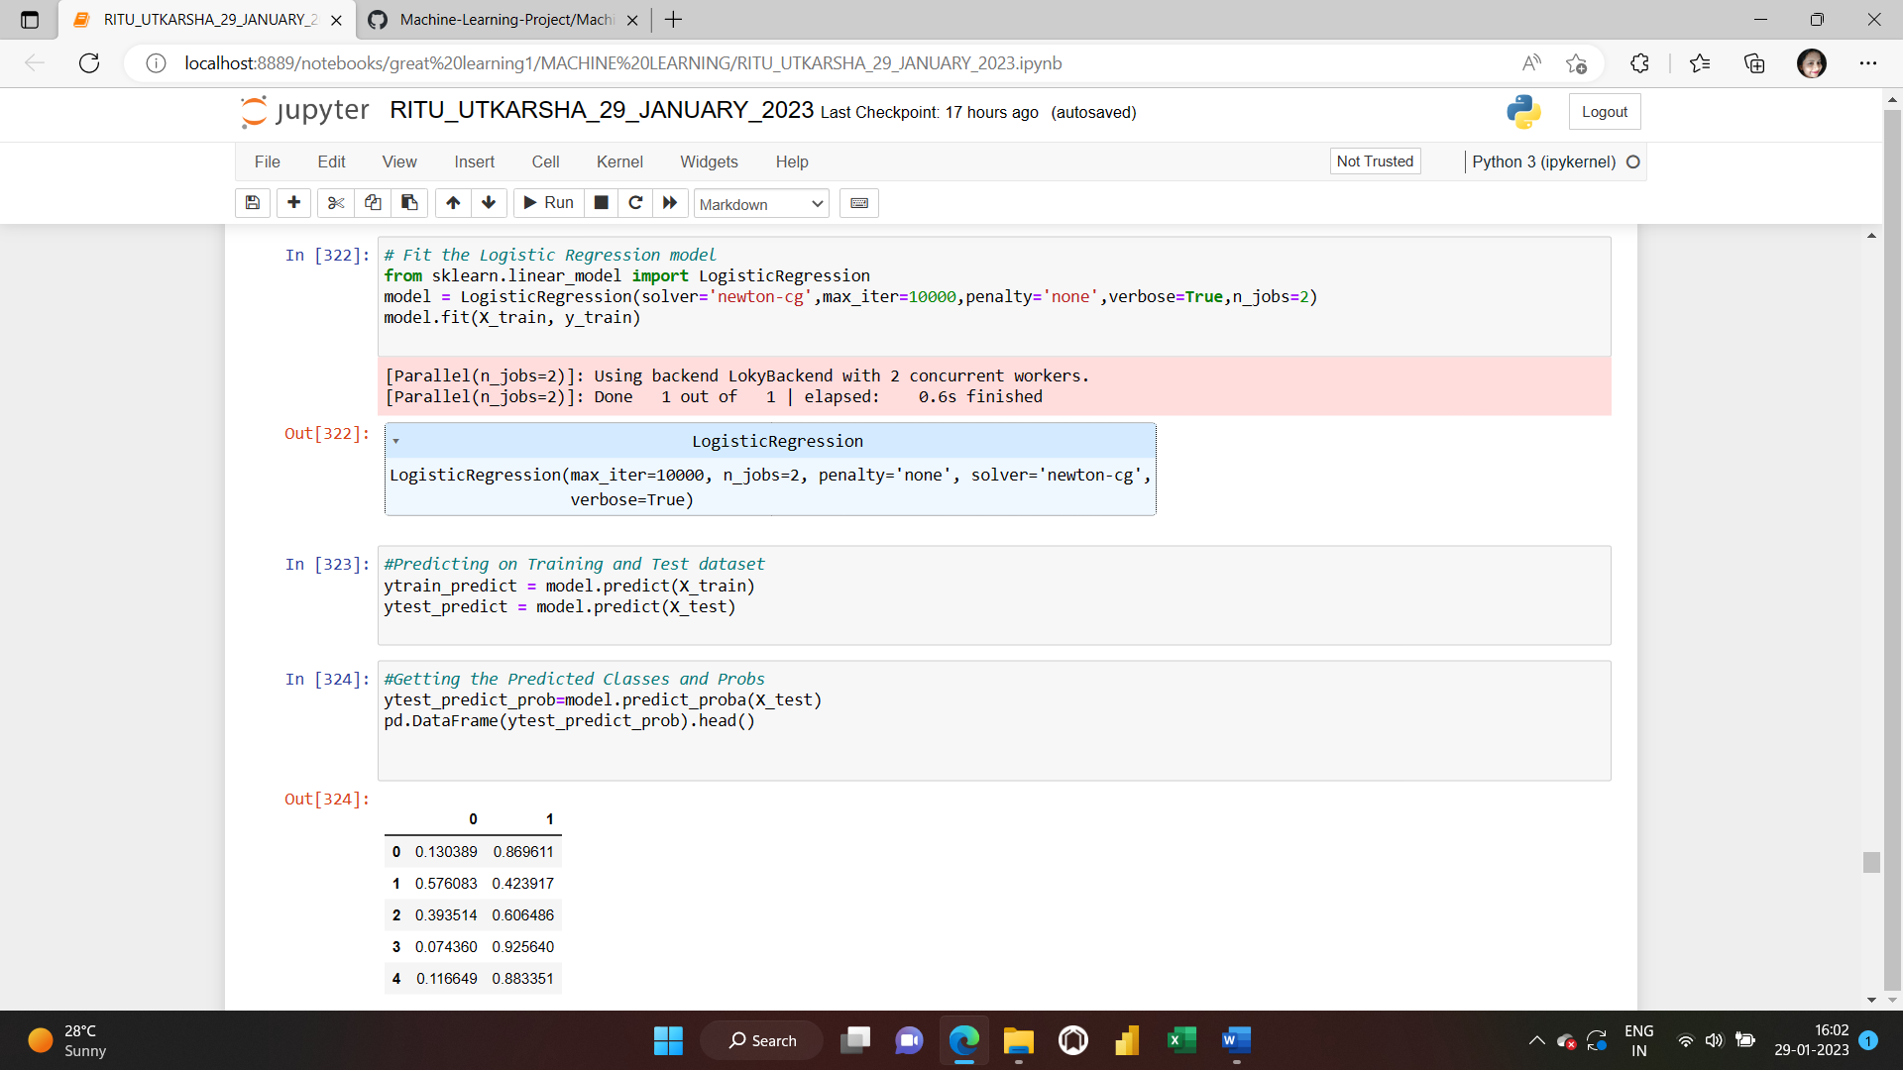

**ACCURACY FOR TRAIN AND TEST DATASET**

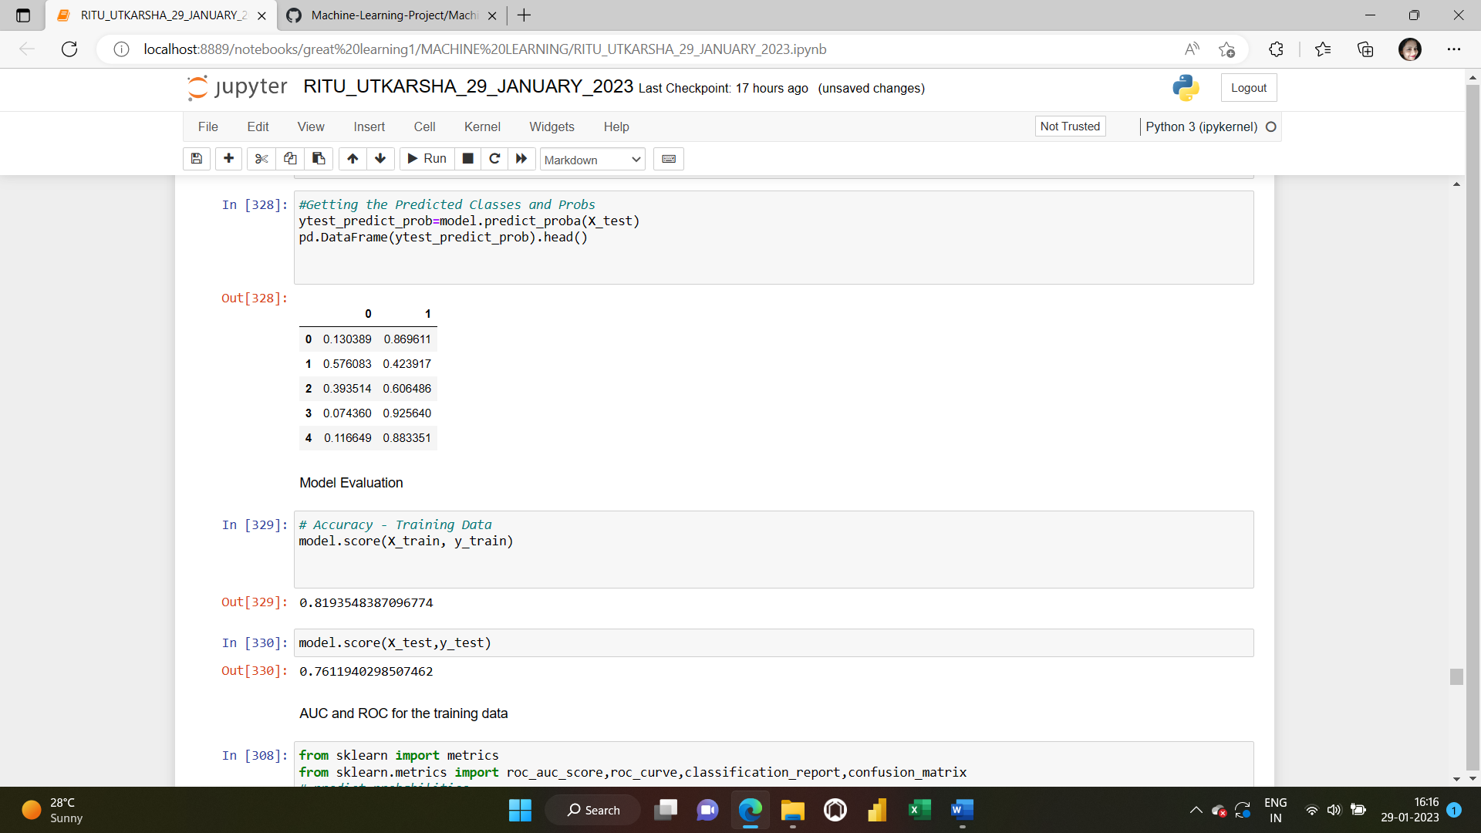

**AUC and ROC for training data**

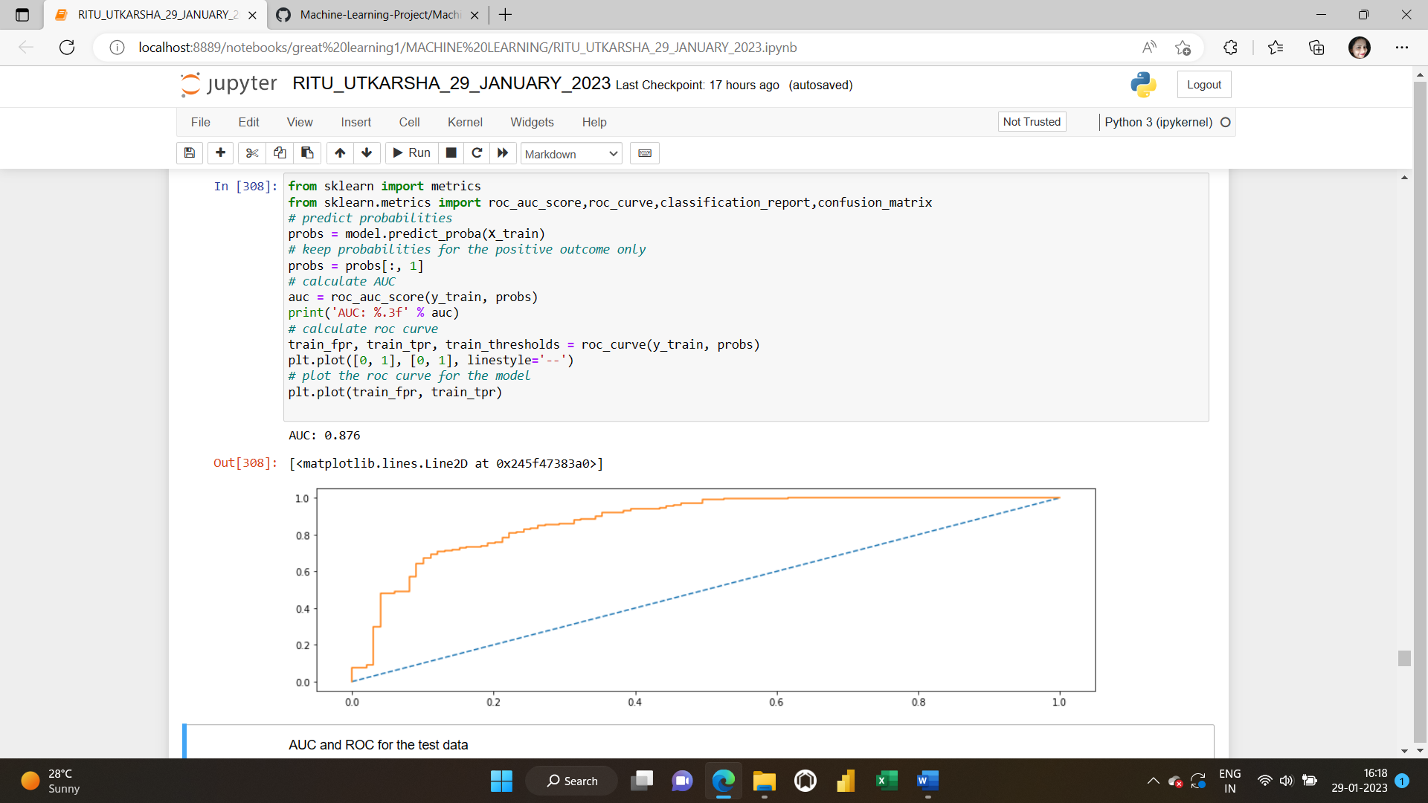

**AUC and ROC for test data**

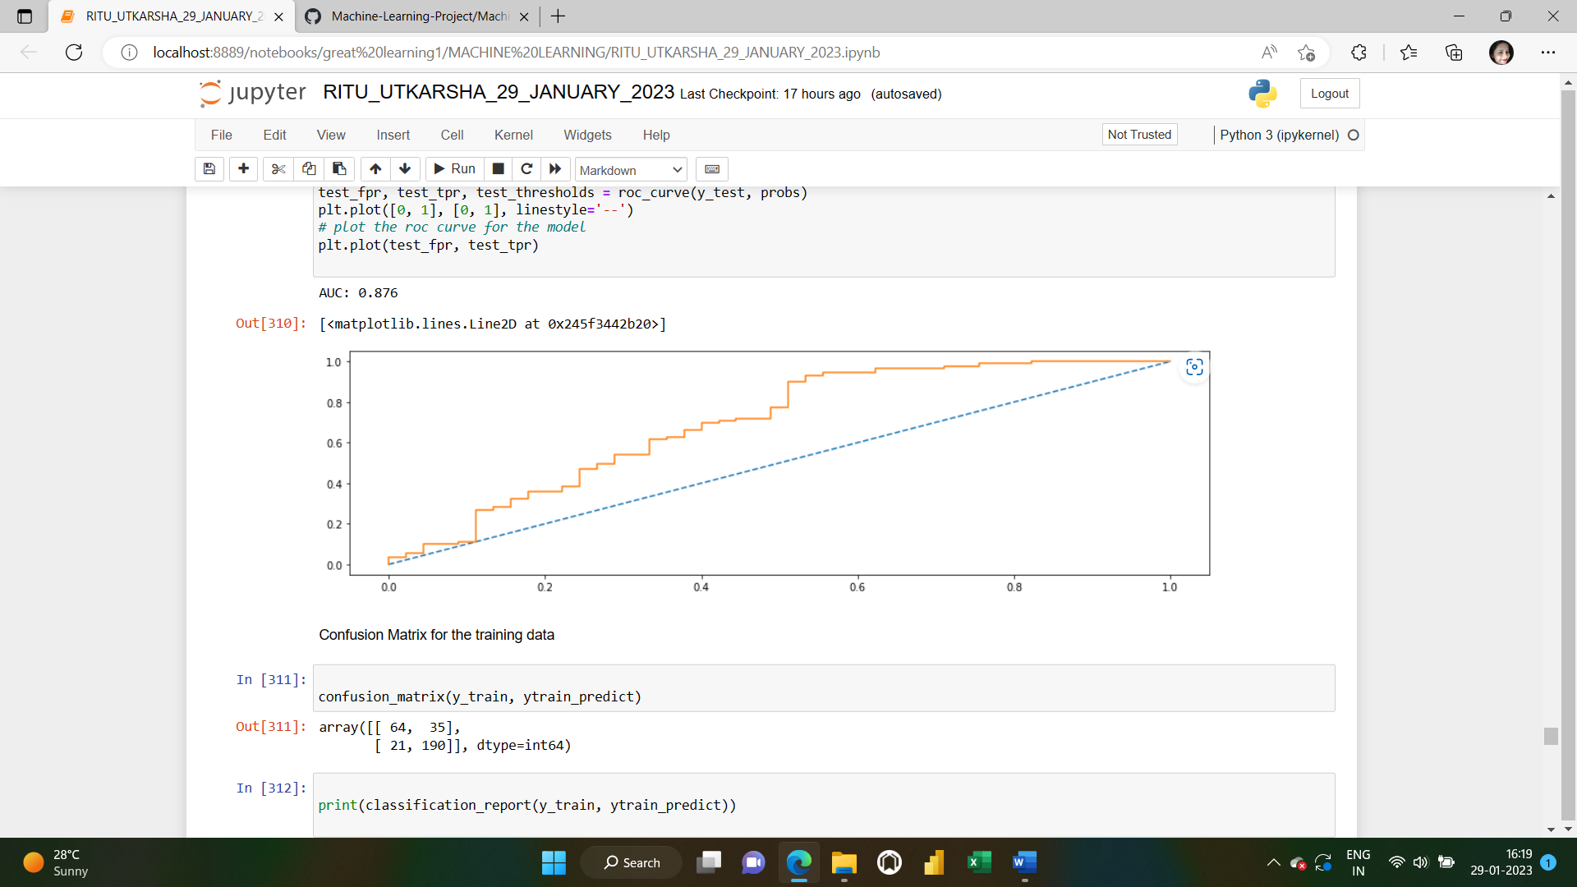

**CONFUSION MATRIX AND CLASSIFICATION REPORT FOR TRAINING DATA:**

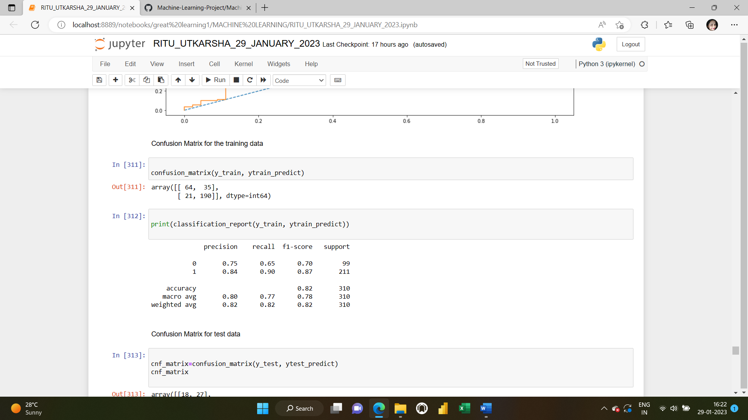

**CONFUSION MATRIX AND CLASSIFICATION REPORT FOR TEST DATA:**

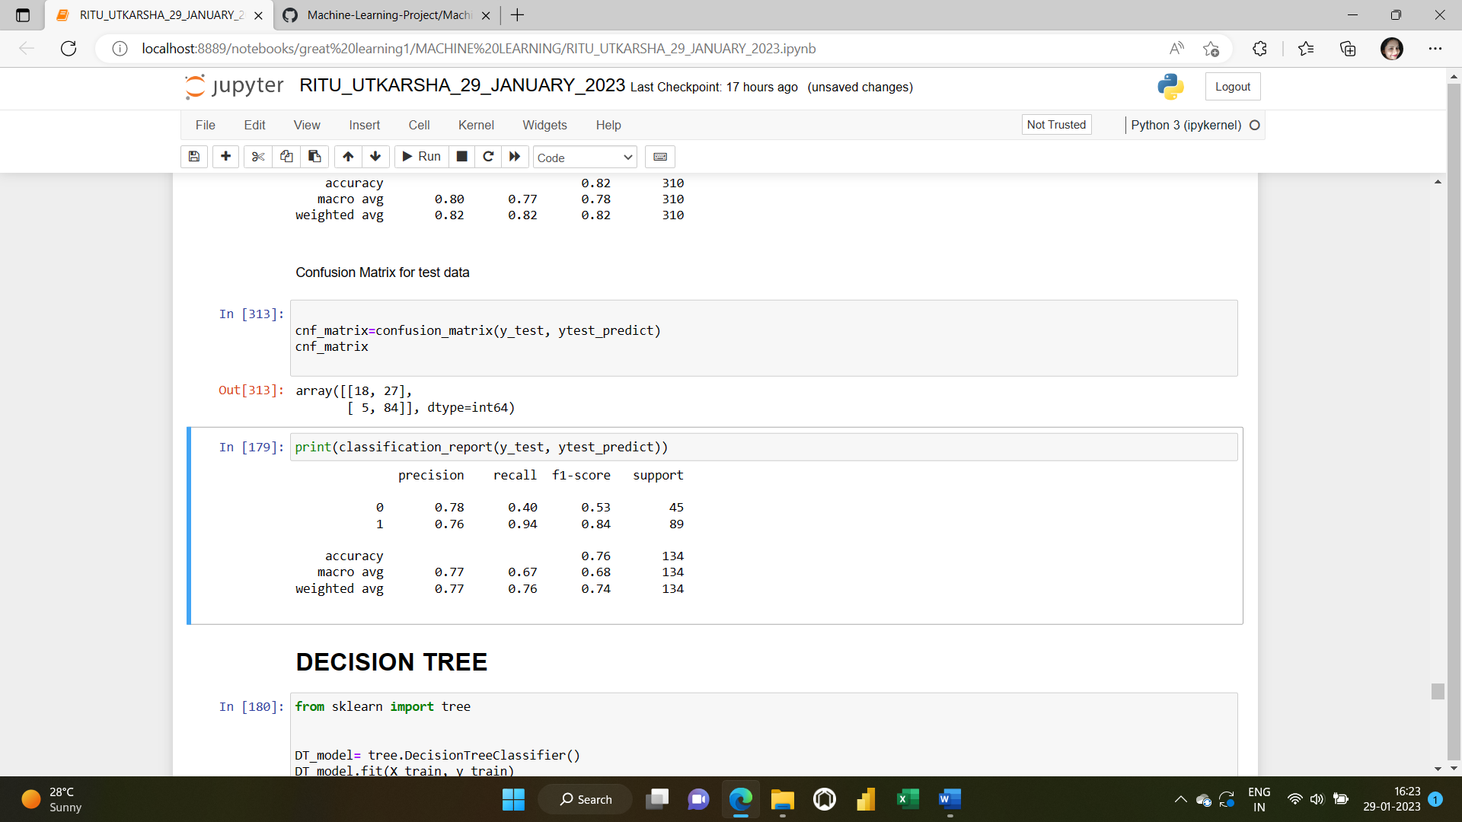

**2)DECISION TREE MODEL:**

**IMPORTING AND FITTING THE DECISION TREE MODEL**

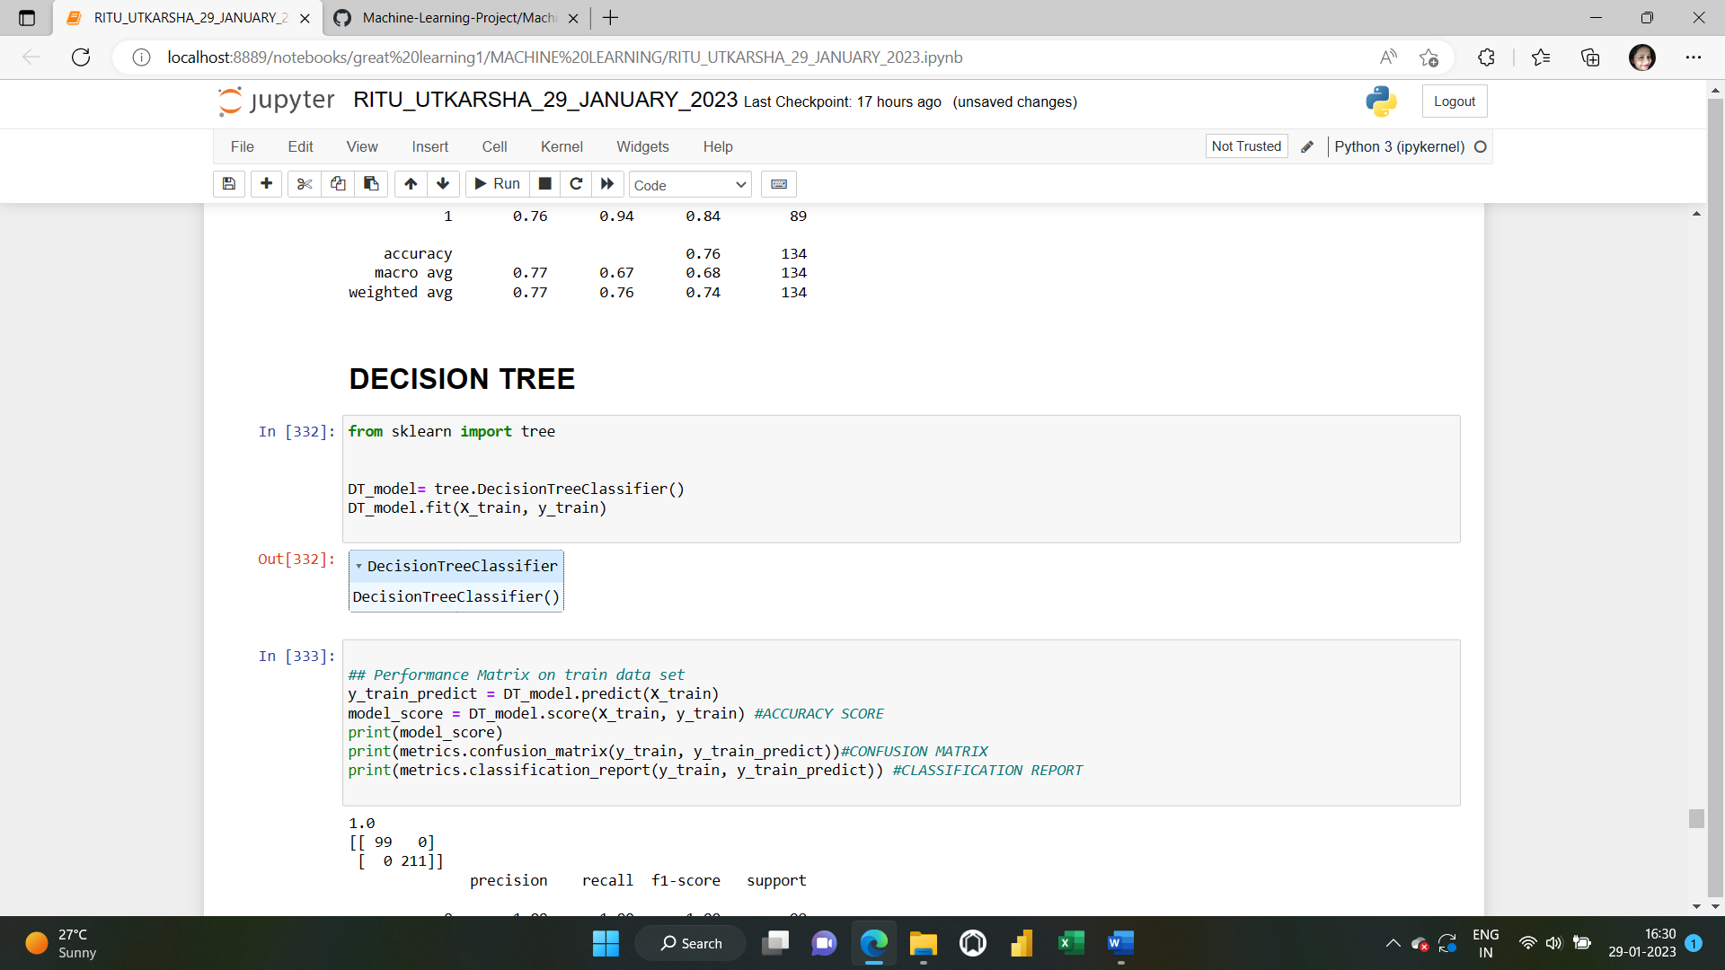

**ACCURACY SCORE,CONFUSION MATRIX AND CLASSIFICATION REPORT ON THE TRAIN AND TEST DATASETS**

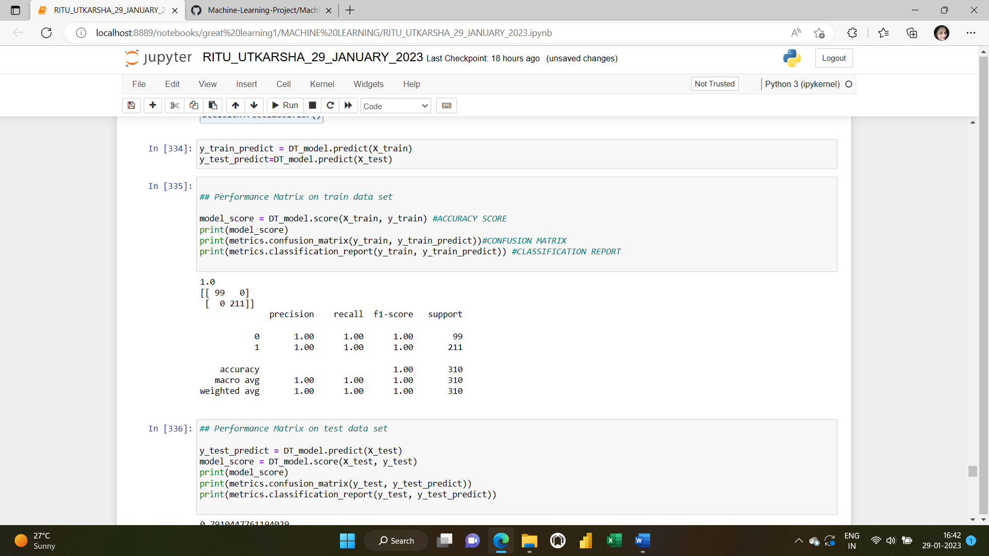

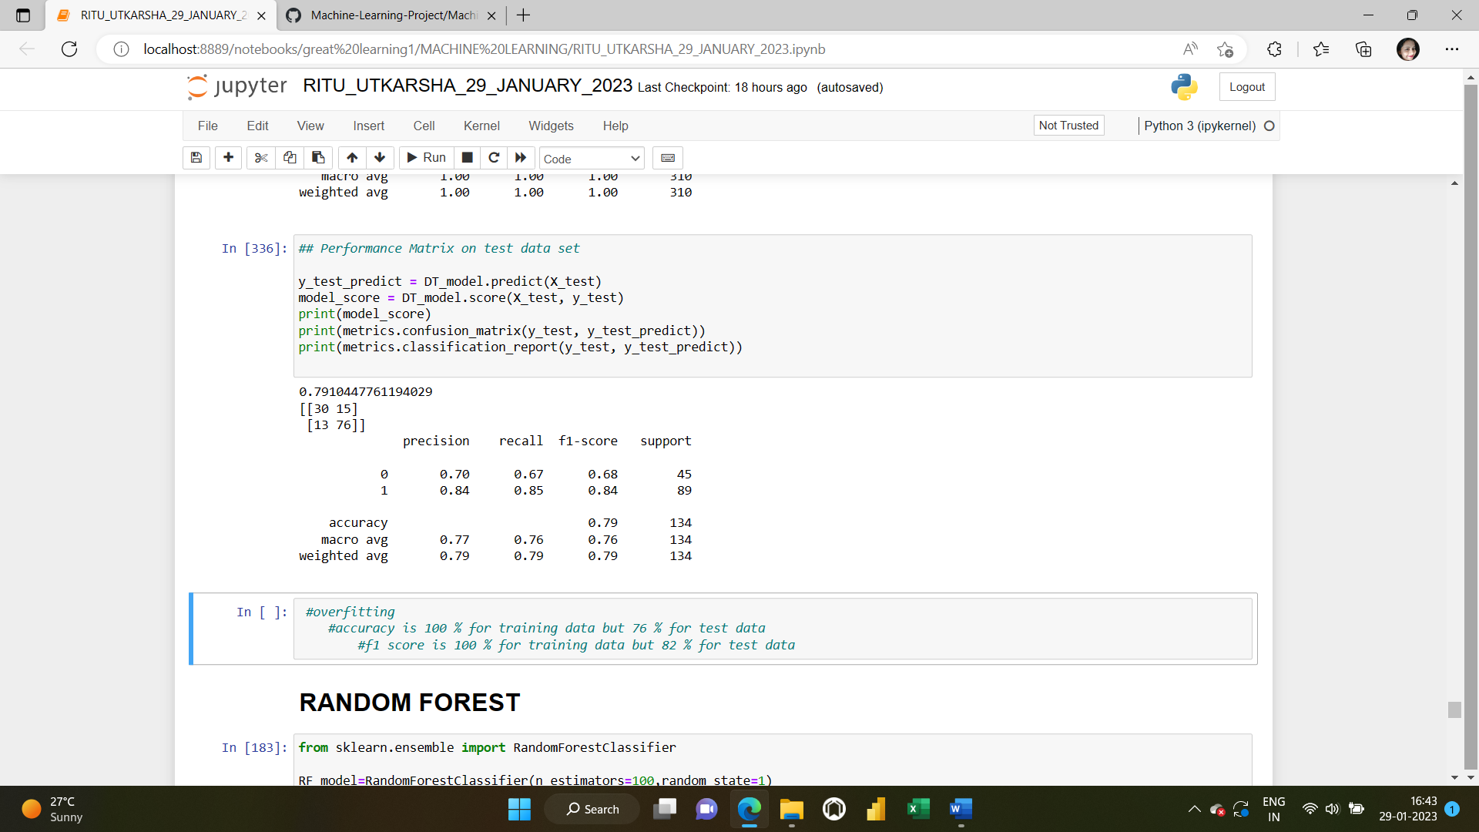

**3)RANDOM FOREST MODEL**

**IMPORTING AND FITTING THE RANDOM FOREST MODEL**

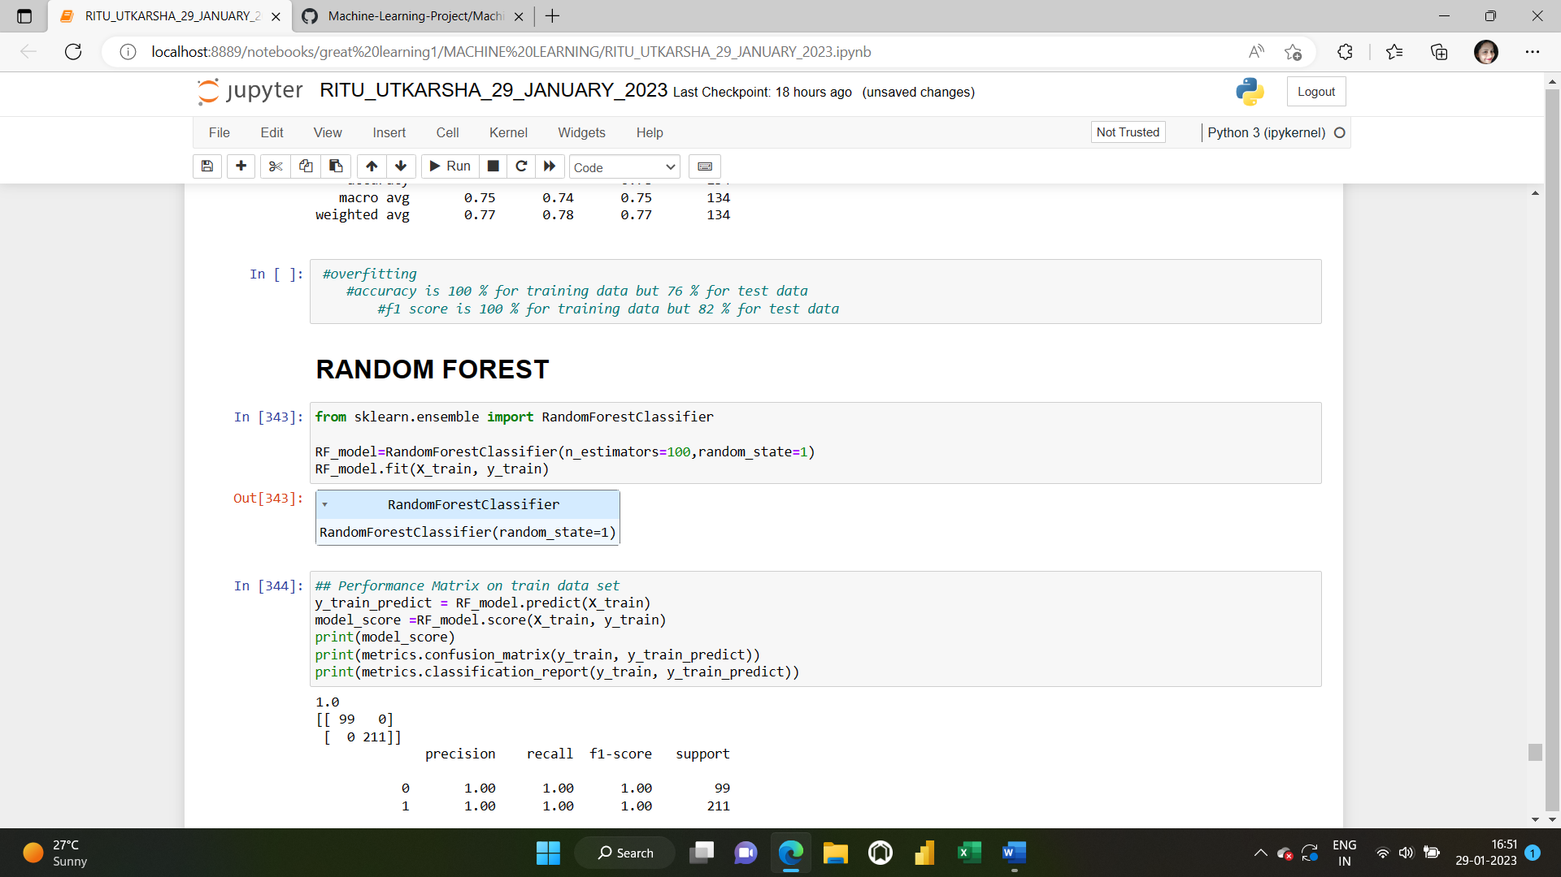

**FEATURE IMPORTANCE:**

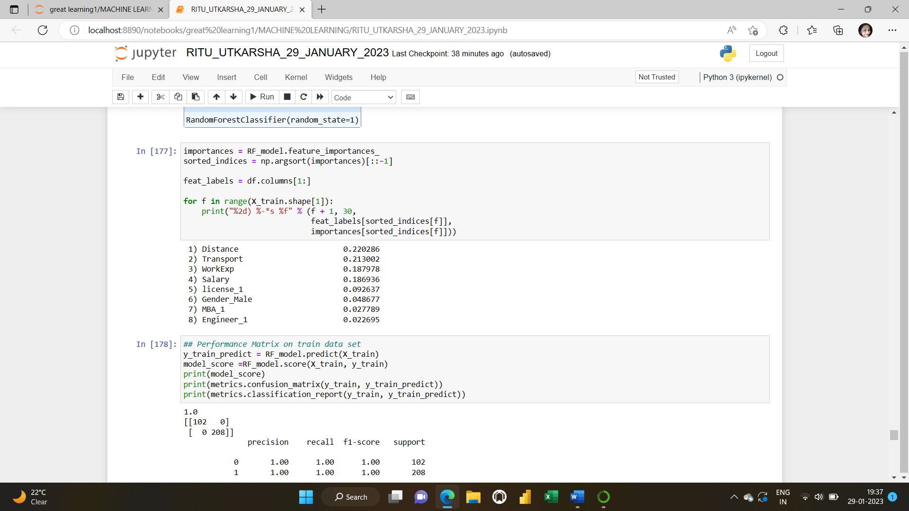

**ACCURACY SCORE,CONFUSION MATRIX AND CLASSIFICATION REPORT ON THE TRAIN AND TEST DATASETS**

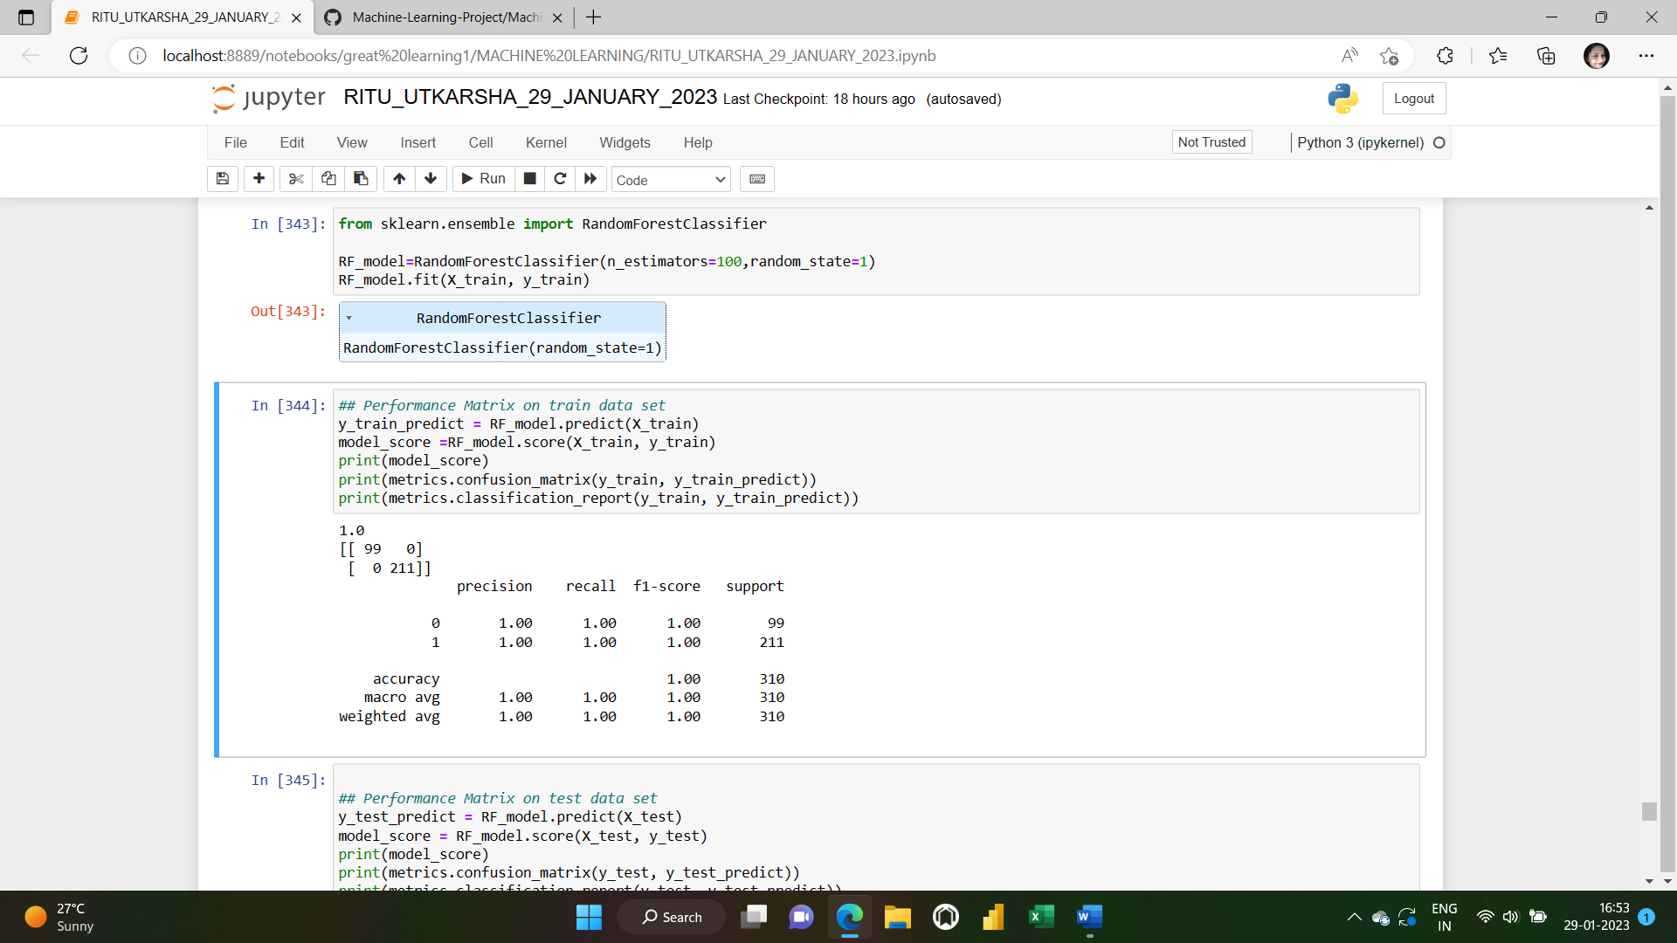

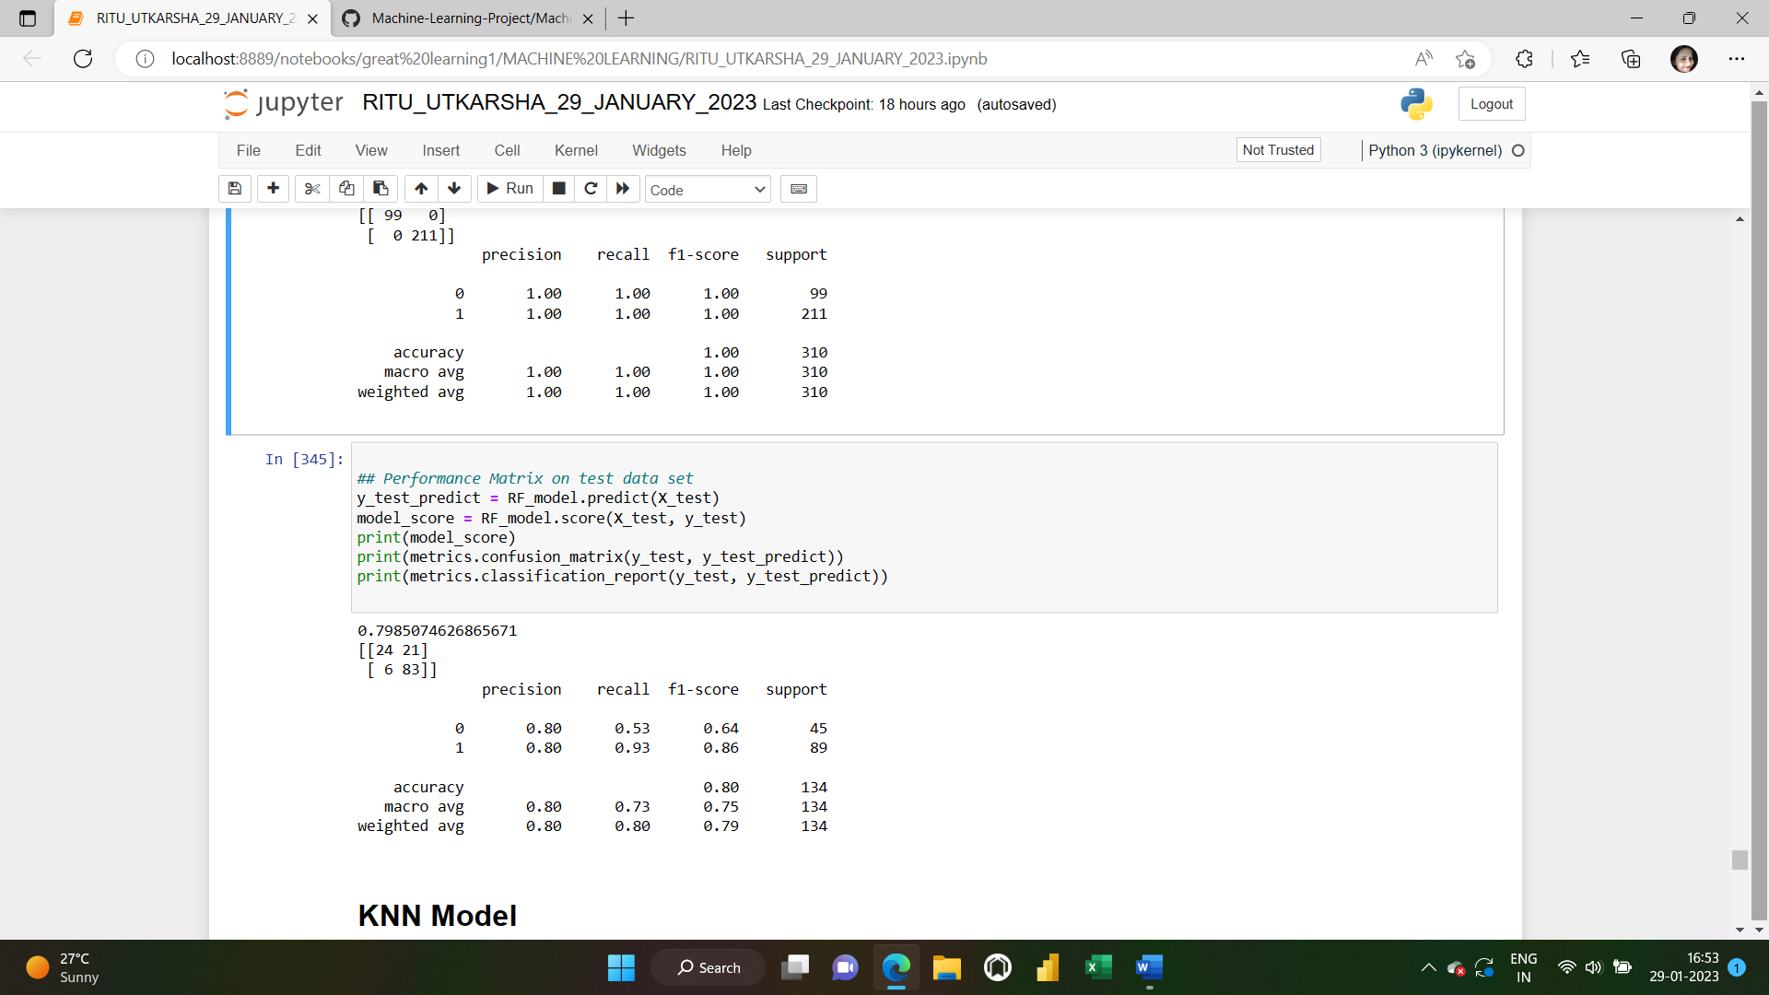

**4 ) KNN MODEL:**

**IMPORTING AND FITTING THE KNN MODEL**

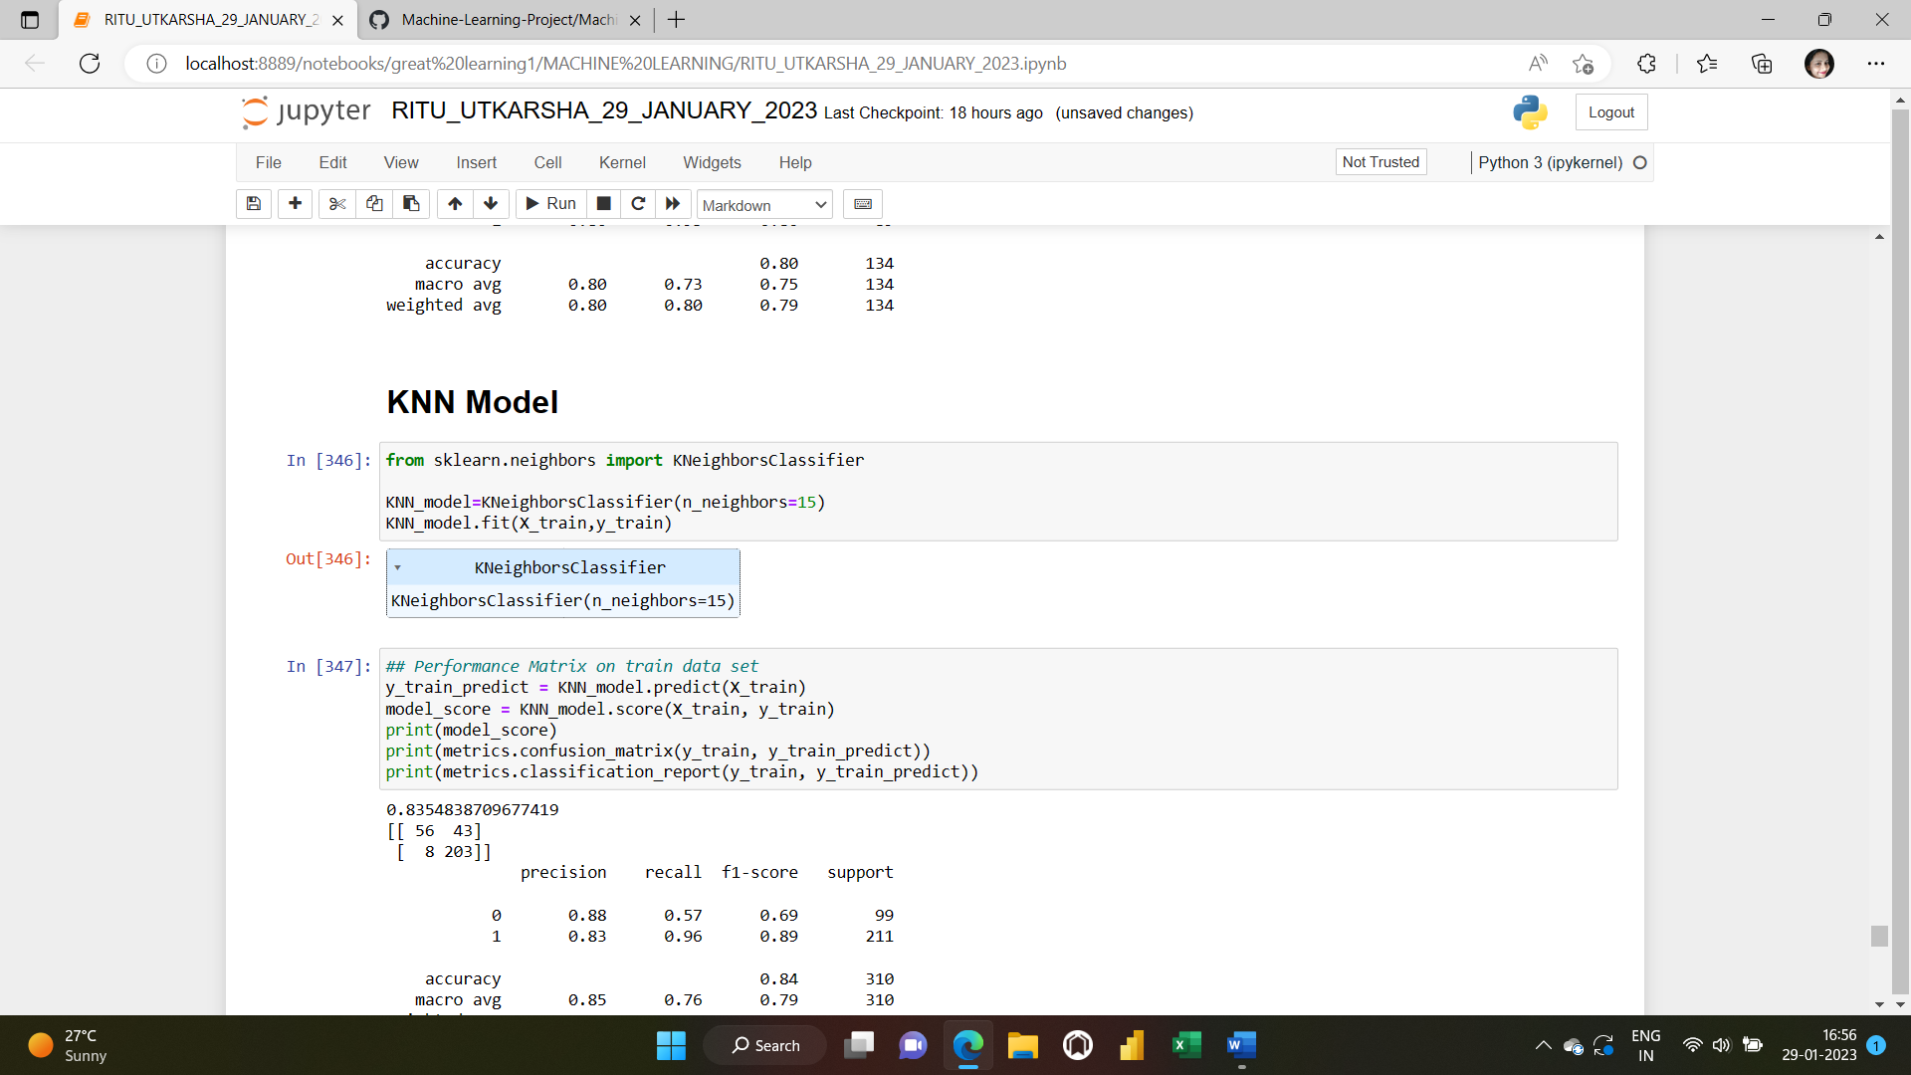

**ACCURACY SCORE,CONFUSION MATRIX AND CLASSIFICATION REPORT ON THE TRAIN AND TEST DATASETS**

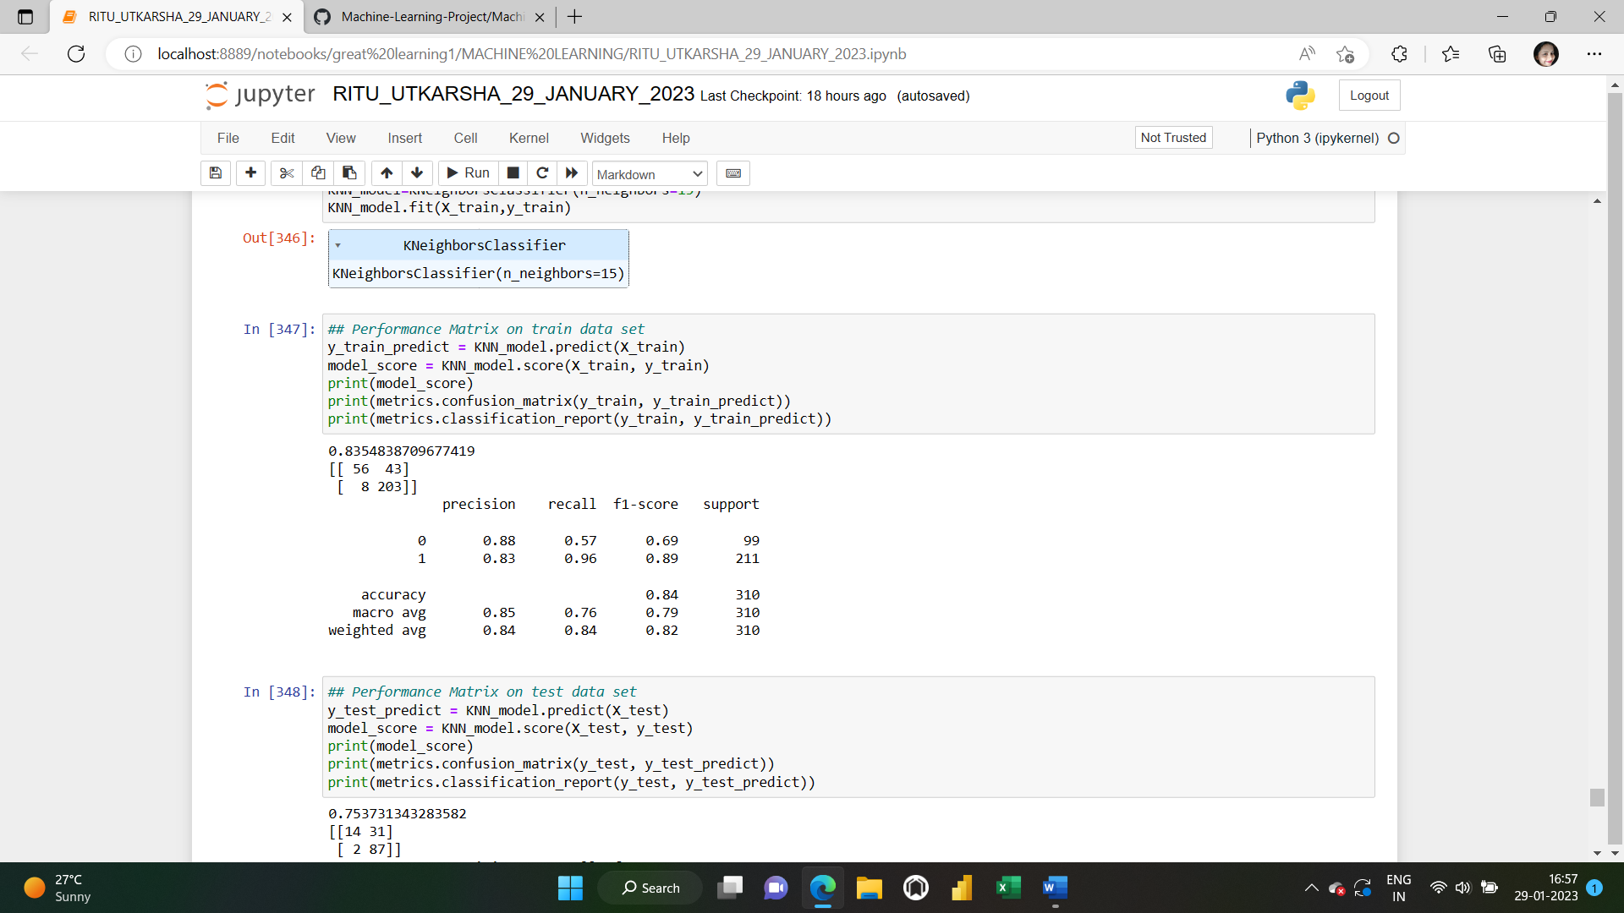

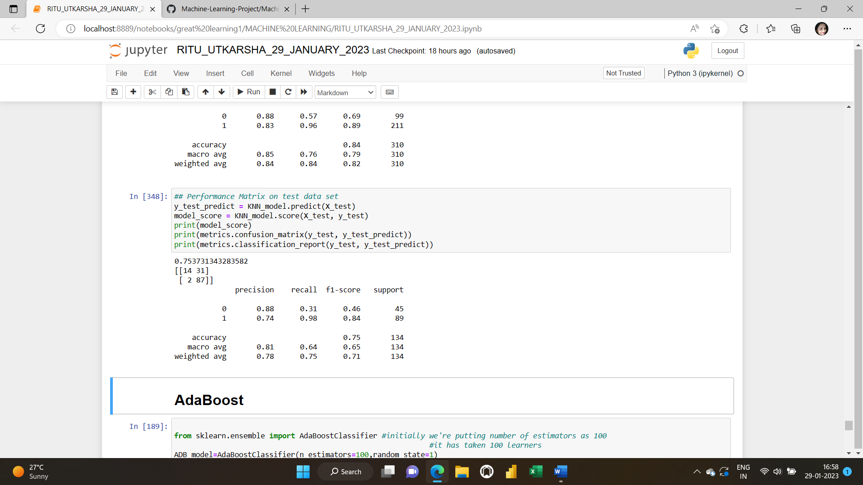

**5) ADAPTIVE BOOSTING (AdaBoost)MODEL:**

**IMPORTING AND FITTING THE AdaBoost MODEL**

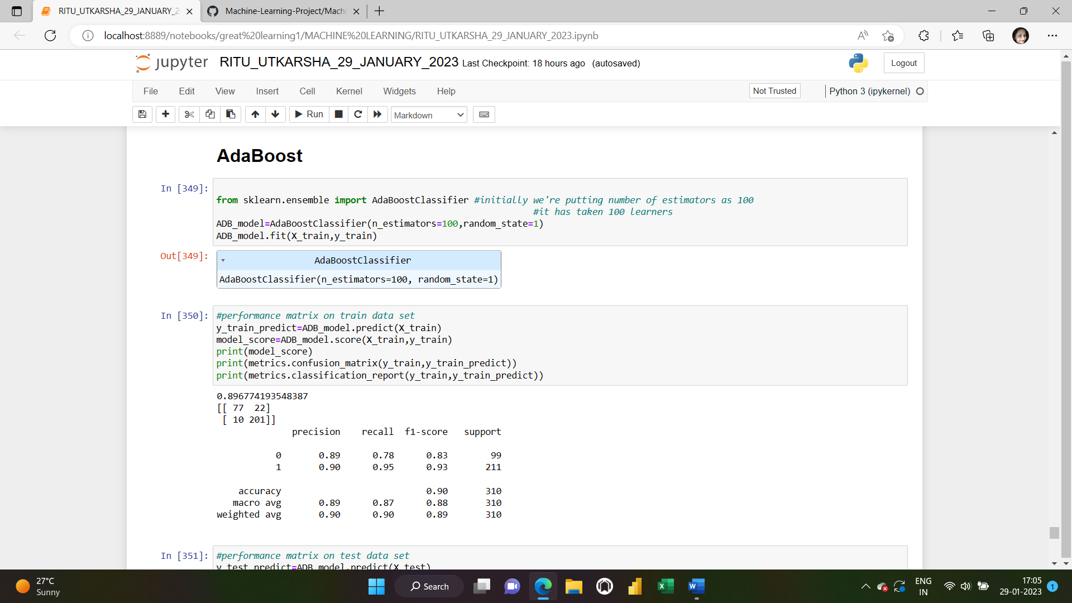

**ACCURACY SCORE,CONFUSION MATRIX AND CLASSIFICATION REPORT ON THE TRAIN AND TEST DATASETS**

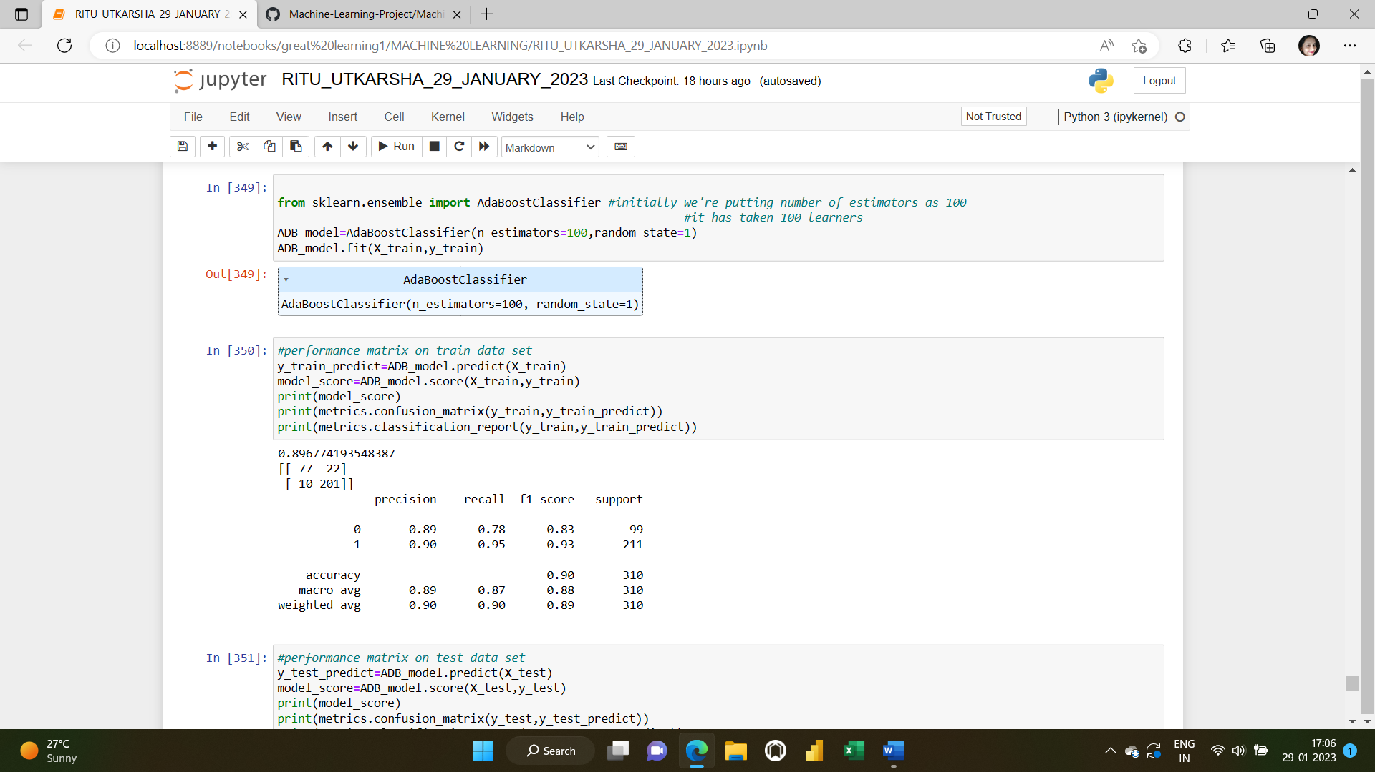

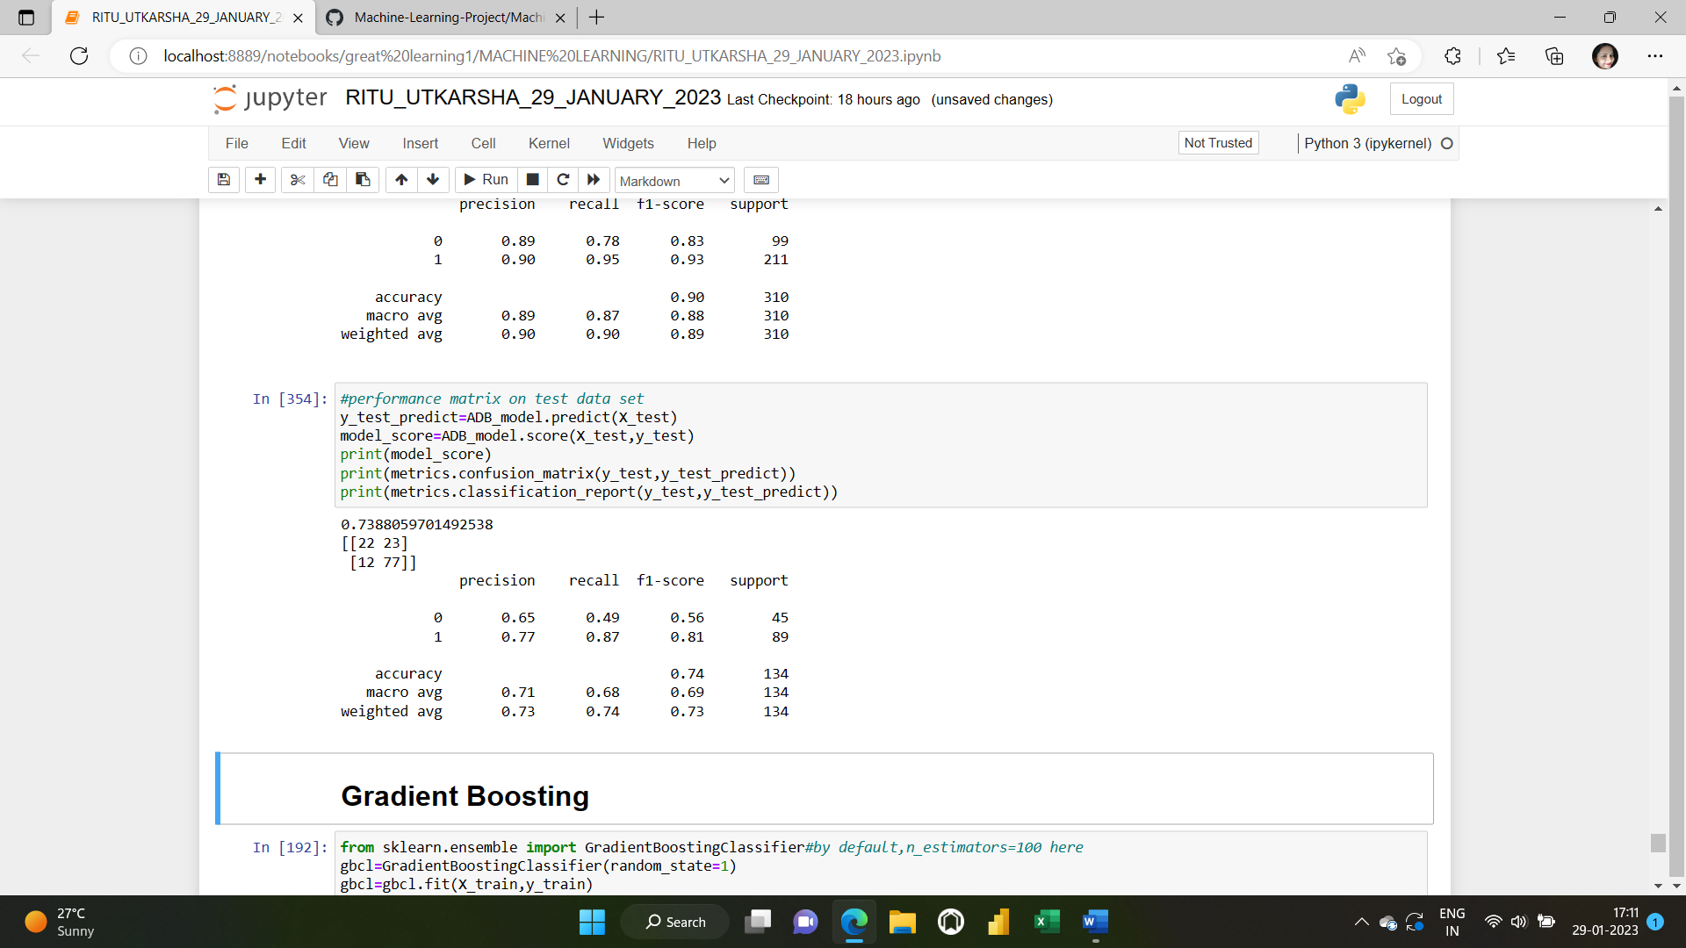

**6) GRADIENT BOOSTING MODEL:**

**IMPORTING AND FITTING THE GradientBoost MODEL**

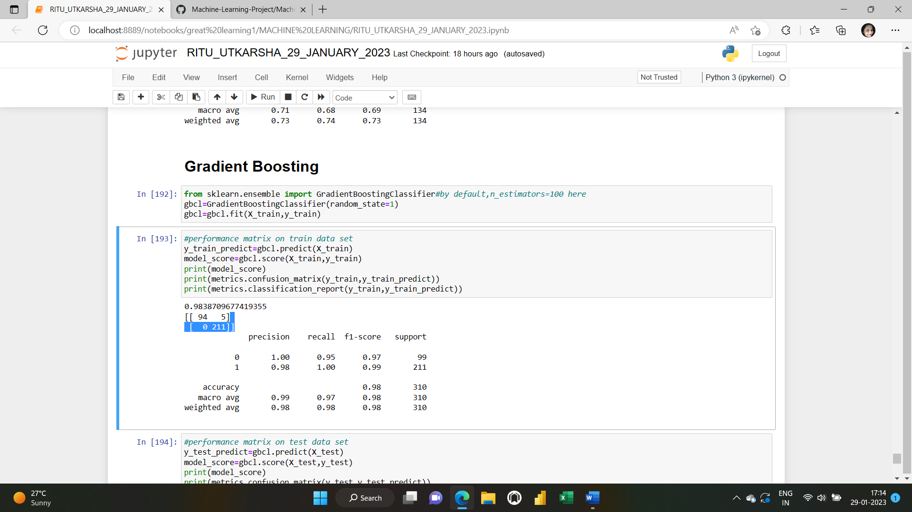

**ACCURACY SCORE,CONFUSION MATRIX AND CLASSIFICATION REPORT ON THE TRAIN AND TEST DATASETS**

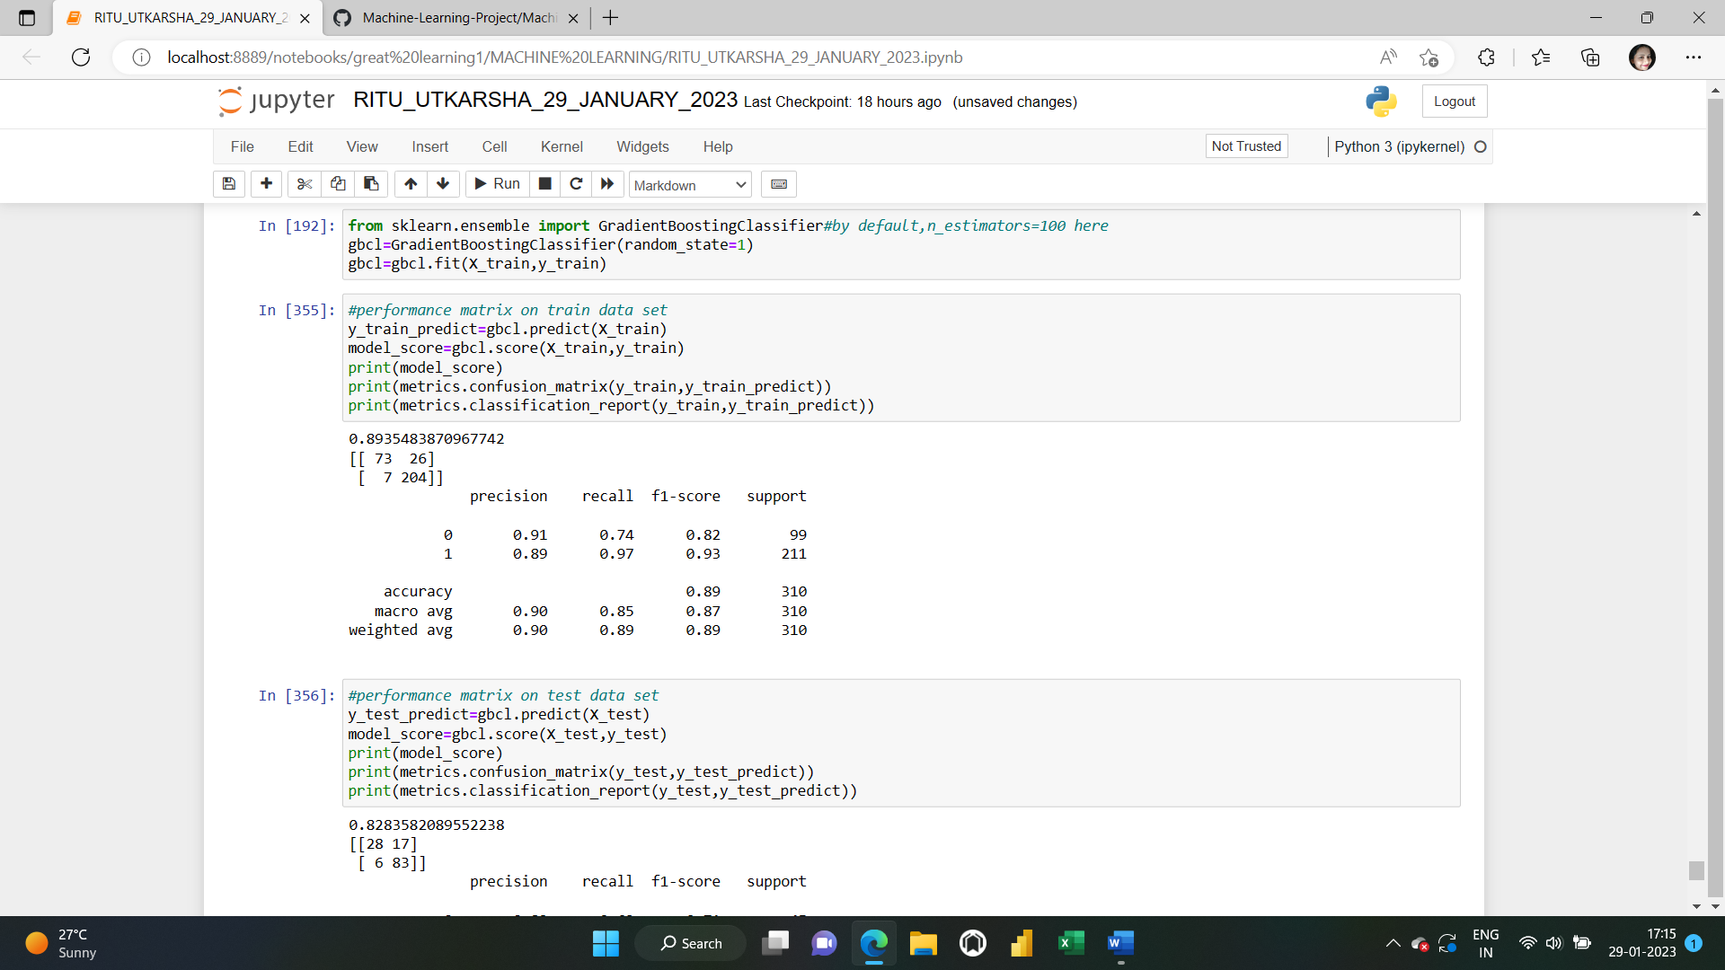

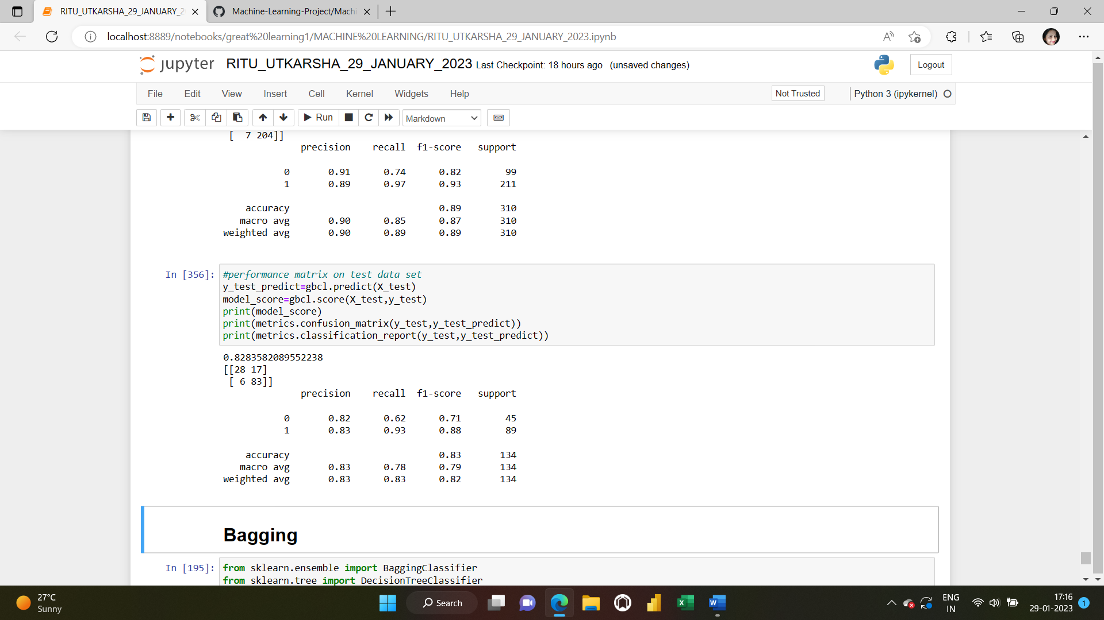

**7) BAGGING MODEL:**

**IMPORTING AND FITTING THE BAGGING MODEL**

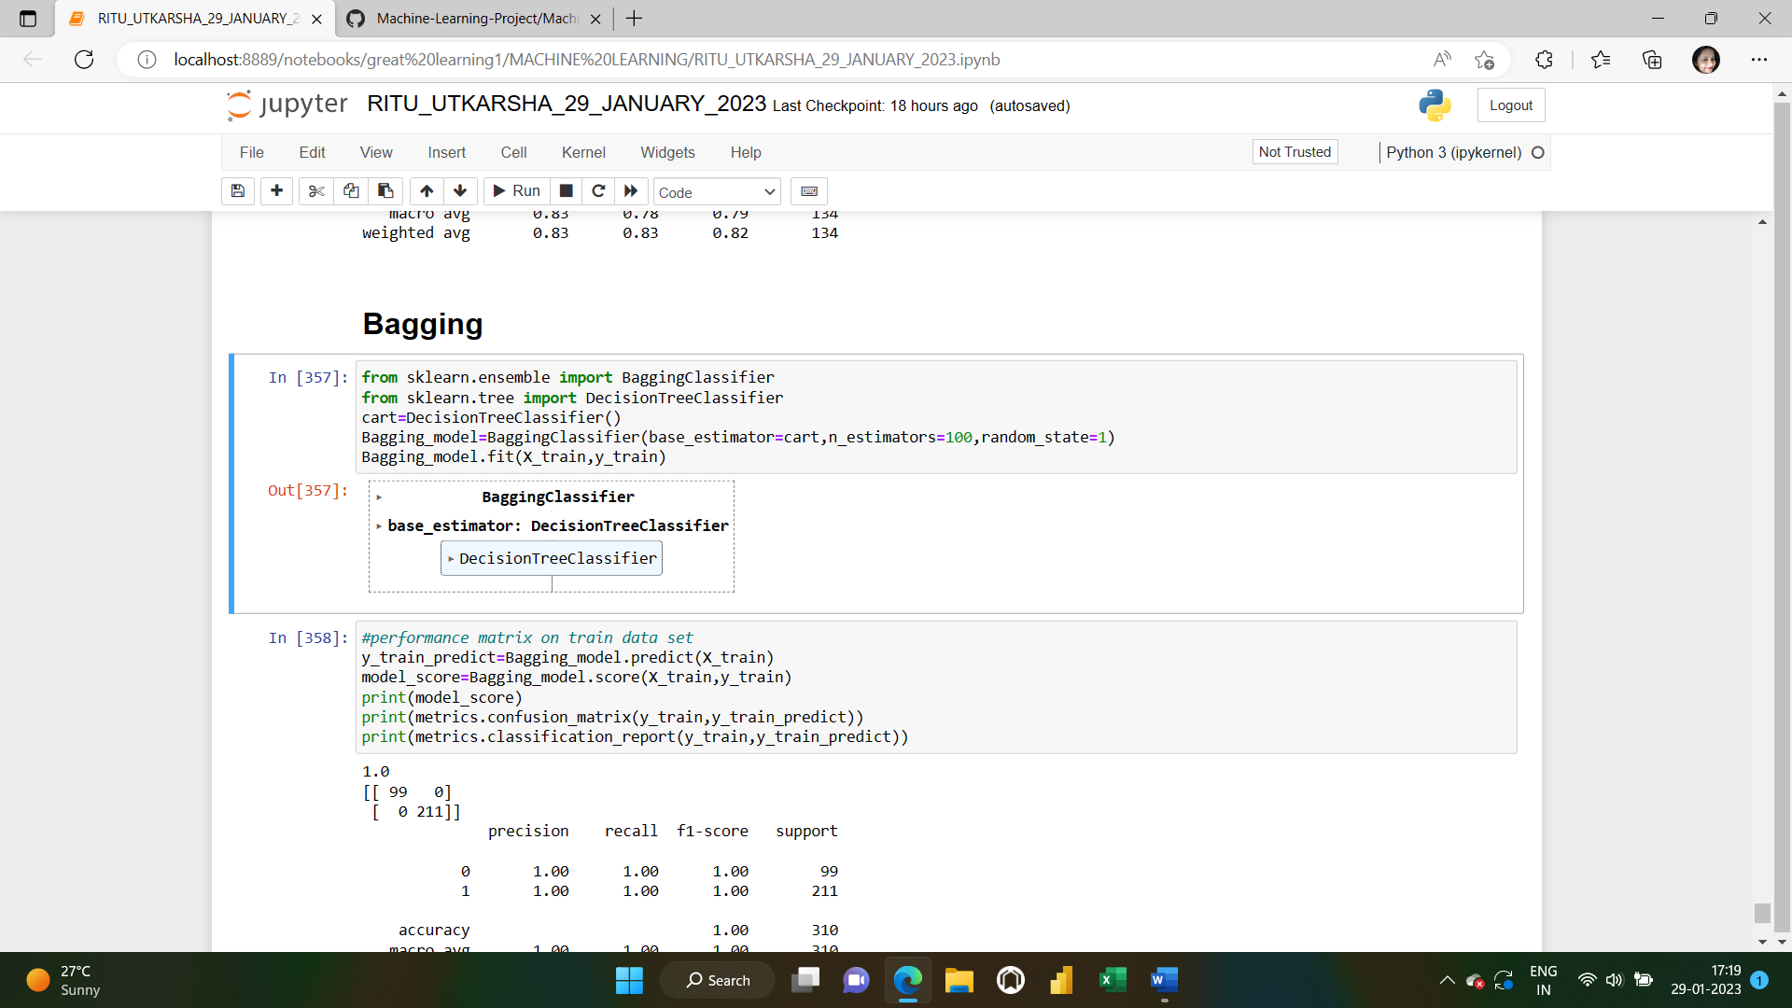

**ACCURACY SCORE,CONFUSION MATRIX AND CLASSIFICATION REPORT ON THE TRAIN AND TEST DATASETS**

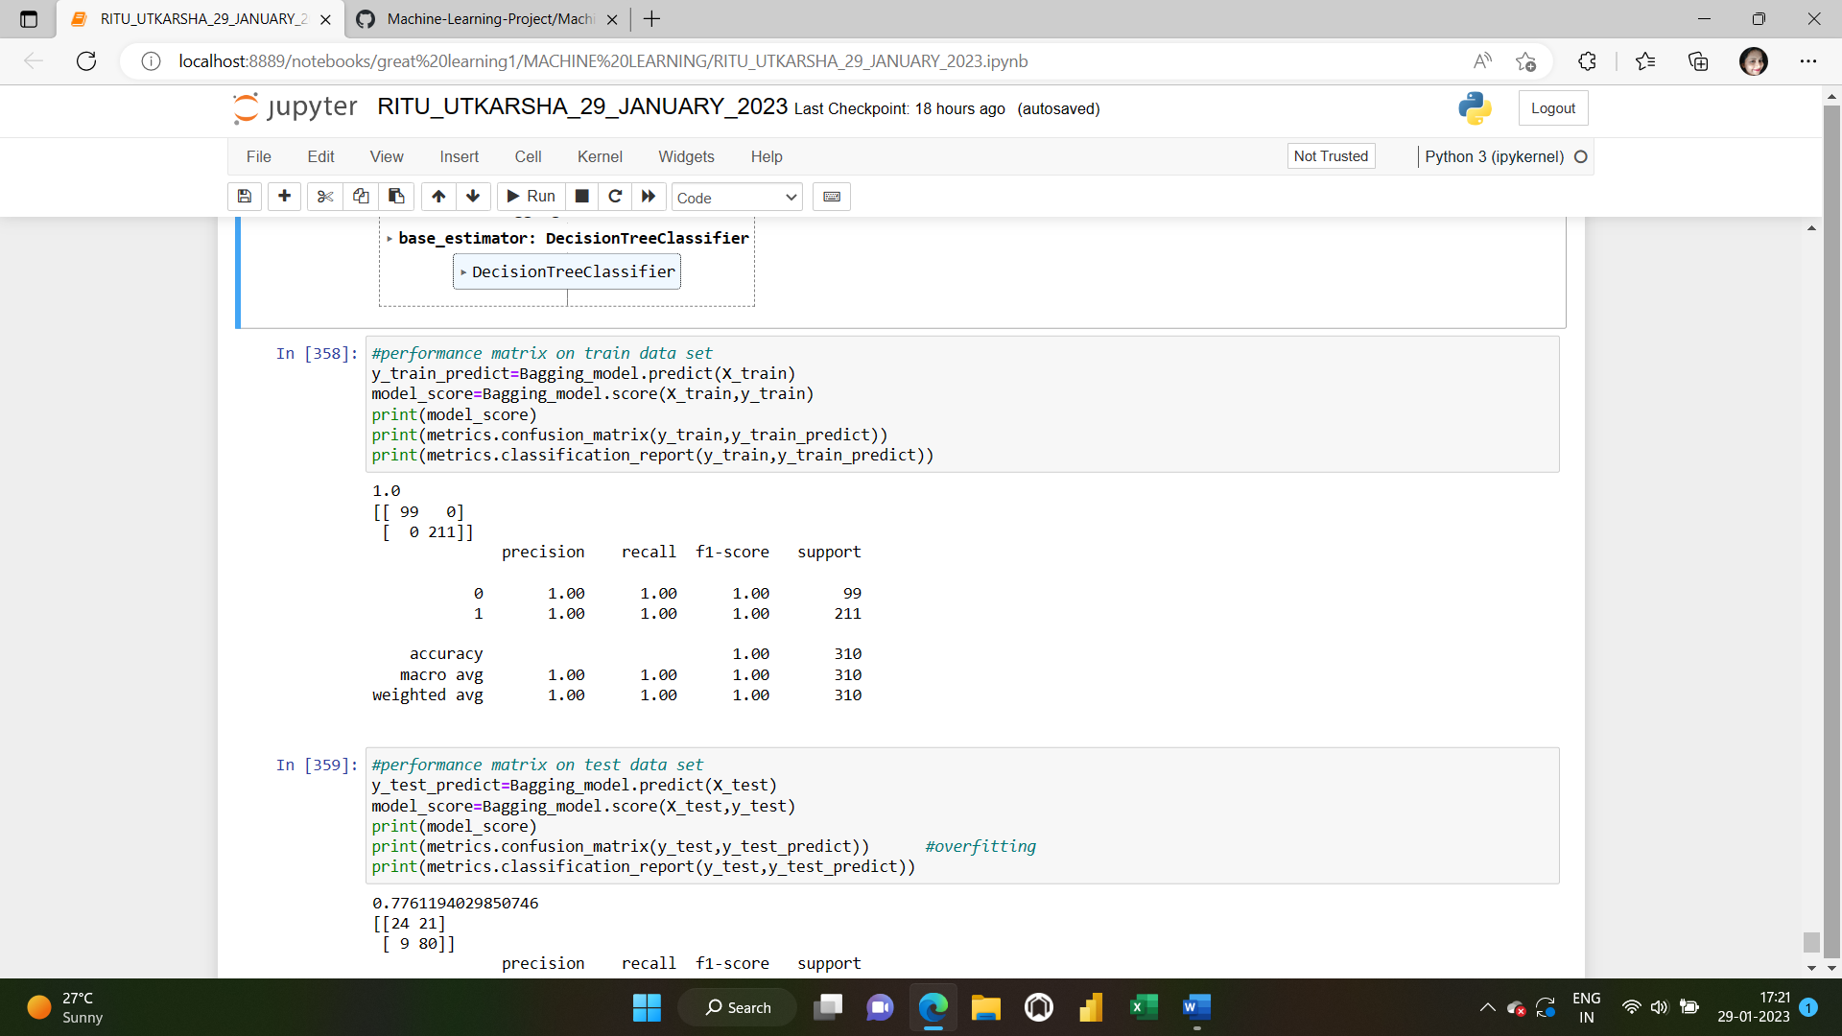

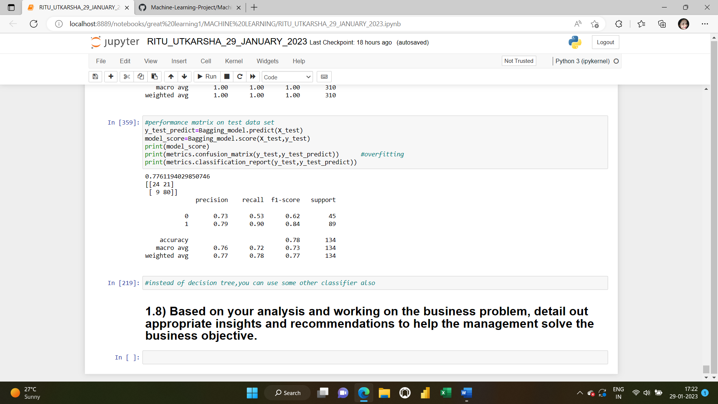

To assess the quality of our model,here we will use combination of metrics **F1 Score** and **Accuracy.** For both the metrics, the higher the value the better a model can classify observations into classes. However, each metric is calculated using a different formula and there are pros and cons to using both.

**F1 score** represents the model score as a function of precision and recall score. F-score is a machine learning model performance metric that gives equal weight to both the Precision and Recall for measuring its performance in terms of accuracy, making it an alternative to Accuracy metrics (it doesn’t require us to know the total number of observations). It’s often used as a single value that provides high-level information about the model’s output quality. This is a useful measure of the model in the scenarios where one tries to optimize either of precision or recall score and as a result, the model performance suffers.

Mathematically, it can be represented as a harmonic mean of precision and recall score.

**F1 Score = 2* Precision Score * Recall Score/ (Precision Score + Recall Score/**

**Accuracy score**is a machine learning classification model performance metric that is defined as the ratio of true positives and true negatives to all positive and negative observations. In other words, accuracy tells us how often we can expect our machine learning model will correctly predict an outcome out of the total number of times it made predictions. For example: Let’s assume that you were testing your machine learning model with a dataset of 100 records and that your machine learning model predicted all 90 of those instances correctly. The accuracy metric, in this case, would be: (90/100) = 90%. The accuracy rate is great, but it doesn’t tell us anything about the errors our machine learning models make on new data we haven’t seen before. The **accuracy metrics is also not reliable**for the models trained on **imbalanced or skewed datasets.**

Mathematically, it represents the ratio of the sum of true positive and true negatives out of all the predictions.

**Accuracy Score = (TP + TN)/ (TP + FN + TN + FP)**

**If we look at the accuracy and F1 scores of all the models created, the best performance is being shown by “Gradient Boosting algorithm”.**

Its accuracy for the training and test datasets is 89% and 83% respectively, which is decent. Also its F1 score for the training and test datasets is 93% and 88 %, which is quite good and much better than the other models built.

**1.8) Based on your analysis and working on the business problem, detail out appropriate insights and recommendations to help the management solve the business objective.**

**Solution: Insights:**

In this classification model ,we have to predict whether the mode of transport (dependent variable) is “Private transport” or “Public transport” using independent variables Age,Gender,Engineer,MBA,WorkExp,Salary,Distance,license.We built multiple models such as logistic regression,decision tree, random forest,KNN,AdaBoost,Gradient Boosting and Bagging for this buisness problem and found Gradient boosting to be the best one.

However ,while building the Random forest classifier model,we saw that some variables were of greater importance compared to the other ones.”Distance”and “Transport “ have the highest variable importance while “ license” has the least variable importance.

Due to multicollinearity,the model was getting affected as multicollinearity reduces the precision of the estimated coefficients, which weakens the statistical power of regression model.We might not be able to trust the p values then to identify independent variables that are statistically significant ones.While building the logistic regression model,we saw that WorkExp was having very high VIF(VIF means there is multicollinearity) and so we had to get rid of that variables.Also some of the variables’ pvalues were much greater than 0.05 (which means they were statistically insignificant) and so we removed them in building the final logistic regression model.

**Recommendations:**

To help the management solve the buisness objective,data collection from different sources can be improved. There are many other factors that influence the choices of mode of transport. One of them can be “Cost of transport”. Public transport such as Sea transport is the cheapest means of transporting bulky goods provided the speed of carriage is not an essential requirement. Rail transport is also a cheaper way of transport over long distances.Private transport is only confined over small distances and can’t be used for carrying higher weights.

Other factor that can affect our target variable can be “Speed”.The quickest mode of transport is obviously airways whereas the slowest is the water transport. Private vehicles would be of moderate speed.

One factor can be “flexibilty “also.While choosing a particular mode of transport,we have to consider the flexibility also. In this respect,road transport and private transport would be the best ones.

Other very important factor affecting the mode of transport can be “Regularity”also. In case of private transport, regularity of service is the most assured.The scheduled movement of public transport can be affected by weather conditions.

There are many other factors such as Safety,Nature of commodity etc which influence the choice of mode of transport.

The quality of data can be made better so that not much data cleaning would be required.And it should be made sure that the practical implementation of best model is made possible.

|  |  |  |  |  |  |  |  |
| --- | --- | --- | --- | --- | --- | --- | --- |